Creating a Job Requisition (Job Card)

Navigate to New Job on your dashboard, from the Bubble menu or from right side navigation bar AKA: the main menu button.
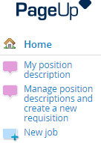

You will be directed to the opening page to create a new job for recruitment.
Tip: To complete the Job Card/Requisition process, you need ALL of the following information:
Position number
Budgeted Salary
FTE Percentage
Index Account

Select the button next to the position field, type Adjunct in the title field, and select the search. From the list of titles, press the select button next to Adjunct Faculty.
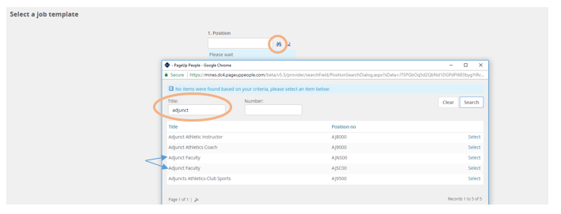
After you have selected the position, select no template and then next. This will allow some fields to auto populate.
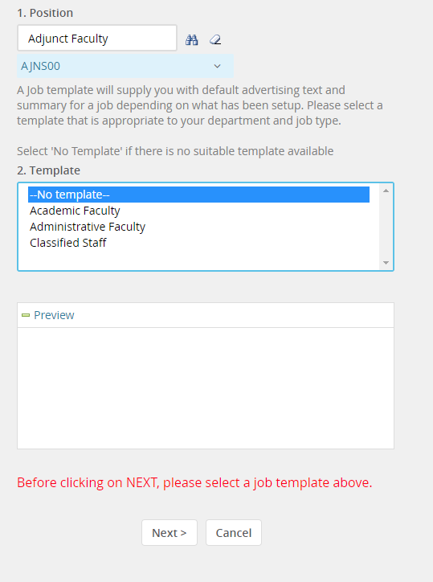
Title:
Position E-class, working title and Position/Classification title will auto populate. You may NOT edit the working title.

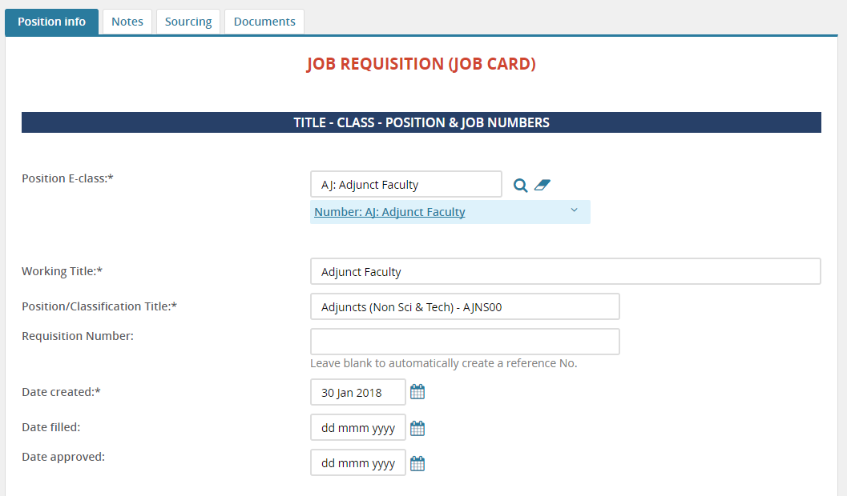

Headcount:
The first position will auto populate. You may add additional slots by entering the number of positions in either the new or replacement fields, then select the add button. If replacement write in the name of the person being replaced.
Note for this training session: Add at least 5 positions when you create the job. If you need to add additional positions after you have saved, you must request that from HR.
Do not be alarmed in March when you see the modification in the headcount management section. Rather than asking for number of positions before the position table, the entry of additional new or replacement positions has been relocated at the bottom as an 'Add more'.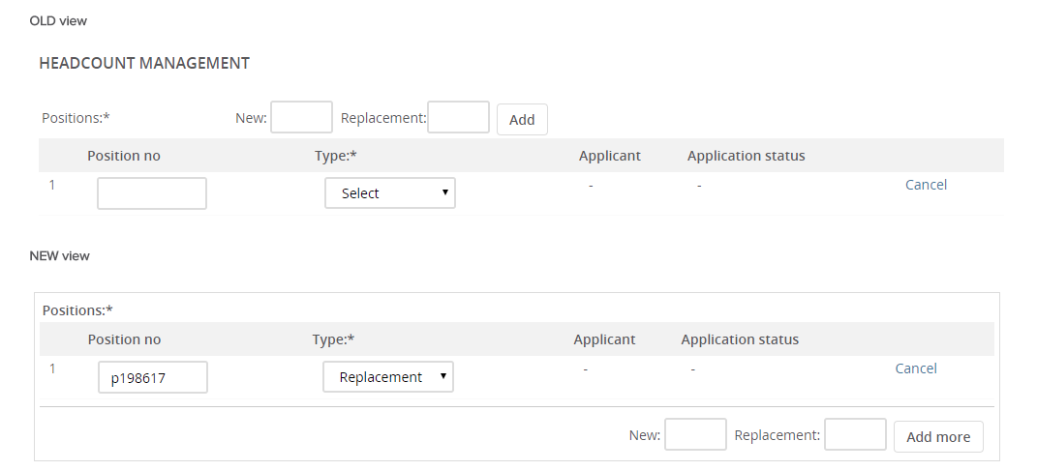
Position Details:
Complete the following fields
- Select the reason for hiring
- Recruitment process: Direct Appointment Paid
- If temporary specify duration
- Initial Term appointment end date
- Work type
- Brand
- College/Org Level
- Department

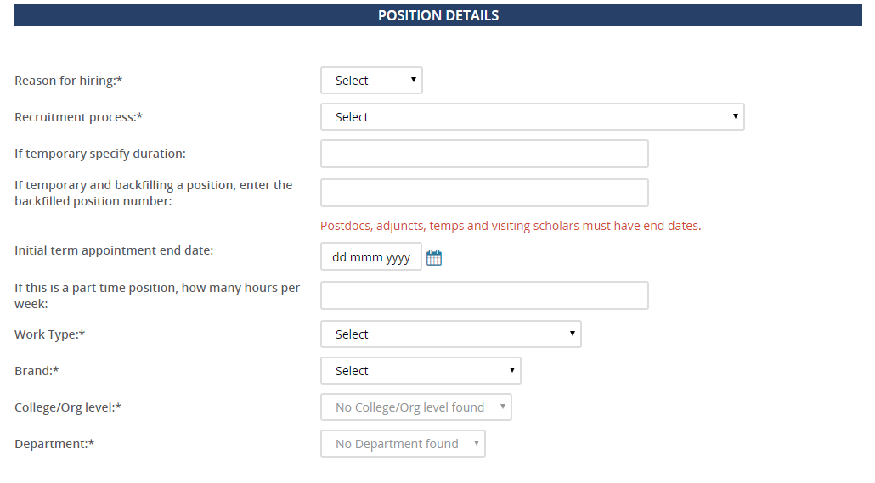
Salary & Budget:
Complete the following fields
- Annual position budget (amount to pay for the semester)
- FTE
- Is this position exempt (always Yes)
- Do you expect to hire at a different salary than budgeted (always No)

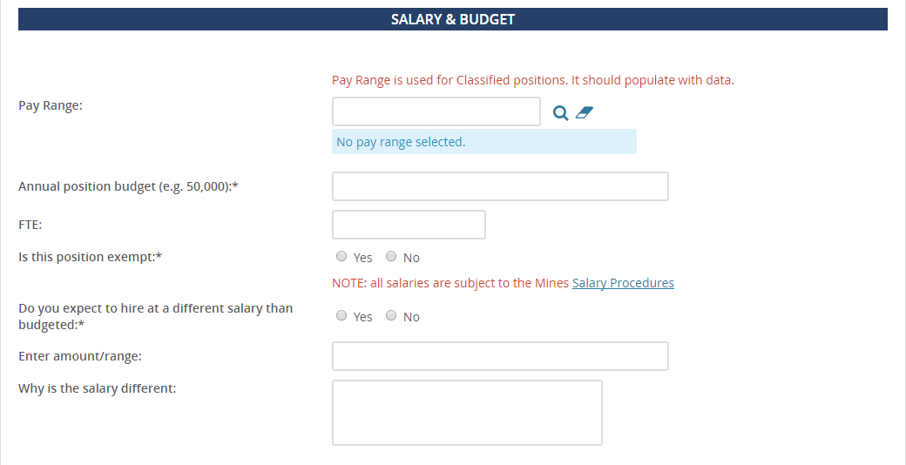

Accounts and Percent Distribution:
Insert the index number in front of the account number in the index field. Skip all other fields unless using multiple index and accounts.
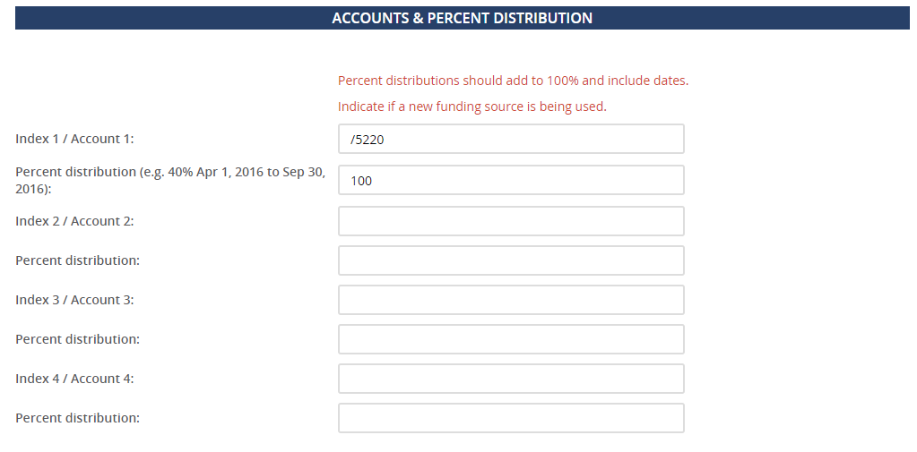

*Skip the sections of selection criteria, search committee, search process and advertising, as this is a direct appointment.

Users & Approvals:
- Skip Budget and ORA approver fields
- Fill in the Department Head/supervisor/contact field
- Approval process select Adjunct
- Fill in the Department Head field
- Select adjunct for the approval process and fill in the Department Head
- Select pending for the status
- Select save and exit. The approval process will begin. Once the job is approved the hiring manager will receive an email notification.

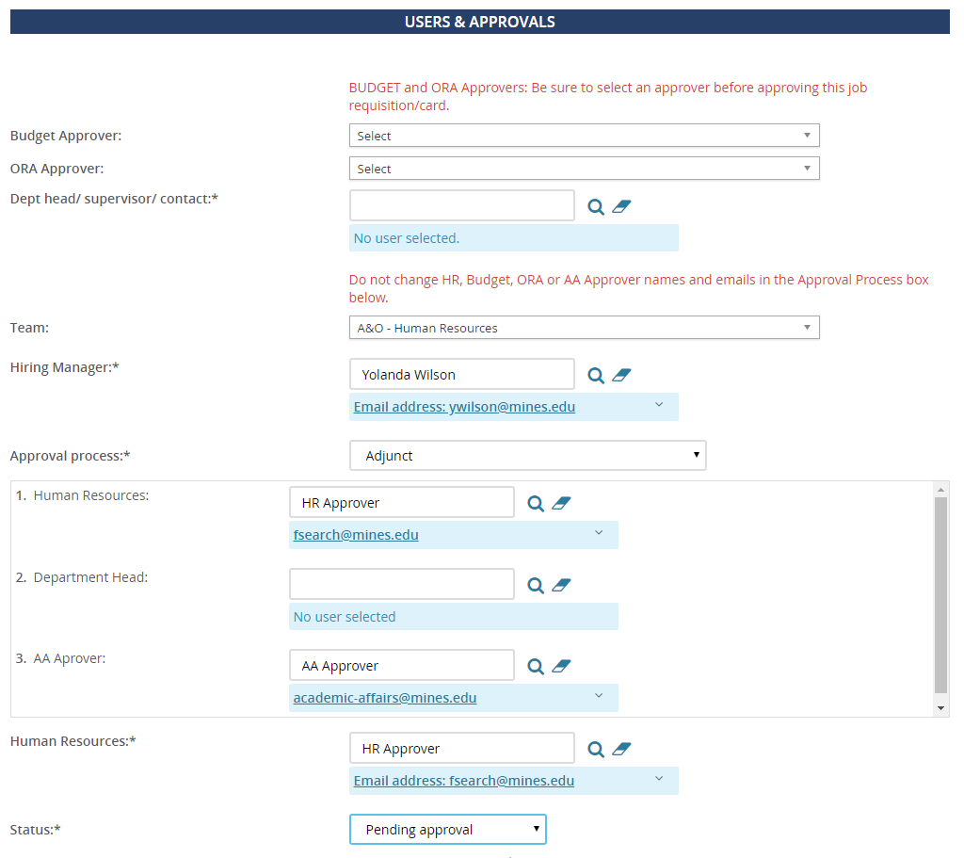

How to find the job card

Go back to your home dashboard. Next to new job select, the jobs open link to see select the job card you would like to view
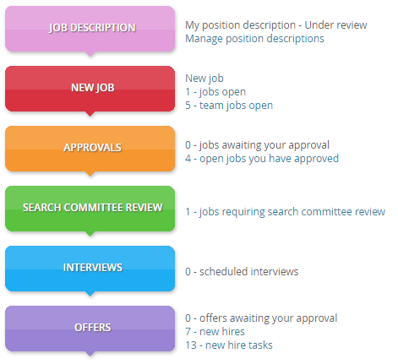

Attach documents to the job card

There is an optional feature that allows you to add documents and notes to the job card. One example would be the email authorizing the hire.

Open the job card, select the documents tab, and select document from a file type to upload the document.

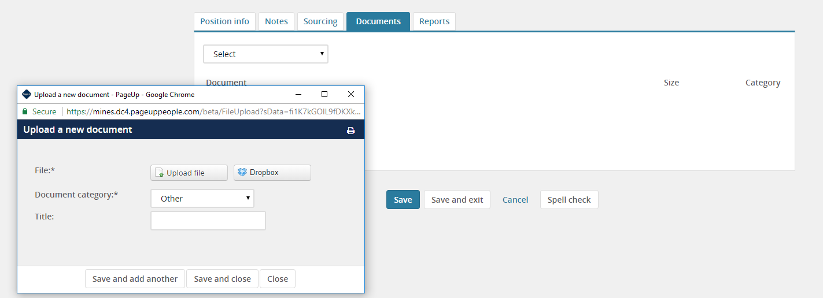

Add an applicant to the requisition

Add an applicant that has never applied for a position through PageUp:
Open the job card.
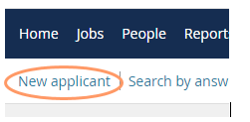
Select view applications, select new applicant, enter the applicant’s information, be sure to select yes to disclose, and select save.

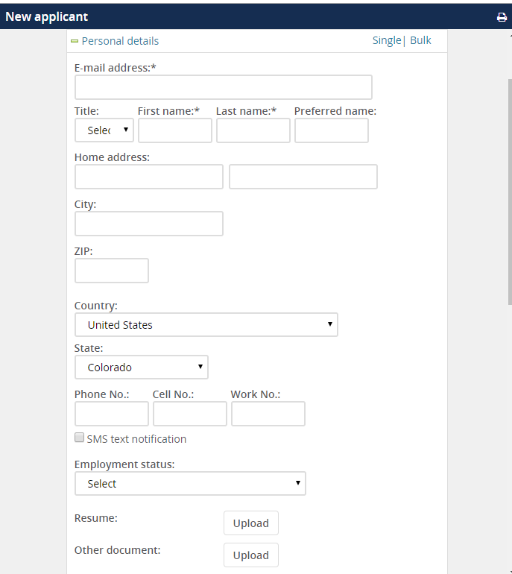
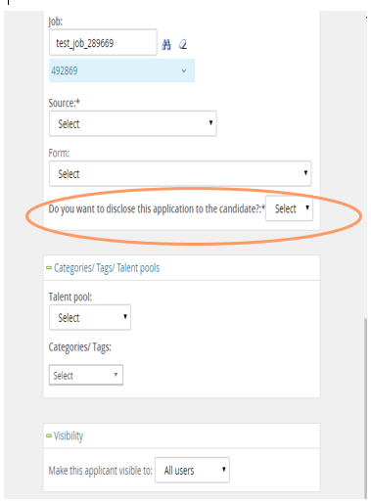

Add an applicant that has applied for a position through PageUp:
If you attempt to add an applicant that previously applied to another job you will receive an error message, “An account exists with this email address.”

There is a secondary way to add this applicant. Type the applicants name in quick search and select the applicants name to open their applicant card.

On the applicant card under actions, select New application
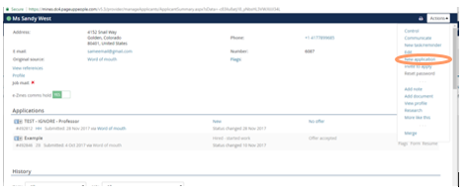
Type in the job number, select application source, select yes to disclose the application, select application method of just apply them to the job, select application status of new, and then select apply.
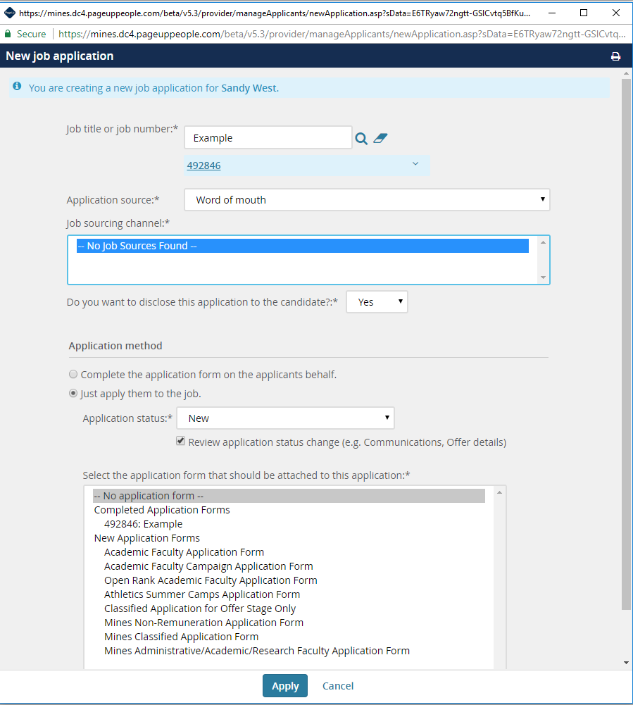

Do not send an email to the applicant. Select no next to email the applicant and then select move now.

