PageUp Direct Appointment
Create Pre-Offer Salary request

From your home dashboard select, the link jobs open. This will open the list of all your open jobs. From the list that appears select view to the far right of the job you would like to open. This will open the job card.

From “View applications,” click on the name of the applicant to be made an offer. You could also use the white search bar at the top left of your dashboard and type in the applicant’s name. You will land on the applicant card. Click on the status:
*The current applicant status will be New
Change application status to Pre-offer salary request and then select Next.
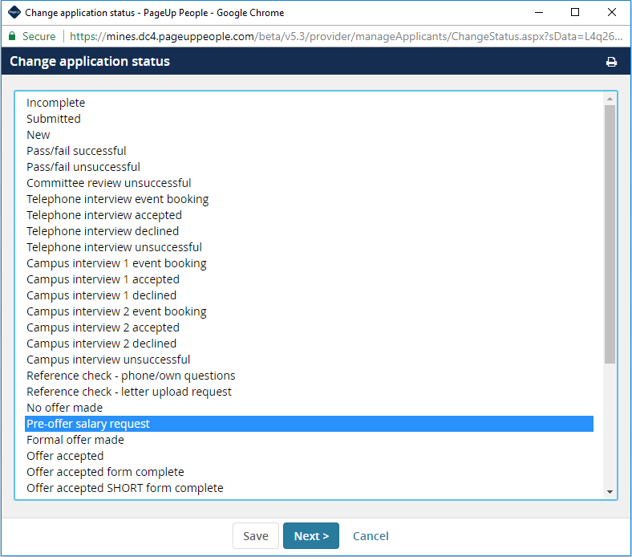

At the bottom of the next screen, click Move Now and this will take you to the offer card.
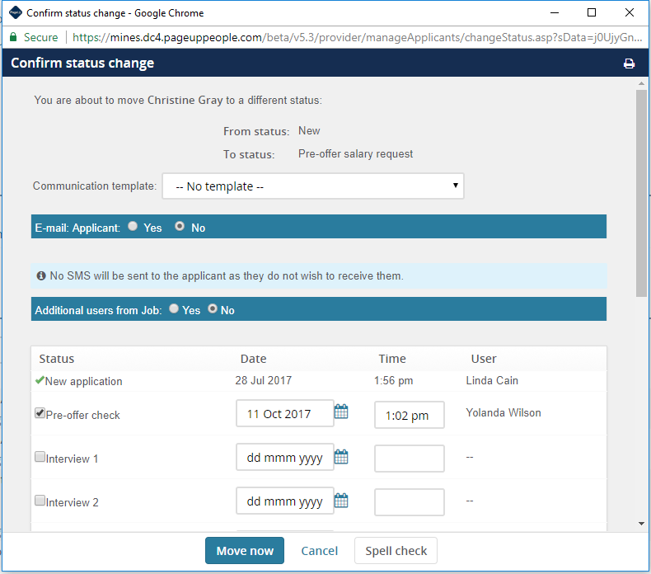

After you select move now the offer card will display. The top three sections of the offer are prefilled by the system. (Personal details, Job details and Offer details)
Make required adjustments for Position Details, Accounts & Distributions, Salary & Budget, and Onboarding

POSITION DETAILS:
- Start date
- End date
- Adjunct assignment (list courses to be taught)

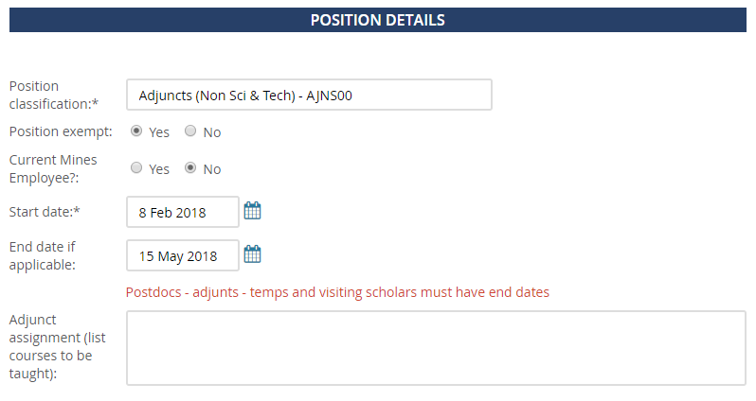

ACCOUNTS & DISTRIBUTIONS:

- Verify the index/account is complete
- Percent distribution
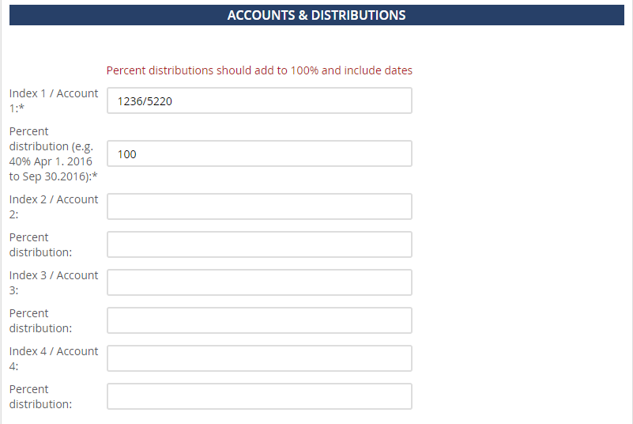

SALARY & BUDGET:
- Final approved salary (e.g. 60,000 – no dollar signs)
- FTE percentage and Web timecard approver
- Skip Budget and ORA approver
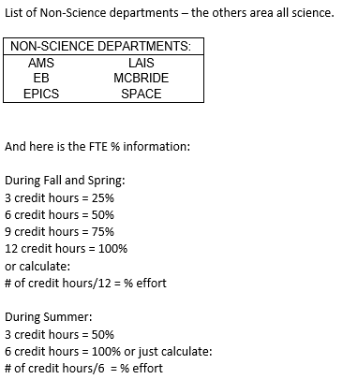
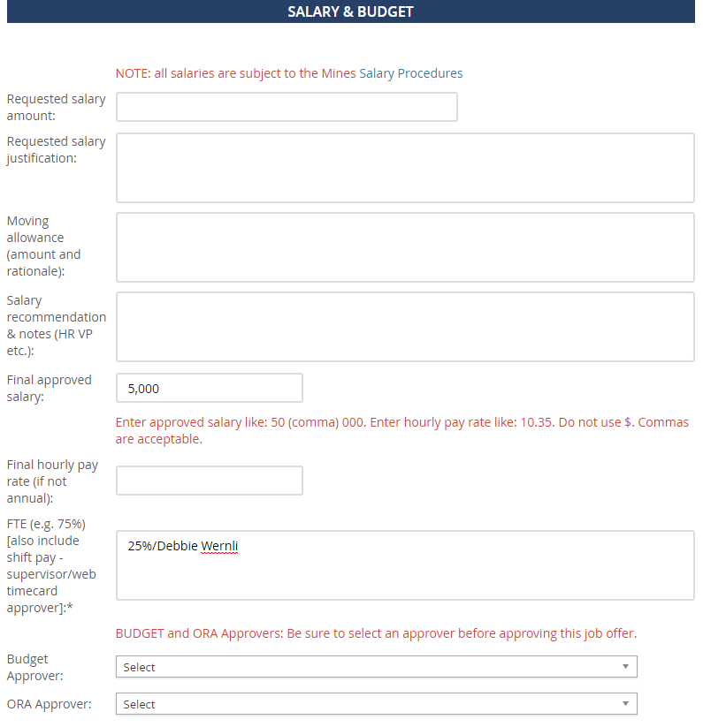

*Skip pre-employment checks section (HR will fill in this field), and skip contracts section.

ONBOARDING:
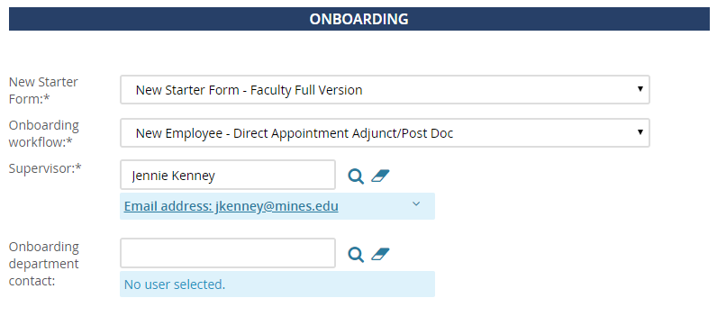

If paid direct appointment:
- New Starter Form: New Starter Form – Faculty Full Version
- Onboarding workflow: New Employee – Direct Appointment Adjunct/Post Doc

If volunteer or unpaid visiting scholar direct appointment:
- New starter form: New Starter Form - No Remuneration/Volunteer
- Onboarding workflow: Non-Remuneration/Volunteer

Continuing down the offer card, it is important to note that the section titled OFFER PROGRESS is part of the automated system and should not be completed.
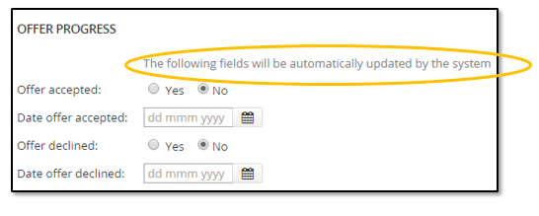

APPROVAL PROCESS:
You are now ready to get your offer approved. Scroll down to the Approval process section. You will be asked to select the appropriate approval process. This is very similar to the job requisition approval process. The offer will not progress if you do not select an approval process.

You do NOT need to add the HR Approver and AA Approver fields the system will automatically fill in those fields. You MUST fill in the fields for the Department Head and College Fiscal Officer.
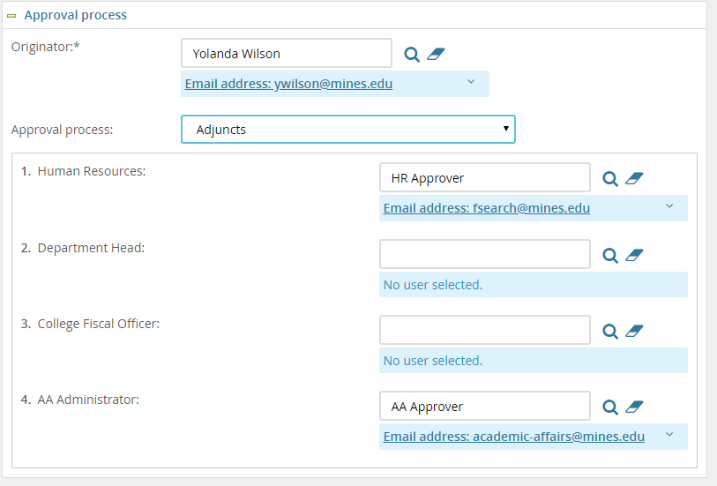
Once approval is complete, the Hiring Manager will receive an email notification and Jennie will prepare the offer letter in PageUp and send it to the new hire. The new hire will be sent an email requesting that they login to PageUp to accept their offer. Once the offer is accepted, they will immediately be prompted to complete the new starter form.

If you have not received the notification email that the offer is approved you can view the offer card to see the progress. Type the applicants name in quick search and enter, select the name of the applicant, select the offer incomplete link, and scroll to the bottom of the offer card to view the approval section.

