Quick Reference Guide

for Department Deposits in Transact

Crosswalk from Banner to Workday

The image below shows the new terminology used in Workday, and how it relates to the terminology used in Banner. Use this guide to determine what is the equivalent of Banner Index, Organization, Fund, Account, Program, and Activity Code in Workday. The equivalent terms are listed across from each other:

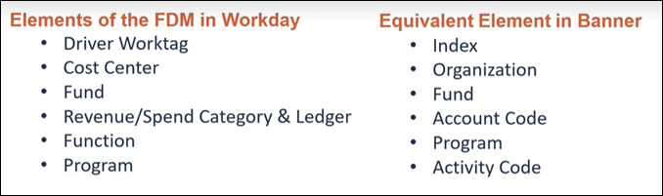

Department Deposits in Transact
When making a department deposit in Transact, use the guide below to enter the corresponding elements from Workday on your deposit G/L. Please note, the terms listed on the top are elements of the FDM in Workday, while the ones listed in parenthesis are their equivalents in Banner.

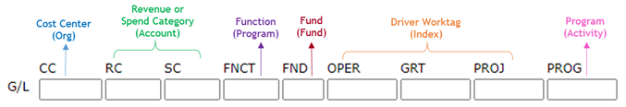

Account Code Conversion
Refer to Controller’s Website for account code conversion: https://www.mines.edu/controllers-office/
For questions and clarifications, please contact the Office of the Bursar at 303-273-3158.

