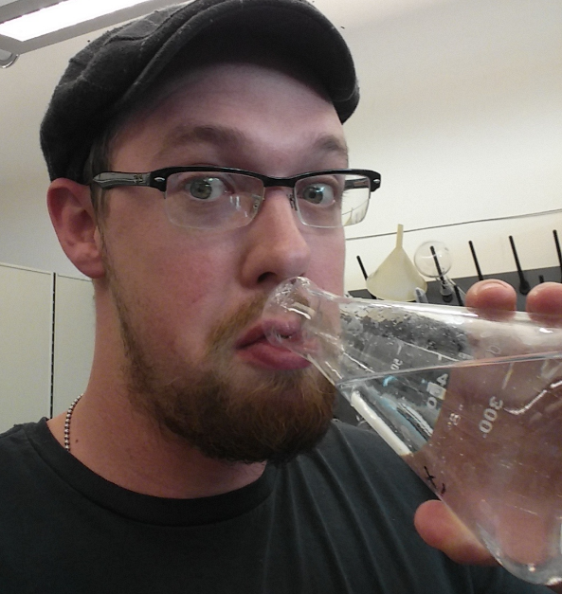
Kurt Livo is currently a PhD candidate in Petroleum Engineering at the Colorado School of Mines. He is a research assistant working on low-field Nuclear Magnetic Resonance (NMR) properties of fluids and porous media in the OCLASSH and DHI Fluids research groups. Kurt’s research interests include pressure dependent NMR response for fluid relaxation and mineralogical controls on NMR derived properties in both unconventional and conventional reservoir rocks. His professional experience has included being an Oil and Gas bill writer and consultant for the Colorado House of Representatives, a reservoir engineer working on steam injection implementation and optimization in heavy oil reservoirs for Freeport-McMoRan Oil and Gas in Bakersfield, California, and a production and reservoir engineer for Schlumberger Petrotechnical Services working on petrophysical modeling and evaluation of the Mowry shale in the Powder River Basin of Wyoming.

Contact Information:
11960 W. 22nd PL.
Lakewood, CO 80215
303-501-0156
klivo@mymail.mines.edu

