Standard Operating Procedure
[CHEMICALNAME]
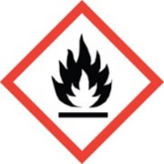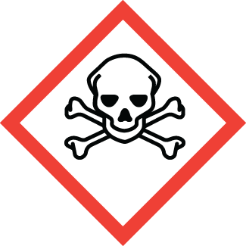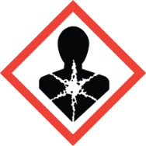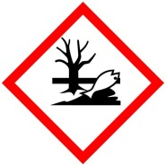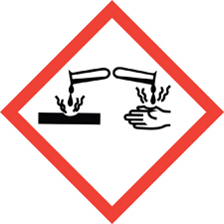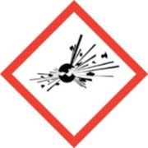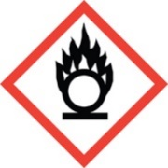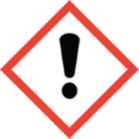
Chemical name, CAS: |  |  | [CHEMICALNAME]
PI: |  |  |  | Date:
Building: |  |  |  | Lab #:

- Material Use:
Describe materials to be used

- Potential Hazards:
Describe the potential hazards and known toxicological information. The information below are examples, change this information to your particular materials.
Material | OSHA Permissible Exposure Limit | ACGIH Threshold Limit Value
Cadmium | 5 ug/m³ | 10 ug/m³
Cd Telluride | 5 ug/m³ | 2 ug/m³ (as Cd compound)
Cd Sulfide | 5 ug/m³ | 2 ug/m³ (as Cd compound)

- Engineering Controls:
Examples of engineering controls include:
Process under vacuum. Vacuum pumps are exhausted to the laboratory exhaust. The laboratory exhaust is HEPA filtered before being emitted from the building.
All handling of hazardous compounds will be done in the laboratory hood.
HEPA filtered portable exhaust is available for positioning near openings to capture airborne contaminants when opening and cleaning chambers.
An eyewash is located in the lab, and an eyewash/safety shower combination unit is located in the hallway.

- Work Practice Controls:
- Wash hands immediately after handling hazardous materials. Wash hands before exiting the lab.
- Leave laboratory coats in the laboratory.
- Keep all personal items, backpacks, laptops, water bottles outside of the laboratory.
- To keep contamination to a minimum, work on top of a disposable bench protector – such as Sterilin BenchGuard, or Labmat Bench Liner. Dispose of used bench protector in solid hazardous waste container.
- Place a sticky mat at the lab exit, remove the off top sheet of the sticky mat when dirty.
- Periodically wipe down countertops, hood, and sample staging areas.

- Personal protective equipment (PPE):
Lab Coat | Chemical Resistant Apron | Splash Goggles | Face Shield | Gloves | Respirator

- Storage:
Store compounds in containers clearly labeled with contents. Keep containers in secondary containment. Keep containers tightly closed and store in a dry, cool, well ventilated location.

- Waste Disposal:
Dispose of waste materials in a solid hazardous waste container.
Include obviously contaminated wipes, gloves, respirators or clothing in solid waste containers. Do not put in regular trash.

- What to do if exposed:
If inhaled
Remove to fresh air. If not breathing, give artificial respiration. If breathing is difficult, give oxygen. Get medical attention.

In case of skin contact
Immediately flush skin with plenty of water for at least 15 minutes while removing contaminated clothing and shoes. Get medical attention immediately. Wash clothing before reuse. Thoroughly clean shoes before reuse.

In case of eye contact
Immediately flush eyes with plenty of water for at least 15 minutes, lifting lower and upper eyelids occasionally. Get medical attention immediately.

- Spill Procedure:
Incidental (small) spill. Wearing lab coat, safety glasses and heavy nitrile gloves use a moistened wipe to clean up debris. Vacuum surface after wipe down with a HEPA filtered vacuum.

Large spill. Call x-3316 and notify EHS personnel for assistance.

- Training and medical monitoring of personnel:
Lab workers must complete Hazardous Waste Generator Training and Laboratory Safety Training with the EHS Department.
Each new lab worker should be oriented to the contents of this SOP and provided with lab specific safety training – such as safety expectations, where personal protective equipment is kept, how to use and store the PPE.

I have read and understand this SOP. I agree to fully adhere to its requirements.
Last | First | CWID | Signature | Date

