Standard Operating Procedure
Cyanide Salts
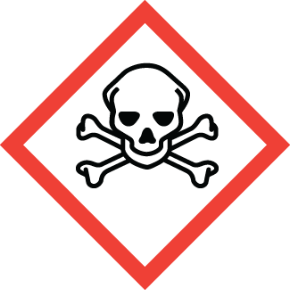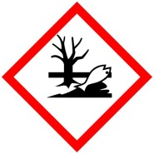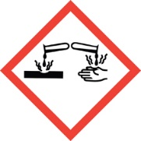
Chemical name: |  |  | Cyanide Salts (Potassium Cyanide, Sodium Cyanide)
PI: |  |  |  | Date:
Building: |  |  |  | Lab #:

- Material Use:
Cyanide salts (sodium cyanide and potassium cyanide) are used in chemical synthesis, electroplating, and mining technologies to extract gold and other precious metals.

- Potential Hazards:
Potassium and Sodium Cyanide are highly acutely toxic when ingested or absorbed by the skin. Exposure to as little as 50-150mg can be fatal. Cyanide salts react with acid or water to produce hydrogen cyanide gas, which is both toxic and flammable. Moisture from the atmosphere may also react with cyanide salts to produce HCN gas. HCN gas may have a bitter almond smell, but the smell is undetectable to a large percentage of people. Symptoms of HCN gas exposure include: weakness, headache, dizziness, and nausea.
Material | OSHA Permissible Exposure Limit | ACGIH Threshold Limit Value
Sodium cyanide | 5 mg/m³ | 5 mg/m³
Potassium cyanide | 5 mg/m³ | 5 mg/m³
Hydrogen cyanide (gas) | 10 ppm | 10 ppm

- Engineering Controls:
- All handling of cyanide salts compounds must be done in the laboratory hood.
- Put up signage warning others that cyanide is being used in your work area.
- Laboratory hood sash height should be kept low to minimize escaping fumes and provide protection from splashes.
- HCN gas detectors should be used whenever there is a potential for HCN gas production.
- Access to an eyewash and safety shower must be readily available.
- The lab personnel must have easy access to a telephone (landline or cell phone).

- Work Practice Controls:
- Ensure that you have all the PPE required for handling cyanide salts.
- Use HCN Gas Detector when mixing cyanide salts with water.
- No acids should be in laboratory fume hood or work area when working with cyanide salts.
- Work surfaces and tools should be wiped down in the hood using a pH 10 buffer or dilute bleach solution.
- Purchase the smallest feasible quantity of cyanide salts and conduct small-scale experiments.
- Wash hands immediately after handling hazardous materials. Wash hands before exiting the lab.
- Do not work alone when handling cyanide salts. Inform others in the immediate area when you are working with cyanide salts
- Lab emergency contact information must be readily available.

- Personal protective equipment (PPE):
Lab Coat | Splash Goggles | Gloves  Nitrile | Long Pants/Closed-toe Shoes

- Storage:
- Store cyanide in a secured area, separated from all acids, nitrites, nitrates, water, steam, heat, chlorates, and strong bases.
- Store cyanide in a sealable secondary container (ideally polypropylene). Always remove cyanide from its secondary container in a chemical fume hood to allow any accumulated gas to be vented safely.
- Store compounds in containers clearly labeled with contents. Keep containers tightly closed and store in a dry, cool, well ventilated location.
- Do not store near water or acids.

- Waste Disposal:
- Dispose of waste materials in a hazardous waste container, and store in Satellite Accumulation Area.
- Include obviously contaminated wipes, gloves, lab plastics or clothing in solid waste containers. Do not put in regular trash.
- Clearly label waste containers. Do not mix incompatibles (e.g. water & acids) with cyanide salt waste.

- What to do if exposed:
If inhaled or ingested
Alert others and exit lab to fresh air. If not breathing, give artificial respiration. If breathing is difficult, give oxygen. Call 911 immediately. Inform emergency medical personnel of exposure.

In case of skin or eye contact
Immediately flush skin or eyes with plenty of water for at least 15 minutes while removing contaminated clothing and shoes. Seek medical attention immediately (Call 911). Wash clothing before reuse. Inform emergency medical attention of exposure.

- Spill Procedure:
Incidental (small) spill: Wearing lab coat, safety glasses, and heavy nitrile gloves sweep small amounts of dry chemical into a waste container. Do not use water or wet paper towels to clean up cyanide salt spills.

Large spill: Call 303-273-3316 and notify EHS personnel for assistance.

- Training and medical monitoring of personnel:
- Hazardous Waste Generator Training and Laboratory Safety Training with the EHS.
- Lab Specific Training provided by supervisor that covers: safety expectations, PPE use and storage, SOPs, and emergency response.

I have read and understand this SOP. I agree to fully adhere to its requirements.
Last | First | CWID | Signature | Date

