Standard Operating Procedure
Hydrofluoric Acid
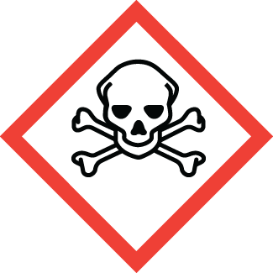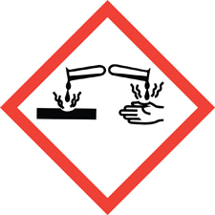
Chemical name, CAS: |  |  | Hydrofluoric Acid (HF, Hydrogen Fluoride), CAS: 7664-39-3
PI: |  |  |  | Date:
Building: |  |  |  | Lab #:

- Material Use:
Hydrofluoric acid, HF, is a mineral acid often used in research for its ability to etch silicon compounds. HF is a critical compound in semiconductor and electronic fabrication, mineral processing, and glass etching.

- Potential Hazards:
Hydrofluoric is highly corrosive and extremely toxic. HF penetrates tissue more readily than most mineral acids. HF poisoning can occur via exposure to skin, eyes, inhalation, or ingestion. Symptoms of HF poisoning may not be immediately evident, but may include: irritation or burns of skin, eyes, and throat. HF poisoning can be fatal if untreated, and will effect calcium and magnesium levels in the body leading to multiple organ failure and death.
Material | OSHA Permissible Exposure Limit | ACGIH Threshold Limit Value
Hydrofluoric Acid | 3ppm

- Engineering Controls:
- All work must be conducted in a designated laboratory hood labelled: “DANGER, Hydrofluoric Acid”
- Calcium Gluconate must be available at laboratory hood.
- Access to an eyewash and safety shower must be available.
- Laboratory hood sash height should be kept low to minimize escaping fumes and provide protection from splashes.
- The lab personnel must have easy access to a telephone (landline or cell phone).

- Work Practice Controls:
- Ensure that you have all the PPE required for handling HF.
- Do not leave any skin exposed when handing HF.
- Never work alone, and inform others in the immediate area when you are working with HF.
- Wash hands immediately after handling hazardous materials. Wash hands before exiting the lab.
- Purchase the smallest feasible quantities of HF, and conduct small-scale experiments.
- Always use secondary containment when pouring or transferring HF.
- Lab emergency contact information must be readily available.

- Personal protective equipment (PPE):
Lab Coat | Chemical Resistant Apron | Splash Goggles | Face Shield | Gloves  Arm length butyl gloves | Long Pants/Closed-toe Shoes

- Storage:
- HF must always be stored in plastic (Nalgene / polypropylene) containers. DO NOT store HF in glass bottles/containers.
- Store in corrosive/acid storage cabinet within a secondary containment (Nalgene/polypropylene bin).
- Do not store with oxides, organic chemicals, bases or metals.

- Waste Disposal:
- Dispose of waste in a hazardous waste container. Do not pour HF down the drain.
- Include contaminated wipes, gloves, respirators or clothing in solid waste containers. Do not put in trash.

- What to do if exposed:
If inhaled
Remove to fresh air. If not breathing, give artificial respiration. Avoid mouth contact. If breathing is difficult, give oxygen. Seek medical attention (Call 911).

In case of skin contact
Immediately flush skin with plenty of water for at least 5 minutes while removing any contaminated clothing and shoes. Get medical attention immediately (Call 911). Wearing compatible gloves, massage calcium gluconate gel into the affected area. Re-apply calcium gluconate every 15 minutes until help arrives.

In case of eye contact
Immediately flush eyes with plenty of water for at least 15 minutes, lifting lower and upper eyelids occasionally. Seek medical attention immediately (Call 911).

- Spill Procedure:
Incidental (small) spill: Call x-3316 and notify EHS personnel for assistance.

Large spill: Call x-3316 and notify EHS personnel for assistance.

- Training and medical monitoring of personnel:
- Hazardous Waste Generator Training, Laboratory Safety Training, and HF Training with EHS.
- Lab Specific Training provided by supervisor that covers: safety expectations, PPE use and storage, SOPs, and emergency response.

I have read and understand this SOP. I agree to fully adhere to its requirements.
Last | First | CWID | Signature | Date

