Standard Operating Procedure
Picric Acid
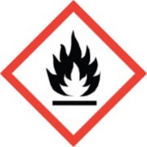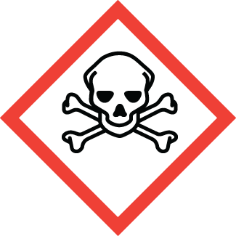
Chemical name, CAS: |  |  | Picric Acid (2,4,6-Trinitrophenol, Picronitric Acid) CAS: 88-89-1
PI: |  |  |  | Date:
Building: |  |  |  | Lab #:

- Material Use:
Picric acid has been used in munitions and explosives, for staining of microscopic specimens, and in pharmaceutical applications. At CSM, picric acid is used often as a metal etchant and as a chemical reagent in teaching and synthesis labs.

- Potential Hazards:
Picric acid is 2,4,6-trinitrophenol. Pure picric acid is a solid organic compound with a yellow color. Dry picric acid is explosive, and must be kept wet with at least 30% water. Contact EHS immediately if you have old or dry picric acid. Do not handle dry picric acid! Picric acid reacts easily with metals, bases, and other materials to form explosive picrate salts. Picric acid is corrosive and will cause skin, eye, or respiratory irritation. Picric acid is toxic and exposure can cause headache, vomiting, inflammation of the kidneys, and acute hepatitis.
Material | OSHA Permissible Exposure Limit | IDLH
Picric acid | 0.1 mg/m³ [skin] | 75 mg/m³ [skin]

- Engineering Controls:
- All work must be conducted in a designated laboratory hood labelled: “DANGER, Picric Acid”
- Access to an eyewash and safety shower must be readily available.
- Laboratory hood sash height should be kept low to minimize escaping fumes and provide protection from splashes.
- The lab personnel must have easy access to a telephone (landline or cell phone).

- Work Practice Controls:
- Ensure that you have all the PPE required for handling picric acid.
- Wash hands immediately after handling hazardous materials. Wash hands before exiting the lab.
- Do not use metal spatulas when manipulating picric acid. Explosive metal picrate salts can be formed.
- Keep work areas clean. Picric acid can sublimate and react with nearby metals or other materials to form dangerous picrate salts.
- Do not use glass stoppers. Picric acid can get stuck in the neck of the bottle and explode upon opening.
- Wipe down bottleneck, cap, and threads of bottle with wet cloth before re-capping.
- Do not work alone with picric acid.

- Personal protective equipment (PPE):
Lab Coat  Flame Resistant | Splash Goggles | Face Shield | Gloves  Butyl or Viton | Long Pants/Closed-toe Shoes

- Storage:
- Do not allow to evaporate to dryness.
- Store compounds in containers clearly labeled with contents. Keep containers in secondary containment.
- Keep containers tightly closed and store in a dry, cool, well-ventilated location.
- Store only in glass or plastic. Picric acid can react with metals to form explosive metal picrate salts.
- Do not store with: oxidizers, reducing agents, inorganic salts, or metals.

- Waste Disposal:
- Make sure all waste still has water content. Do not let picric acid waste evaporate to dryness.
- Immediately call EHS (x-3316) to dispose of picric acid containers that are dry or crystallized.
- Dispose of waste materials in a hazardous waste container. Do not pour down the drain.
- Include contaminated wipes, gloves, respirators or clothing in solid waste containers. Do not put in trash.

- What to do if exposed:
If inhaled
Remove to fresh air. If not breathing, give artificial respiration. If breathing is difficult, give oxygen. Seek medical attention immediately (Call 911).

In case of skin contact
Immediately flush skin with plenty of water for at least 15 minutes while removing contaminated clothing and shoes. Seek medical attention immediately (Call 911). Wash clothing before reuse. Thoroughly clean shoes before reuse.

In case of eye contact
Immediately flush eyes with plenty of water for at least 15 minutes, lifting lower and upper eyelids occasionally. Seek medical attention immediately (Call 911).

- Spill Procedure:
Incidental (small) spill: Call x-3316 and notify EHS personnel for assistance.

Large spill: Call x-3316 and notify EHS personnel for assistance.

- Training and medical monitoring of personnel:
- Hazardous Waste Generator Training, Laboratory Safety Training, and Picric Acid Training with EHS.
- Lab Specific Training provided by supervisor that covers: safety expectations, PPE use and storage, SOPs, and emergency response.

I have read and understand this SOP. I agree to fully adhere to its requirements.
Last | First | CWID | Signature | Date

