Standard Operating Procedure
Pyrophoric Chemicals
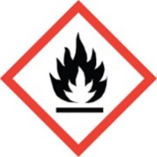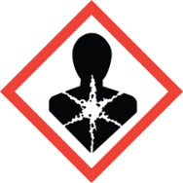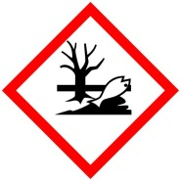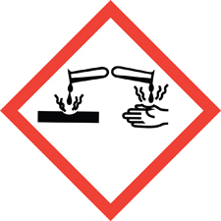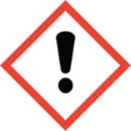
Chemical name, CAS: |  |  | Pyrophoric Chemicals
PI: |  |  |  | Date:
Building: |  |  |  | Lab #:

- Material Use:
Pyrophoric chemicals are liquids or solids that can ignite spontaneously on contact with air, moisture in the air, oxygen, or water. Pyrophoric chemicals are often used in chemistry research labs as catalysts or reagents.
Pyrophoric Chemicals Include:
- Organo-metallic reagents (i.e. Grignard reagents)
- Alkali earth elements (sodium, potassium, cesium)
- Finely divided metals (Raney nickel, aluminum powder, zinc dust)
- Metal hydrides (sodium hydride, germane, lithium aluminum hydride)
- Alkyl metal hydrides (butyllithium, trimethylaluminum, triethylboron)
- Metal carbonyls (nickel carbonyl, iron pentacarbonyl)
- Gases (arsine, diborane, phosphine, silane)
- Silicon halides (dichloromethylsilane)

- Potential Hazards:
Pyrophoric chemicals are violently reactive with oxygen and/or water and will ignite spontaneously upon exposure to air. Do not underestimate the hazards of pyrophoric materials. Before working with pyrophorics, you must get thorough training from an experienced supervisor.

- Engineering Controls:
- All transferring of pyrophoric materials should be done in an inert-atmosphere glove box.
- All reactions using pyrophoric materials must be performed under an inert atmosphere in a laboratory hood, glove box, or appropriate engineering control.
- An appropriate fire extinguisher (Class ABC or Class D) must be available in the laboratory.
- An eyewash and safety shower must be readily available near the work area.

- Work Practice Controls:
- Substitute pyrophoric materials for less hazardous reagents whenever possible.
- Additional training is required for use of pyrophoric materials. Talk with supervisor and EHS before use.
- Never work alone with pyrophoric materials.
- Keep an appropriate spill kid readily available. Sand, metal-x, or lime often work well for smothering pyrophoric materials.
- Do not store unnecessary flammable chemicals near the pyrophoric work area.
- Oven dry all glassware, syringes, cannula, and other equipment, and cool in inert atmosphere before working with pyrophoric materials.
- Never use a syringe at its maximum volume. Never exceed 2/3 of the maximum syringe capacity to prevent the syringe plunger from popping out.
- You must be trained by an experienced lab supervisor before working with pyrophoric materials.

- Personal protective equipment (PPE):
Lab Coat  Nomex/Flame Resistant | Chemical Resistant Apron | Splash Goggles | Face Shield | Gloves | Long Pants/Closed-toe Shoes

- Storage:
- Store pyrophoric material according to SDS, and away from any flammable materials.
- Storage in an inert-gas atmosphere (glove box or desiccator) may be a suitable storage area.
- Always ensure that sufficient protective solvent, oil, kerosene, or inert gas remains in the container during storage.

- Waste Disposal:
- Any container with pyrophoric residue must be rinsed with compatible dry solvent three times under inert atmosphere before disposal. Rinsate solvent must be collected and quenched.
- Any unused or unwanted reactive materials must be quenched safely before disposal.
- Do not leave any container with pyrophoric residue open to the atmosphere.

- What to do if exposed:
If inhaled
Remove to fresh air. If not breathing, give artificial respiration. If breathing is difficult, give oxygen. Get medical attention.

In case of skin contact
Immediately flush skin with plenty of water for at least 15 minutes while removing contaminated clothing and shoes. Get medical attention immediately.

In case of eye contact
Immediately flush eyes with plenty of water for at least 15 minutes, lifting lower and upper eyelids occasionally. Get medical attention immediately.

- Spill Procedure:
All Spills: Immediately evacuate lab. Call 911 if there is any risk of fire or explosion. If there is no risk of fire or explosion, call 303-273-3316 and notify EHS personnel for assistance. If possible to do safely, smother any spill with powdered lime, sand or other extinguishing agent.

- Training and medical monitoring of personnel:
- Hazardous Waste Generator Training, Laboratory Safety Training, and HF Training with EHS.
- Lab Specific Training provided by supervisor that covers: safety expectations, PPE use and storage, SOPs, and emergency response.
- Pyrophoric Specific Training provided by experienced supervisor.

- Additional Resources:
- Sigma Aldrich Technical Bulletin AL-134 – Handling Air Sensitive Reagents

I have read and understand this SOP. I agree to fully adhere to its requirements.
Last | First | CWID | Signature | Date

