Standard Operating Procedure
Sodium Azide
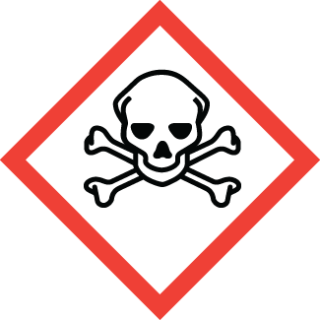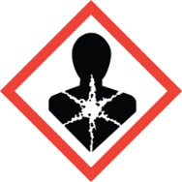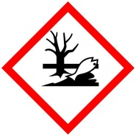
Chemical name, CAS: |  |  | Sodium Azide, CAS: 26628-22-8
PI: |  |  |  | Date:
Building: |  |  |  | Lab #:

- Material Use:
Sodium azide (NaN₃) is is colorless crystalline solid that is readily soluble in water. Solutions of sodium azide are used at Mines to preserve biological samples, and as a reagent in organic chemistry.

- Potential Hazards:
Sodium azide is highly acutely toxic by all routes of exposure. It is readily absorbed by skin. Skin exposure, ingestion, or inhalation of sodium azide can be fatal. Sodium azide can form explosive compounds on contact with metal surfaces including lab equipment and sink drains. Do not dump solutions of sodium azide down the drain. Sodium azide mixed with acids or water will release toxic gas (hydrazoic acid). Heating sodium azide above 275C may cause it to violently decompose.
Material | OSHA Permissible Exposure Limit | ACGIH Recommended Exposure Limit
Sodium azide (NaN₃) | None | 0.3mg/m³ [skin] Ceiling
Hydrazoic acid (HN₃) | None | 0.1mg/m³ [skin] Ceiling

- Engineering Controls:
- All handling of sodium azide (solid and solutions) must be done in the laboratory hood.
- Put up signage warning others that sodium azide is being used in your work area.
- Laboratory hood sash height should be kept low to minimize escaping fumes and provide protection from splashes.
- When heating sodium azide a blast shield should be in used.
- Access to an eyewash and safety shower must be readily available.
- The lab personnel must have easy access to a telephone (landline or cell phone).

- Work Practice Controls:
- Ensure that you have all the PPE required for handling sodium azide.
- No acids should be in laboratory fume hood or work area when working with sodium azide.
- Do not dump solutions of sodium azide down the drain. Even dilute solutions can form explosive compounds with lead and copper piping.
- Do not use metal spatulas to manipulate sodium azide.
- Purchase the smallest feasible quantity of sodium azide and conduct small-scale experiments.
- Wash hands immediately after handling hazardous materials. Wash hands before exiting the lab.
- Do not work alone when handling sodium azide. Inform others in the immediate area when you are working with sodium azide.
- Clean lab hood and equipment with 70% ethanol after using sodium azide.
- Lab emergency contact information must be readily available.

- Personal protective equipment (PPE):
 |  |  |  | 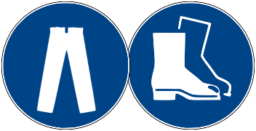
Lab Coat | Splash Goggles | Face Shield | Nitrile Gloves | Long Pants/Closed-toe Shoes

- Storage:
- Store sodium azide in a secured area, separated from all acids, metals, acid chlorides, halogenated hydrocarbons, hydrazine, and dimethyl sulfate.
- Store in a secondary container, and do not store on metal shelves.
- Store compounds in containers clearly labeled with contents. Keep containers tightly closed and store in a dry, cool, well ventilated location.
- Do not store near water or acids.

- Waste Disposal:
- Dispose of waste materials in a hazardous waste container, and store in Satellite Accumulation Area.
- Include obviously contaminated wipes, gloves, lab plastics or clothing in solid waste containers. Do not put in regular trash.
- Clearly label waste containers. Do not mix incompatibles (e.g. acids and metals) with waste.

- What to do if exposed:
If inhaled or ingested
Alert others and exit lab to fresh air. If not breathing, give artificial respiration. If breathing is difficult, give oxygen. Call 911 immediately. Inform emergency medical personnel of exposure.

In case of skin or eye contact
Immediately flush skin or eyes with plenty of water for at least 15 minutes while removing contaminated clothing and shoes. Seek medical attention immediately (Call 911). Wash clothing before reuse. Inform emergency medical attention of exposure.

- Spill Procedure:
Incidental (small) spill: Wearing lab coat, safety glasses, and heavy nitrile gloves sweep small amounts of dry chemical into a waste container. Absorb spilled solutions with paper towels, and clean surfaces with pH>9 water. Collect all spill materials, and dispose of as hazardous waste.

Large spill: Call 303-273-3316 and notify EHS personnel for assistance.

- Training and medical monitoring of personnel:
- Hazardous Waste Generator Training and Laboratory Safety Training with the EHS.
- Lab Specific Training provided by supervisor that covers: safety expectations, PPE use and storage, SOPs, and emergency response.

I have read and understand this SOP. I agree to fully adhere to its requirements.
Last | First | CWID | Signature | Date

