Submitting Waste
The system requires you to be on Mines wifi or VPN
Log in to EHSA (https://pehsassist.mines.edu/ehsa/) using your Trailhead ID and Password.
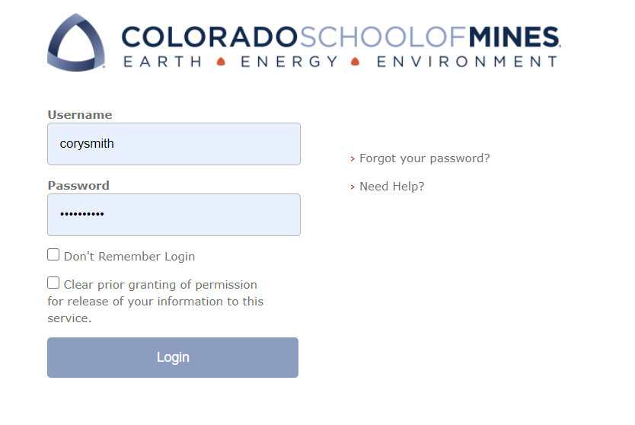
Navigate to the Waste Tab.
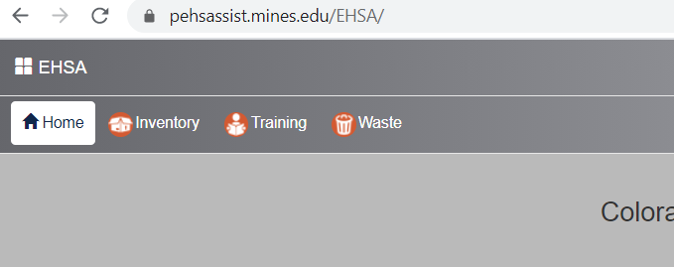
Select ‘Manual Waste Pickup Request’
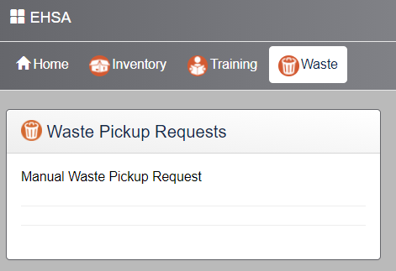
In the new window, select ‘Add Waste Request’
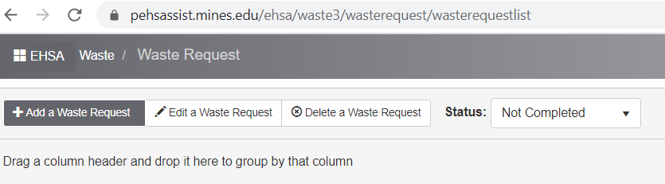
***First time submitting a waste pick up Request ONLY*** Create a Waste Profile
When you go to enter waste for the first time, you will be prompted to set up a waste request profile
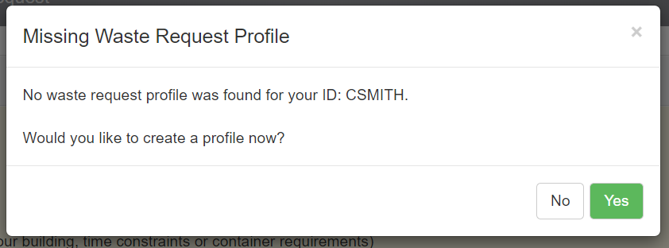
Most of your information should automatically populate the fields. Verify all your information is correct before you continue. All fields with a red star are required to continue.
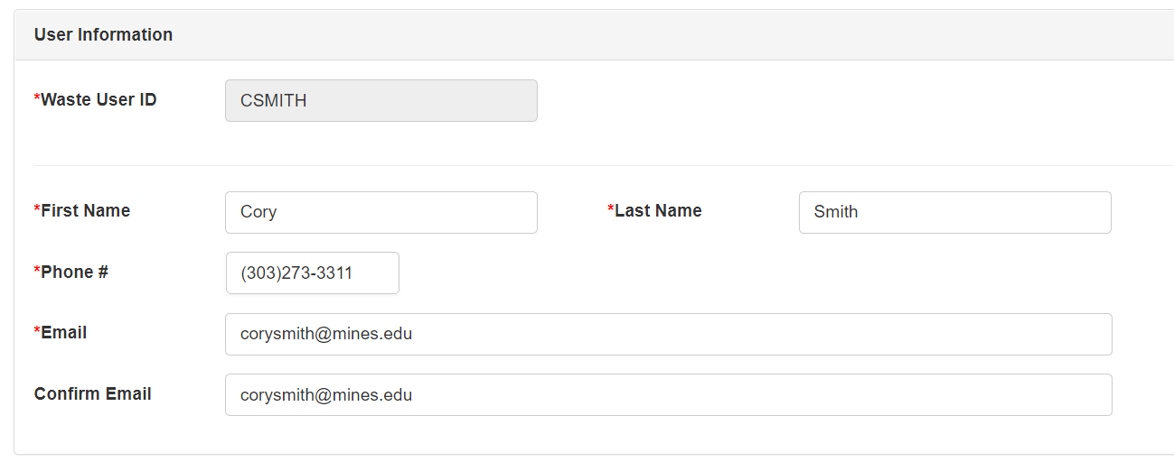
Scroll down and set your Waste Request Information. Click on ‘Add’ to set up a new location.
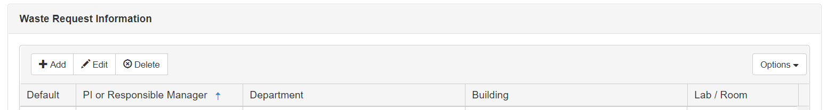
Add the department, building and Lab/Room number for your profile. This will be the default options every time you submit waste. You will be able to select any room in any building by checking the box ‘Allow any Location’

Create a waste pick up request
- Add a Waste Request (from Manual waste request)
Identify the Building and Room number. It will default to the lab you are assigned to. To change the building/room click on the ‘edit’ button next to ‘Location’.
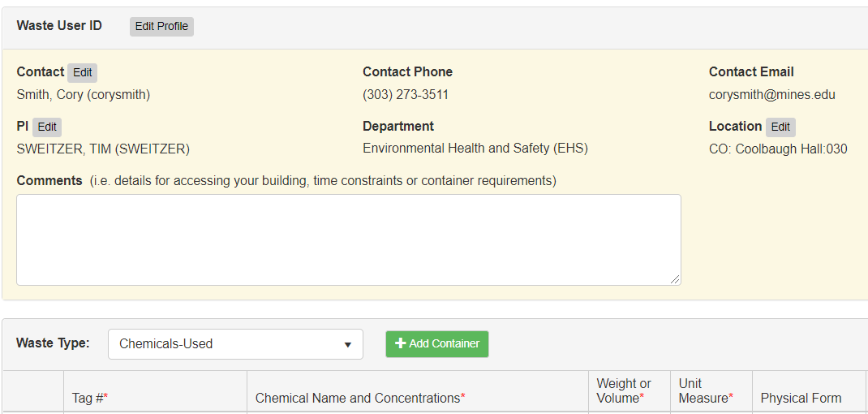

You will be able to view all labs in the drop down menu on campus by checking the box next to ‘Allow Any Location’. Then clicking ‘Save’
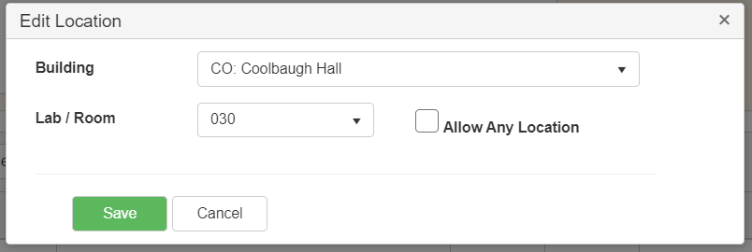
Adding waste for pick up
First select the waste type from the drop down menu
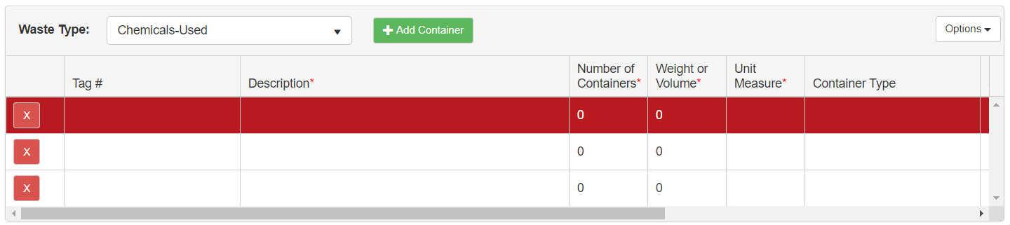
Enter the waste tag number by clicking in the column below ‘Tag #’. Clicking in the column will allow you to type text in the field.
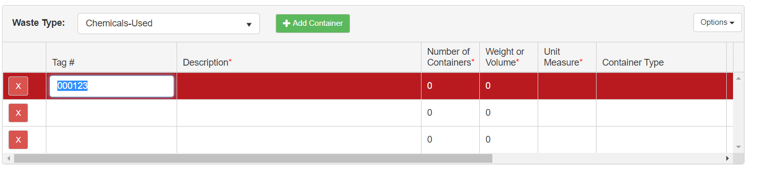
Enter the constituents under description, the weight or volume of the container, the container type, and the location in the lab.
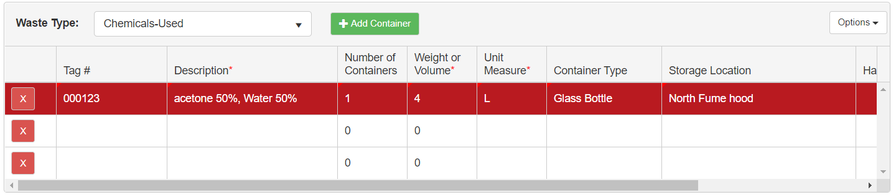
You can submit multiple waste containers, by clicking in the next row. You do not need to use every row, they can be left blank. You can add more rows by clicking on ‘Add Container’. The default number of containers is three, but you can add as many as you like.
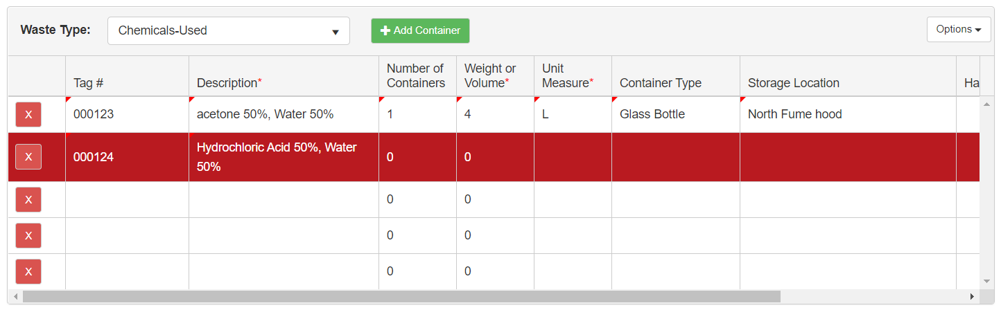
Once you have entered all the waste containers click ‘Submit’ at the bottom of the page.
Viewing your waste request.
All submitted waste containers can be viewed in the Waste Request screen. The view will default to waste that has not been picked up.
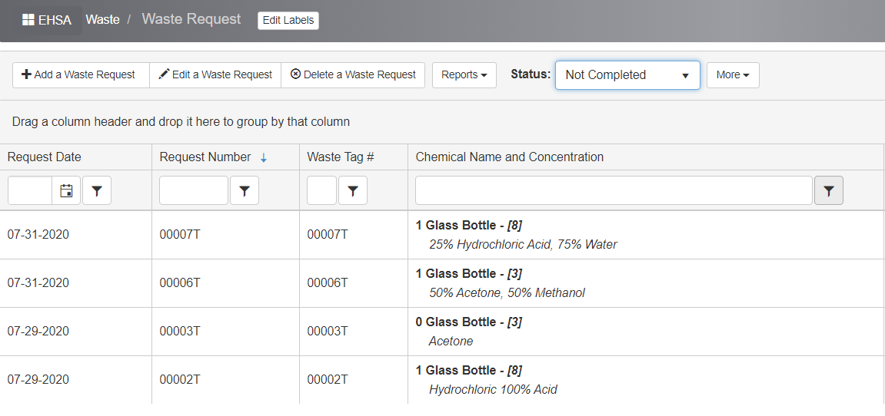
Waste that has not been picked up can be edited, or deleted by selecting those options. Once the waste has been picked up you will no longer have the options to edit or delete the waste submittal.
To view waste that has been picked up, use the drop down menu next to ‘Status’ to select ‘Completed’. In this view you can see the date when your waste was picked up.
