Satellite Accumulation Areas
Hazardous waste generated in Mines laboratories are stored satellite accumulation areas (SAA). When managed properly, a SAA provides a safe method to accumulate hazardous waste before removal by EHS. Please follow these hazardous waste storage requirements.
- WASTE MUST BE STORED IN AN APPROPRIATE CONTAINER – Empty containers are available from both EHS office locations. Empty reagent chemical bottles can be reused for waste accumulation provided the waste is compatible with the former contents of the empty container. DO NOT USE A 70% NITRIC ACID BOTTLE TO ACCUMULATE ORGANIC WASTE and vice versa.
- CONTAINERS MUST BE COMPATIBLE WITH THE WASTE THEY CONTAIN – Do not use a metal container to accumulate acid waste, or use a glass container to accumulate hydrofluoric acid. Never use food containers such as milk jugs, juice and soda bottles.
- CONTAINERS MUST REMAIN CLOSED AT ALL TIMES EXCEPT WHEN ADDING WASTE - Open containers in a SAA are a violation of the Colorado Hazardous Waste Regulations, and are unsafe for laboratory occupants. For waste containers that may generate pressure, be sure to use a pressure-relieving lid or funnel. Nital etchant and Piranha solution must be stored using a pressure-relieving funnel.
- CONTAINERS MUST BE LABELED WITH A MINES HAZARDOUS WASTE LABEL – Fill out the label completely including:
- Name of the waste generator
- The date waste was first placed in the container
- Description of the waste – list chemical names and concentrations
- Check the primary hazard of the waste (Flammable, Corrosive, Toxic, etc.)
SEE THE ATTACHED HAZARDOUS WASTE LABEL FOR AN EXAMPLE OF A COMPLETED LABEL
- LIQUID WASTE MUST BE STORED IN SECONDARY CONTAINMENT BINS – Bins are available from EHS office locations.
- ALL CONTAINERS MUST BE IN GOOD CONDITION AND NOT LEAKING – Leaking and damaged waste containers must be repackaged. Contact EHS for assistance with any spill clean-up needs in your SAA.
- CONTAINERS MUST BE STORED AT OR NEAR THE PONT OF WASTE GENERATON – Waste containers must remain in the laboratory where the waste was generated. A SAA can be a benchtop, lab hood, or chemical storage cabinet. Do not place SAAs in areas such as hallways, offices, sinks or in high traffic areas in your lab space.
- WASTE STORAGE VOLUME MUST BE LESS THAN 55 GALLONS – Arrange for a waste pick up when containers are full, or when you no longer anticipate generating/adding to a waste container.

- CONTAINERS MUST BE SEGREGATED BY CHEMICAL COMPATIBILITY – Store acids away from bases, oxidizers away from organics. Segregation can be achieved by using secondary containment bins or by physical distance. Accumulate highly toxic, reactive and mercury waste separately from your flammable, acidic or alkaline wastes.
- SATELLITE ACCUMULATION AREAS MUST BE INSPECTED ON A WEEKLY BASIS – Waste generators MUST conduct weekly inspections of SAAs. The inspection must ensure waste containers are:
- Closed
- Labeled
- Good Condition
- Properly Segregated
- Stored in Secondary Containment
- SUBMIT WASTE ONLINE – Using your Trailhead Username and password, log in to the EHS waste submittal page and request a waste pick up. The waste submittal page is available at: https://webapps.mines.edu/ehs/ehswaste/

Properly Completed Hazardous Waste Tag
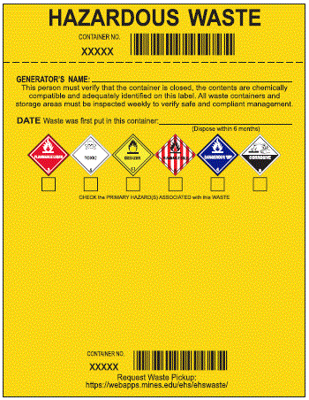
X
X
Water 10 to 20 %
Hydrochloric Acid 10 to 20 %
Methanol 10 to 20 %
Acetone 30 to 45 %
08-08-2019
Dr. Demento
