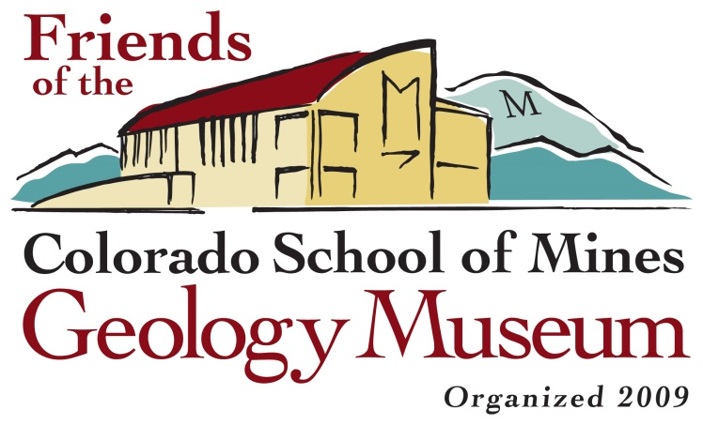
Membership Application

Name:
Street Address:
City: State/Province: Zip/Postal code:
Country:

Home Phone:
Cell Phone:
Email address:
Date:

MEMBERSHIP LEVEL/DUES:

Student $10
Individual $30
Family $50
Patron $100
Prospector $500
Miner $1000
Mogul $5000
Magnate/Corporation $1000

Please do not publish the amount of my contribution (if above $500)

MEMBERSHIP TYPE:
New
Renewal
A gift
Recipient name:
Recipient address:

AREAS OF INTEREST (circle all that apply):

artistry, illustration and graphics
behind-the scenes tours
book signings
Colorado geology
community outreach
computing/info services
exhibit previews
fundraising
gemstones/jewelry
geologic “art,” lectures
leading and/or organizing field trips
legal issues
library research
mailings, distributions, public relations
meteorites
minerals
mining artifacts
mining history
newsletter
organizing parties and other functions
paleontology
photography
planning and budgeting
railroads
special programming
website design
workshops
other: _____________________

Some Friends events that I would like to participate include:
I would be interested in serving as a Friends board member

PLEASE MAKE YOUR CHECK PAYABLE TO: Friends of the Mines Geology Museum (or FCSMGM)
MAIL IT TO: Mines Geology Museum, 1310 Maple Street, Golden, CO 80401

