Contract Amendment Queue – Academic Department (Campus Administrators) Instructions
As part of the Graduate Contract Workflow process, campus departments have access to route contracts to the appointing department if additional information is needed. This guide offers instructions on how to access the “Contract Amendment Queue” and address questions from campus departments in the workflow.
Note: All contract submitters are responsible for knowing Graduate Contract policies. For information on these policies, visit the Graduate Assistantship website (https://www.mines.edu/graduate-studies/graduate-assistantship/). For a high-level overview of the entire graduate contract process, see the Graduate Contracts Process Flow PDF.

How to Process a Graduate Contract in the Contract Amendment Queue
Perform the following steps to use the Contract Amendment Queue to modify and resubmit a graduate contract, or cancel and route a contract to the exit queue.
- A graduate contract may be routed to the Contract Amendment Queue for various reasons and by different departments depending on the workflow.

Upon entry of a contract into the Contract Amendment Queue within each of the three workflows, a notification will be sent to the email address of the original form submitter, which includes the student’s name, the sending department and reason for needed review.

Notification Example:
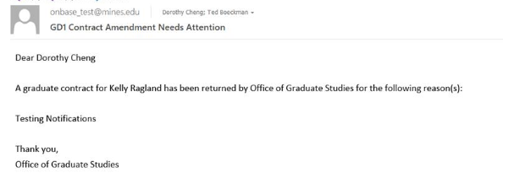

After receiving the email notification, launch the OnBase Unity Client on your desktop, and navigate to the Contract Amendment Queue within the appropriate workflow as listed below:
GD1: Graduate Contract Workflow
For contracts sent by the Office of Graduate Studies (OGS) or International Student and Scholar Services (ISSS).

GD2: Graduate Contract [Bursar/FA] Workflow
For contracts sent by the Bursar’s Office or the Office of Financial Aid.

GD3: Graduate Contract [MAPS] Workflow
For contracts sent by Mines Administrative Processing Services (MAPS).

- Within the Contract Amendment Queue, search for the contract by Student CWID/Name in the search bar.
*Note: To search for a contract using Document Retrieval or Custom Query, see the Quick Reference Guide – Document Retrieval, Custom Query and PDF Packet Creation.

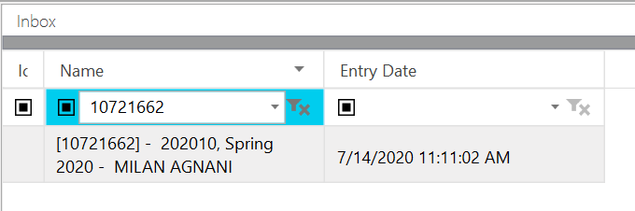

Select the contract to view in the Primary Viewer.

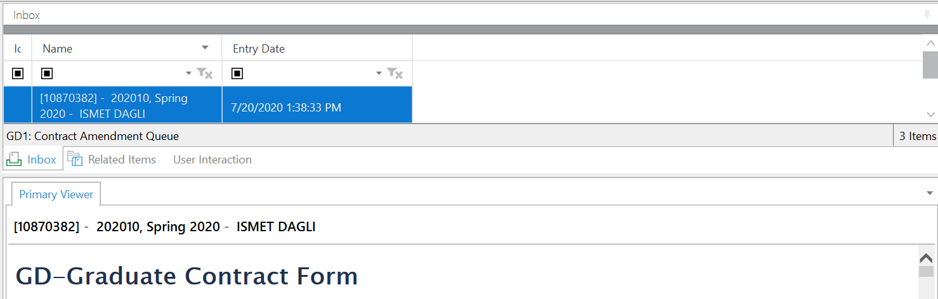
Note: Once the contract is displayed, you can drag the Primary Viewer box up to extend the view of the contract.

- Review the contract based on the reason provided in the email notification.
  - Make any necessary changes to the contract
  - Log any changes made to the contract in the Amendment Details section on the form, including date of change, contract type(s) and details of the change.
  - For cancellations: Only update the Amendment Details section with the date, contract type(s) and details of the cancellation (i.e. last pay period, etc.). Note: Do not make changes to any contract details when cancelling a contract.
Note: It is important that you log any changes made to the contract as departments will depend on this information to identify new vs amended contracts and any modifications needed in Banner.
- Click the Save / Submit button at the bottom of the contract to save changes.

- Following contract review, select one of the following actions located on the toolbar at the top of your screen:

  - Re-Submit Contract: This action will remove the contract from the Contract Amendment Queue and re-route the contract to the necessary departments for review.
  - Cancel the Contract: This action will initiate cancellation email notifications to the student and supervisor(s), as well as a separate notification to campus departments (including OGS, ISSS, MAPS, FA, and Bursar) regarding the cancellation.

For the student/supervisor(s) notification: You will be required to enter a reason for the cancellation that will display as part of the email notification.

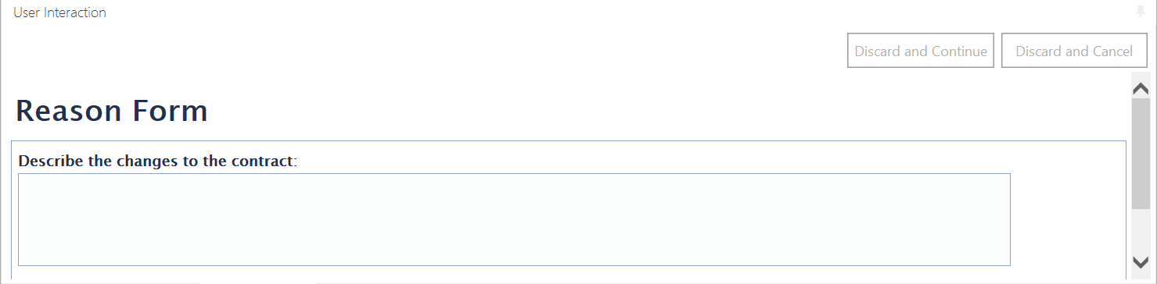

Student/Supervisor(s) Cancellation Notification (reason circled in red)
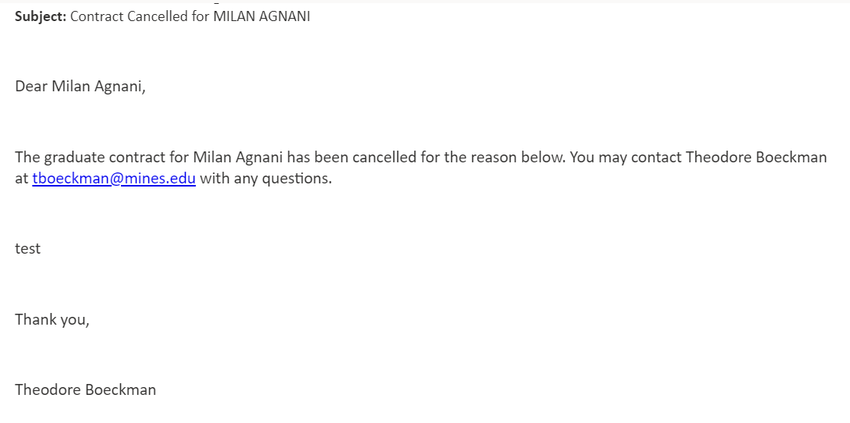
For the department notification: Upon selecting the “Cancel the Contract” user action, OnBase will generate a PDF Packet of the contract and send an email notification to departments (OGS, ISSS, MAPS, FA and Bursar). The notification will include the form submitter contact information as well as a link to the contract and attached PDF Packet.

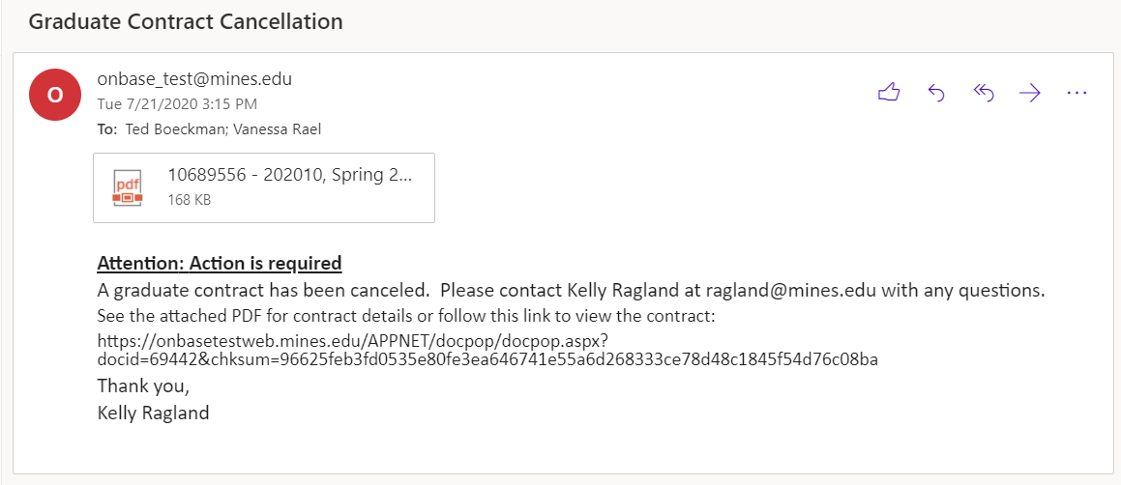

  - Send Update to the Student: This action gives you the option of sending the student a notification to communicate any changes that have been made to the contract after they have authorized it. If something needs to be communicated to the student, this step must be done BEFORE you re-submit the contract (i.e. Make changes to contract, save changes, send update to student, re-submit contract).

Note: Selecting this action will not remove the contract from the Contract Amendment Queue and you will need to select the Re-Submit to Workflow user action to move the contract along for processing.

You will be required to enter a message that will display as part of the email notification.

- After selecting either Re-Submit Contract or Cancel the Contract user actions in Step 5, the contract will be removed from the Contract Amendment Queue and you can proceed with reviewing any remaining contracts in the queue.

