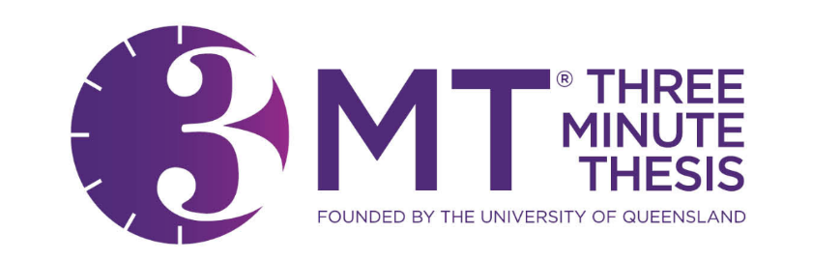

2024 3MT Practice & Competition Schedule

Introductory Sessions | Time | Location
Thursday, February 29 | 12:00 PM – 1:30 PM | Brown Hall, W475
Monday, March 4 | 9:00 AM – 10:30 AM | ZOOM

Workshop/Practice Sessions | Time | Location
Tuesday, March 5 | 4:00 PM – 5:30 PM | Alderson Hall, 152
Wednesday, March 6 | 12:00 PM – 1:30 PM | Alderson Hall, 152
Tuesday, March 12 | 4:00 PM – 5:30 PM | Alderson Hall, 152
Thursday, March 14 | 12:00 PM – 1:30 PM | Student Center, Ballroom D
Final Practice - Tuesday, March 26 | 4:00 PM – 5:30 PM | Alderson Hall, 152
Competition  Sessions | Time | Location
First Round Contest -Thursday, March 28 | 4:30 PM – 6:00 PM | Marquez Hall, 335
Final at Mines – Wednesday, April 3 / Thursday, April 4 | TBD | GRADS Symposium, Green Center

