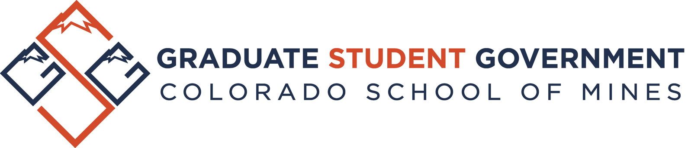

Graduate Student Government Family Assistance Grant 2018-2019
Statement of Purpose The Family Assistance Grant is intended to help defray the costs of child care services and health insurance for graduate students attending Colorado School of Mines with children. This grant is funded by the Graduate Student Government (GSG).

Eligibility*
To be eligible for the grant, students must:
- be a full-time or part-time graduate student at Colorado School of Mines,
- be in good academic standing as defined in the Graduate Catalog,
- have at least one dependent under the age of 18 and have documented financial need**,
- to the best of their knowledge, remain eligible, as defined above, for each semester the grant is awarded
- make less than $70,000 annual income per household,
- self-report total annual income per household, including portions of scholarships not paid directly to Mines,

*All awards are ultimately at the discretion of the grant committee.
**In determining financial need, several factors are considered. Among these are: (i) household income; (ii) educational expenses; (iii) other non-documented sources of income; (iv) and access to other daycare services or health insurance.
Award Details
The following conditions for grants awarded include:
- One award per Colorado School of Mines graduate student, per year,
- no automatic award renewal (you must re-apply each year),
- and a maximum of 8 grants awarded per semester.***
***If more than 8 graduate students apply, the grant committee will determine the 8 applicants with the highest amount of financial need to receive the Family Assistance Grant.
Grant awards through this program are made semi-annually (Fall and Spring semester disbursement only). Currently, the amount of the awards are for $1,000/semester, for a total of $2,000 per academic year. As awards are given in the form of a grant based on financial need, these may, depending on the awardee’s individual circumstances, be tax exempt.
The applications are evaluated by the GSG Family Assistance Grant Advisory Committee. This committee is comprised of 5 members and is charged with evaluating and ranking applications based on the criteria defined above. The Advisory Committee makes its award recommendations to the GSG Executive Committee. The Executive Committee then makes the final decision regarding the awards. For the purposes of evaluating applications to the Family Assistance Grant program, the Graduate Dean is a voting, ex officio member of both the Advisory and Executive Committees.
Please Do Not Submit Page with Application

If you are denied an award and extenuating or other mitigating circumstances exist, you may appeal the award decision. Appeals are considered by the Executive Committee, they must be made in writing, and they must be received by the Executive Committee no later than 5 business days after initial notification of committee decision. Examples of extenuating circumstances that would be considered include, but are not limited to: a sudden illness in the immediate family; large medical bills; or recent loss of a job.
Applications should be addressed to the Assistant Dean of Graduate Studies and turned into the Office of Graduate Studies (Student Center, Room E140). Late applications will only be considered under extenuating circumstances. Applications will be reviewed for eligibility and completeness by the Assistant Dean.

Applications for Fall 2018 must be submitted on or before October 1, 2018.
Applications for Spring 2019 must be submitted on or before December 17, 2018.
Please Do Not Submit Page with Application
Family Assistance Grant Application 2018-2019

Date of Submission: Select date
Name: Enter first and last CWID: Enter CWID
Mines Email: Enter email Phone: Enter number
Residency: Select Residency
Degree-Granting Department: Select Department
Degree: Select Degree
Name of Primary Academic Advisor: Enter Advisor
Name of Department Head: Enter Department Head
First semester enrolled in graduate school at Mines: Select Term Enter Year

Is this application for daycare support, insurance support, or both? Select
Have you previously applied for and/or received this Fellowship? Select
If yes, please list terms (ex: F16, S17…) Enter previous terms applied for and/or received fellowship support
Gross Adjusted Income (entire household, last year) Enter Gross Adjusted Income
Is your tuition covered by an assistantship, fellowship, grant, or sponsorship? Select

Total number of children Enter Total Number of Children
Ages of children (e.g.: 9 mo, 2 1/2 yrs) Enter Children Ages
Is at least one of your children currently enrolled in a licensed day care? Select
If yes, are they enrolled Full-Time or Part-Time? Select Full-Time or Part-Time
Do you/does your spouse have another employer who also provides a child care subsidy? Select
If yes, amount of that subsidy (annually) Enter Amount of any Subsidy
Does any member of your immediate family (spouse and/or children) have access, through an employer or otherwise, to health insurance with a similar cost and similar coverage/benefits to the Mines Student Health Insurance Plan (SHIP)? Select

In addition to this profile, the student applicant must attach the following:
- Graduation timeline, including major milestones to be completed (1/2 a page or less)
- A statement of all income sources and amounts for the student and any co-parents of the student’s qualifying child.
- Copy of lending agencies’ statements showing total student debt. All submitted loan information will be shredded after review.
- Copies of invoices and/or receipts for daycare and/or insurance expenses

Applications for Fall 2018 must be submitted on or before October 1, 2018.
Applications for Spring 2019 must be submitted on or before December 17, 2018.

