How to Approve a Purchase Requisition
This is a guide for campus users who are the fund managers for funds.
- The requisitions are entered in WD by Procurement based on the request email that is sent to procurement@mines.edu.

- Fund Managers need to approve Purchase Requisitions in WD.

- Go to Workday, there should be an area titled Awaiting Your Action
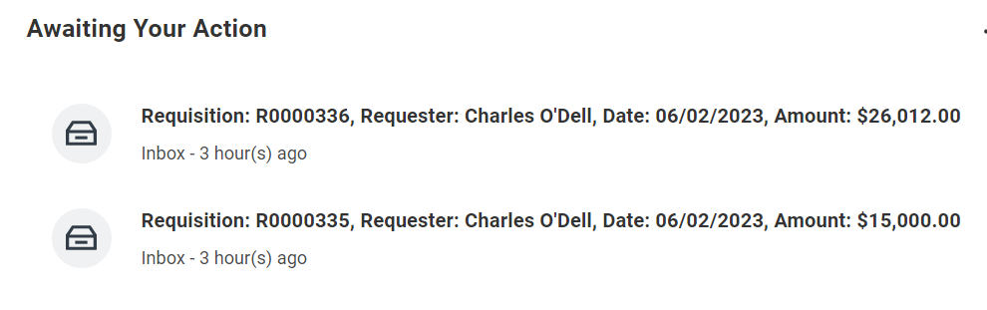
- Click on the item to approve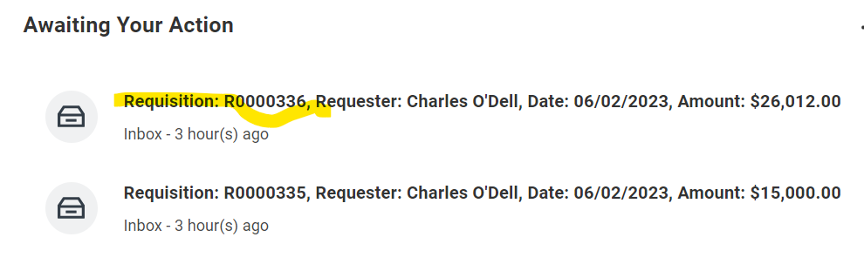
- What to review for accuracy:
  - The funding, the spend category, the dollar amounts, and attachments.
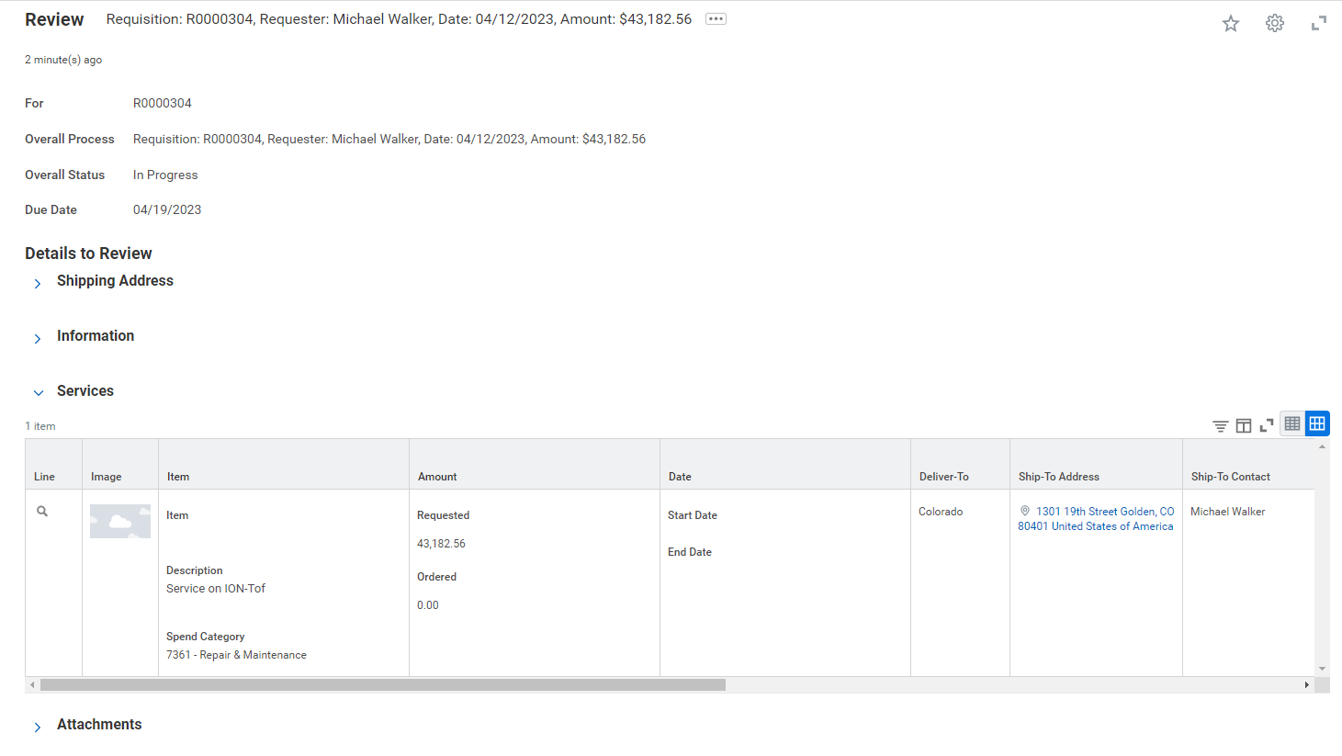
  - Scroll to the right for the funding information.

  - Will have to click on the Attachment carrot to see all attachments.
    - The documents will include the initial request, the quote, any additional quotes (if over $10,000), any other pertinent information.

  - There is the process history at bottom.

  - If everything is correct, click Approve.

  - If there is something wrong, click Send Back.
    - If you Send Back, a Comment is required, explain what is incorrect about the requisition.
    - The requisition will be returned to Procurement to fix the issue.
    - Once the issue is fixed, it will get sent back to the Fund Manager for review and approval. All approvals processes are restarted.

