How to find a supplier
- Type in a vendor name, partial or full

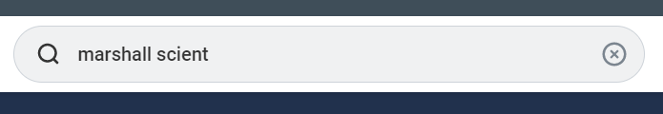

- You may see many results, you are looking for Supplier
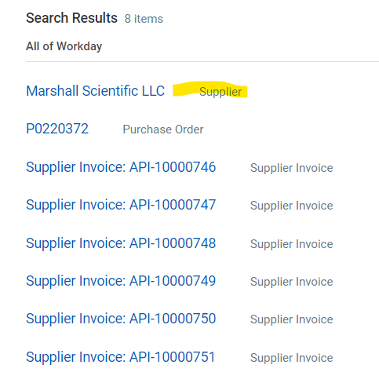
- Click on the supplier name in blue (the hyperlink) – this is the Supplier information
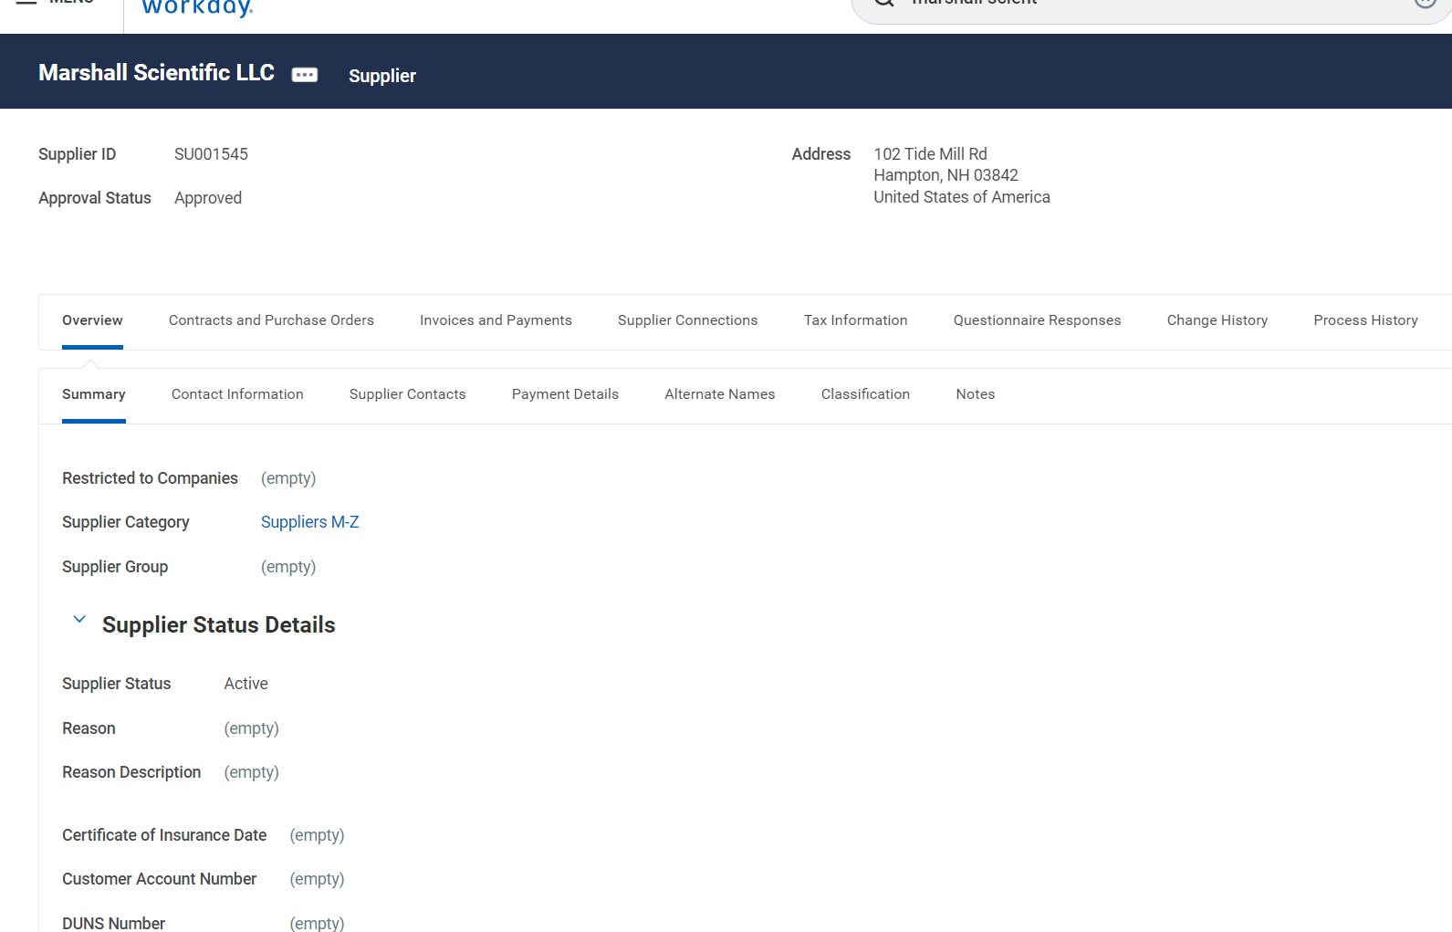

- You can see any Purchase Orders issued to the Supplier.
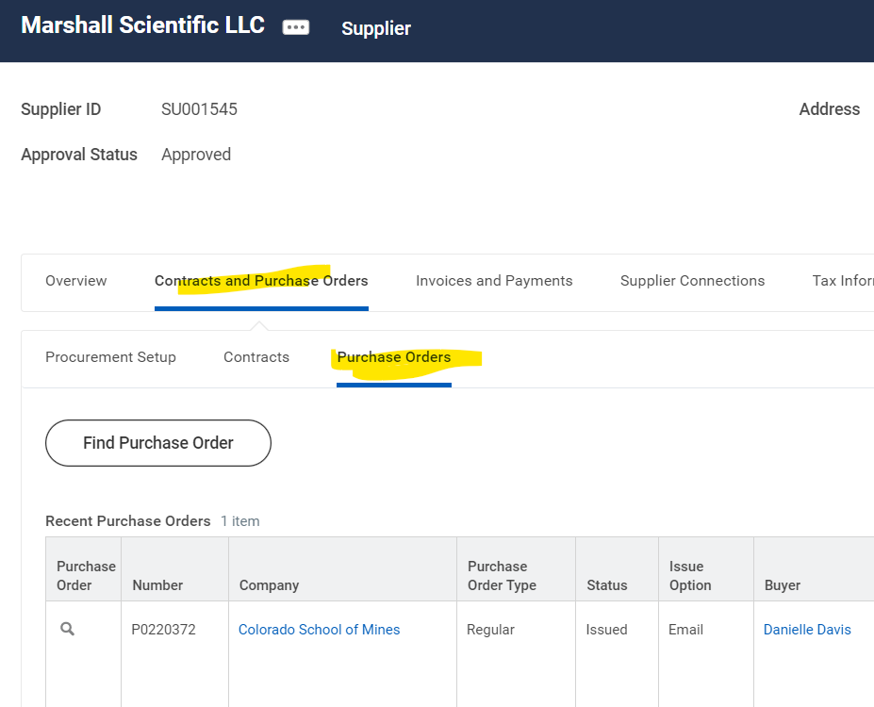

- You can see Invoices and Payments against the Supplier.
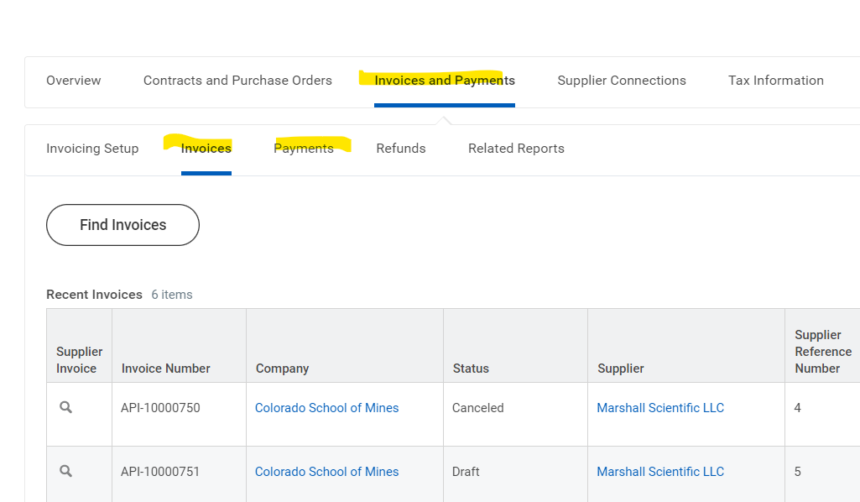

- IN THE FUTURE - In the search bar, type Find Suppliers

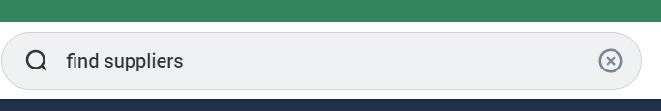

- Click on Find Suppliers under Tasks and Reports
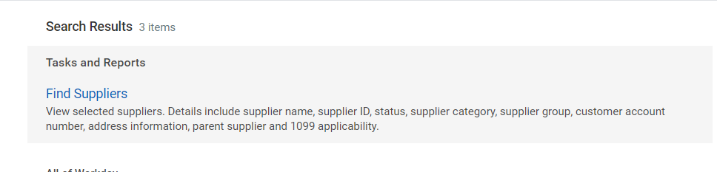

- You can start typing the Supplier name in the Supplier Field
