Requisition Information

Find Requisitions Report
When to use: The following will show you how to locate purchase request information that you or someone in your department has requested that is still in the requisition phase (not yet converted to a purchase order).

Step 1) Search for the “Find Requisitions” report in the search box
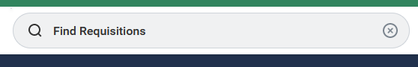

Step 2) Click on “Find Requisitions” report.
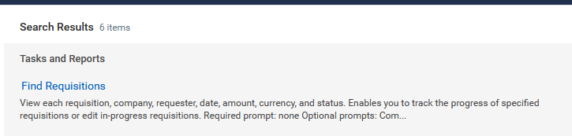

Step 3) Search: You are able to search for your requisition by the Requisition number, your name, the requestor’s name (if not you), date range created, supplier, or worktag, etc. or any combination thereof.
Notes: The starting date range defaults to one month prior to the current date. If you need to find a REQ that is older than one month old, please adjust the date.

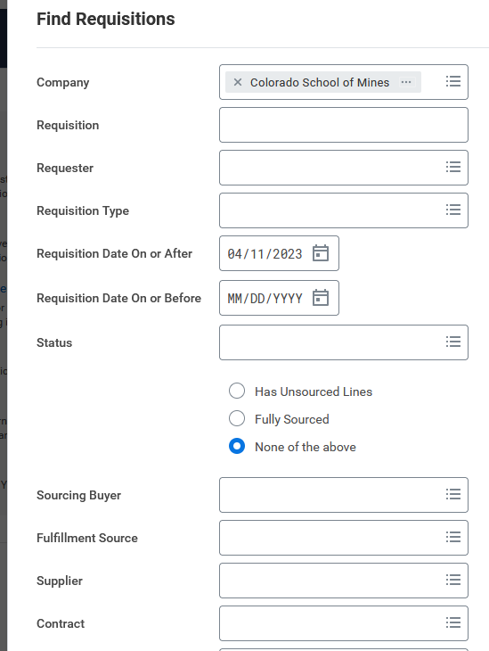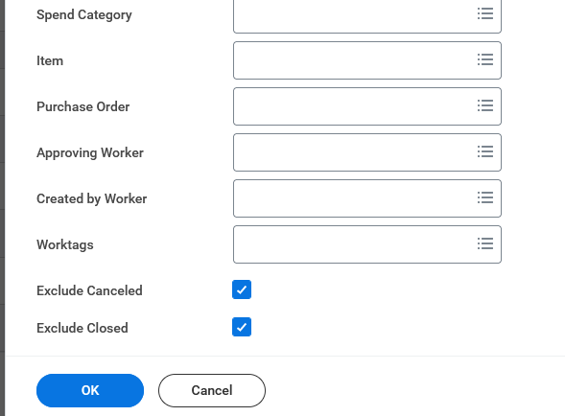
Step 4) Interpretation - The report will display the REQ#, Status, REQ Type, Requestor, date, currency and total amount.

Status Interpretation
Draft | The REQ has been created, but has not been submitted for approval.
In progress | The REQ has been submitted and send for approvals.
Successfully completed | The REQ has been converted to a PO.
Closed
Cancelled

Step 5) Retrieving Additional Data – To retrieve information beyond the fields listed in step 5, select the magnifying glass button. This will open the “View Requisition” Report.

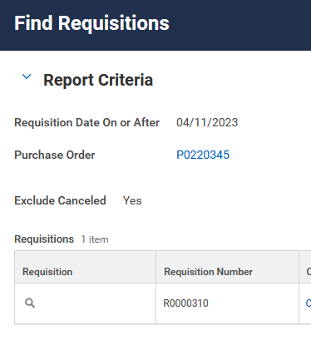

View Requisition Report
When to use: If the “Find Requestion” summary data does not provide enough information, use this report to view the full REQ information.

Step 1: Navigating to Report - To get to the “View Requestion” report either follow steps 1 – 5 for the “Find Requesition” report or, if you have your REQ#, enter the REQ3 in the search bar.

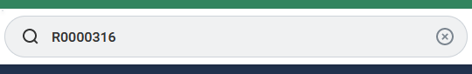

The click on the REQ link.
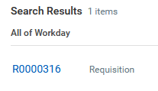

Step 2: Interpretation –

Summary – the top of the screen will show the REQ#, the status and the total amount.
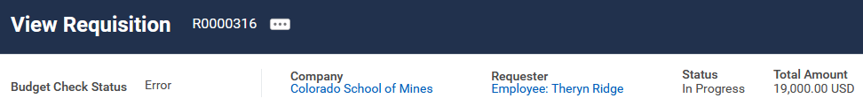

Requisition Information – this section will show the creation date, the purchasing agent, the REQ type and the contract # (If applicable).
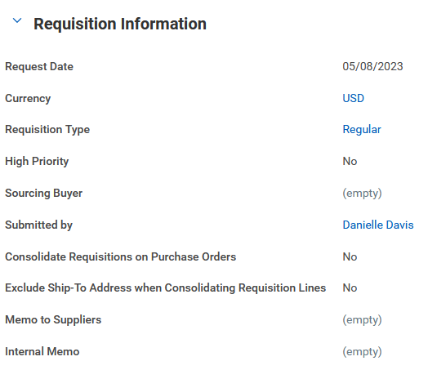
Purchasing Agent
Contract #

Bottom Tabs – the bottom has four tabs with information.
- Services lines – shows the line item (services/goods) information.
- Attachments – shows all documents attached to the REQ such as request email, quote, purchase justification, etc.
- Balances
Commitment Amount | Amount encumbered
Commitment Amount Liquidated | Liquidation/spend amount
Commitment Amount Remaining | Balance

- Process History – shows the process events such as creation and required approvals and their current status.

