Mines Drug and Alcohol Abuse Resource Guide

Recovery Support Groups
- Alcoholics Anonymous (12-step): 1(303) 322-5636
http://www.daccaa.org/meetings.htm
- Narcotics Anonymous (12-step): 1(303) 832-3784
http://www.nadenver.org
- Refuge Recovery (Buddhist-based)
http://www.refugerecovery.org/meetings-in/colorado/
- Celebrate Recovery (Christian-based)
http://locator.crgroups.info
- LifeRing (Secular)
http://liferingcolorado.org/meetings/

Alcoholics Anonymous

Statement of Purpose: Alcoholics Anonymous is a fellowship of men and women who share their experience, strength and hope with each other that they may solve their common problem and help others to recover from alcoholism. The only requirement for AA membership is a desire to stop drinking.

Golden, CO meetings
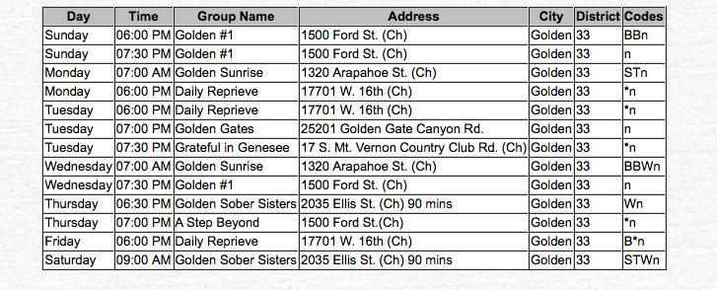
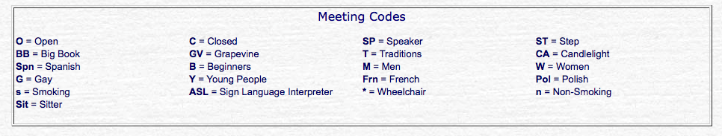

Secular Alcoholics Anonymous
Freethinkers in AA – open meeting THE SECULAR HUB
Monday 6:30-7:45 p.m. 3100 Downing St.
Saturday 9:30- 10:45 a.m. Denver, CO 80205 Contact: freethinkersinaa@gmail.com Website: www.freethinkersinaa.org

Refuge Recovery
Statement of Purpose: Refuge Recovery is a mindfulness-based addiction recovery community that practices and utilizes Buddhist philosophy as the foundation of the recovery process. Drawing inspiration from the core teachings of the Four Noble Truths, emphasis is placed on both knowledge and empathy as a means for overcoming addiction and its causes. Those struggling with any form of addiction greatly benefit when they are able to understand the suffering that addiction has created while developing compassion for the pain they have experienced. We hope to serve you, and meet you on the path.

Denver Contact: Refugerecoverydenver@gmail.com
Facebook: https://www.facebook.com/Refuge-Recovery-Denver-Boulder-1450847561620241/

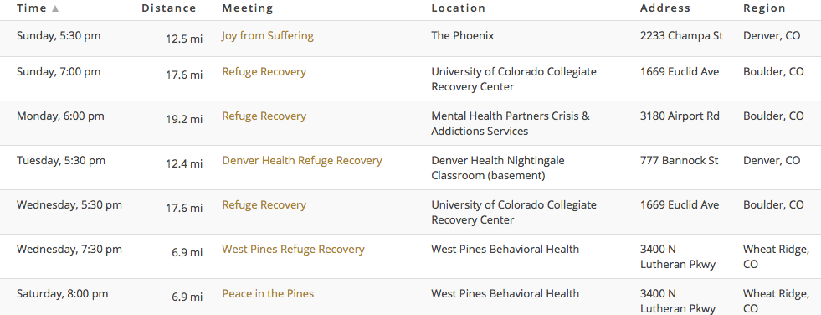

Celebrate Recovery
Statement of Purpose: Celebrate Recovery is a biblical and balanced program that helps us overcome our hurts, hang-ups, and habits. It is based on the actual words of Jesus rather than psychological theory. 26 years ago, Saddleback Church launched Celebrate Recovery with 43 people. It was designed as a program to help those struggling with hurts, habits and hang-ups by showing them the loving power of Jesus Christ through a recovery process. Celebrate Recovery has helped more than 21,000 people at Saddleback, attracting over 70% of its members from outside the church. Eighty-five percent of the people who go through the program stay with the church and nearly half serve as church volunteers.
Denver First Church of the Nazarene: Friday, 6:00pm
3800 E. Hampden Ave
Englewood, Colorado 80113
Contact Person - Lyle Cambell
Phone - (303) 941-9460
E-Mail - z1uncle@msn.com
Iglesia Amistad (Spanish): Friday, 7:00pm
1140 W Cluster Place
Denver, Colorado 80223
Contact Person - Martha Fuentes
Phone - 720-645-6573
E-Mail - marthaf29@gmail.com
Lakewood Church of Christ: Sunday, 6:30
455 S. Youngfield Court
Lakewood, Colorado 80228
Contact Person - Steve Curtis
Phone - 720-371-1269
E-Mail - sfcurtis@comcast.net
New Song Church and Ministries: Thursday, 7:00pm
8242 Pecos St
Denver, Colorado 80221
Contact Person - Elaine and John Duran
Phone - 303-650-5159
E-Mail - elaineduran77@gmail.com
NorthRock Church: Friday, 6:30pm
10100 Grant Street
Thornton, Colorado 80229
Contact Person - Jani Schott
Phone - 303-450-2809
E-Mail - recovery@northrockchurch.com

Life Ring
Statement of Purpose: LifeRing Secular Recovery is an abstinence-based, worldwide network of individuals seeking to live in recovery from addiction to alcohol or to other non-medically indicated drugs. In LifeRing, we offer each other peer-to-peer support in ways that encourage personal growth and continued learning through personal empowerment. Our approach is based on developing, refining, and sharing our own personal strategies for continued abstinence and crafting a rewarding life in recovery. In short, we are sober, secular, and self-directed.

SUN 7:30 PM
Exempla West Pines Treatment Center
3400 Lutheran Parkway, Wheat Ridge, CO 80233
Greg C. gchlumsky@gmail.com 303-250-9797

MON 6:00 PM
Advocates for Recovery Colorado
6981 Federal Blvd, Denver, CO 80221
Jessica G. jessicagrace.jg11@gmail.com 720-209-6683
TUE 6:30 PM
St John’s Episcopal Cathedral – Library
1350 Washington St, Denver CO 80203
Lorraine H. hull.d.lorraine@gmail.com 303-699-2406

WED 6:00 PM
Saint Barnabus Episcopal Church
1280 Vine St, Room 210, Denver, CO 80206
Kathleen G. coloradolifering@gmail.com 303-319-2465
THURS 5:30 PM
Kaiser Permanente – Hidden Lake Medical Office (Rapids Room),
7701 Sheridan Blvd., Arvada, CO 80003
Rob C. kerimaki1968@aol.com 720-708-4840
THU 7:00 PM
LGBTQ Focused LR (Every 3rd Thursday of the month)
Highlands United Methodist Church
3131 Osceola St, Denver, CO 80212
Jud F. liferingdenver@gmail.com 720-422-9621

SAT 6:00 PM
Solace Counseling
6655 West Jewell Ave, #100, Lakewood, CO 80232
Dale O. arias154@aol.com 720.280.0836

Medical Facilities and Treatments

Denver Health: (303) 436-4949

- Adolescent Substance Abuse Treatment
http://www.denverhealth.org/medical-services/mental-health-and-addiction-services/our-services/adolescent-substance-abuse-treatment
- Denver CARES Detox and Drug and Alcohol Rehab
http://www.denverhealth.org/medical-services/mental-health-and-addiction-services/our-services/denver-cares-detox-and-drug-and-alcohol-rehab
- Methadone Clinic Opiate Addiction Treatment
http://www.denverhealth.org/medical-services/mental-health-and-addiction-services/our-services/methadone-clinic-opiate-addiction-treatment
- Addiction Recovery Center and Suboxone Treatment
http://www.denverhealth.org/medical-services/mental-health-and-addiction-services/our-services/addiction-recovery-center-and-suboxone-treatment
- Substance Abuse Recovery Program for Women and Families
http://www.denverhealth.org/medical-services/mental-health-and-addiction-services/our-services/substance-abuse-recovery-program-for-women-and-families

Westpines (In-Patient and Recovery Center): (303) 467-4080
http://www.westpinesrecovery.org

Sandstone Care (Sober Living and Outpatient Centers):
(720) 903-1941 http://www.sandstonecare.com/referral

CeDar(In-Patient and Out-patient): (720) 848-3000
www.cedarcolorado.org

Directory for Colorado Sober Livings, Detoxes, and Rehabs
1(800) 304-2219
http://www.addicted.org/sober-living-9.html

Northstar Transitions | Boulder, CO | Social Detox, RTC, Day Tx, IOP, OP, SL  (303) 558-6400  https://www.northstartransitions.com/ | O: 303-558-6400
Mile High Behavioral Healthcare | Denver, CO | IOP and OP (12-17yo, Women, Co-ed)  (303) 825-8113  http://www.milehighbehavioralhealthcare.org/ | O: 303-825-8113
A New Outlook Counseling Services | Highlands Ranch, CO | OP, 1 day/week for 12-16 weeks  (720) 303-5216 | O: 720-303-5216
Valley Hope of Denver and Parker | Denver, CO | medically-monitored detoxification, customized residential  (303) 694-3829  http://www.valleyhope.org | O: 303-694-3829
Sandstone Care | Denver, CO | IOP 13-30 years old  (888) 850-1890 | P: 888-850-1890
CeDAR - UC Health | Aurora, CO | (720) 937-9955 | P: 720-937-9955
A Healing Place - The Estates | Camarillo, CA | Residential  (844) 388-4100  http://www.ahealingplacetheestates.com | P: 844-388-4100
Community Reach Center | Thornton, CO | Child, Youth and Family Services, Adult and Senior Services  (303) 853-3790  http://www.communityreachcenter.org | P: 303-853-3790
Salvation Army - Harbor Light | Denver, CO | Male Residential  (720) 305-5670 | P: 720-305-5670 F: 303-296-0829
Serenity Peak/Triple Peaks | Colorado Springs, CO | Male/Female Dual Diagnosis  (719) 528-3500, (719) 598-0245, (888) 506-9818  http://peaksrecoveryservices.com/ | P: 888-506-9818 P: 719-528-3500 P: 719-598-0245
Soulbase Couseling | Denver, CO | Private Counseling  (720) 306-9170  http://www.soulbasecouseling.com | P: 720-306-9170
Denver Women's Recovery | Denver, CO | IOP  (888) 233-1553  https://www.denverwomensrecovery.com/ | P: 888-233-1553
Sobriety House |  | Residential, IOP, OP  (720) 381-4337  http://www.sobrietyhouse.org | P: 720-381-4337
Centura Health/Porter Adventist Hospital | Denver, CO | IOP  (720) 778-2115  https://www.centura.org/locations/porter-adventist-hospital | P: 720-778-2115
West Pines Behavioral Health | Wheat Ridge  CO Detox, Inpatient  (303) 467-4080  https://www.westpinesrecovery.org/ |  | P: 303-467-4080
Red Rocks Recovery Center | Lakewood, CO | Outpatient/Sober Living  (888) 719-1097  http://www.redrockrecoverycenter.com | P: 888-719-1097
Centennial Peaks Hospital | Louisville, CO | Detox, Residential, IOP, Youth  (303) 673-9990  http://www.centennialpeaks.com | P: 303-673-9990
Sobriety 1st Crew Recovery | Aurora, CO | PHP, IOP, Relapse Prevention, Sober Living  (720) 476-3074  http://www.sobriety1st.com | P: 720-476-3074
Highlands Behavioral  Health System | Littleton, CO | Acute Stabilization, PHP and IOP for Adults and Youth  (720) 348-2805  http://www.highlandsbhs.com | Admissions: 720-348-2805
The Foundry Treatment Center | Steamboat Springs, CO | Detox, Residential, Transitional and IOP  (844) 955-1066  http://www.foundrytreatmentcenter.com | P: 844-955-1066
Jaywalker Lodge | Carbondale, CO | Inpatient  (970) 704-9292 | P: 970-704-9292
Oxford House | Multiple throughout CO | Sober Living  www.oxfordhouse.org

Additional Resources

The Phoenix-Sober Active Community

Mission Statement: The Phoenix offers a free sober active community to individuals who have suffered from a substance use disorder and to those who choose a sober life. Using a peer support model, we help members heal and rebuild their lives while also striving to eliminate stigma around recovery.

Goal: The goal of The Phoenix is to help as many people as possible find a clear path to recovery, so we make every effort to remove any barriers to getting involved with our community — this includes financial barriers. We host daily, FREE classes and events where the only requirement to attend is at least 48 hours of continuous sobriety. We also provide all necessary gear to make the activities accessible., as the equipment required for the disciplines we teach is often expensive and can deter people from taking up certain activities.

Events offered: Boxing, Climbing, CrossFit, Hiking & Camping, Mindfulness, Road & Mountain Biking, Running, Skiing & Snowboarding, Social Events, Strength Training, Yoga.

See https://thephoenix.org/participate/ for more information on events in the Denver, Wheat Ridge, and Englewood areas.

