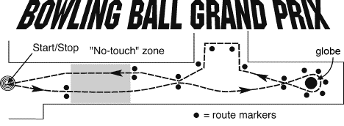
Time of bowling ball: ___________
- Was this easy or hard? If you did this with a soccer ball, would it be easier or harder? Why do you think this?

- Using words and a picture, how do you get the balls to speed up?

- Using words and a picture, how do you get the balls to slow down?

- Using words and a picture, how do you get the balls to go in a circle?

- Using words and a picture, how do you get the balls to make a sharp right turn?

- Describe the motion (speed and path) of the balls in the "no-touch" zone.

- If you don't begin slowing the balls soon enough for a turn, describe the path the balls "wanted" to take using words and a picture.

- Overall, when was it necessary to give the ball force? When it was moving, or when the motion changed?

- Do you know Newton’s 1st law of motion? Hint: Any object at rest………..

- How do you think Newton’s 1st Law of motion applies to this activity?

