Energy, Force, Bungee Jumping, and Dare-Deviled Eggs

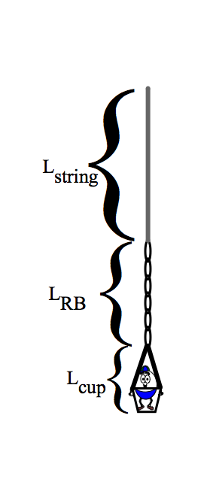

There are no reckless Daredevils! If you ever meet an old stuntman or stuntwoman, you can bet they are great at physics. Rather than practice on yourself or a trusting (but possibly foolish) friend, you will manufacture and test your very first bungee jump cord for your very own raw egg. Using the principles of energy conservation and force analysis, what could possibly go wrong?

But First: Pick your favorite number between 8 and 15 and write it here: ______________
Also, choose a perf-egg name for your ovoid and write it here: _______________________

HERE’S YOUR BUNGEE CHALLENGE: You will be attaching your egg, placed in a small
paper cup with a string handle to the end of your personally designed bungee cord, made of a
daisy-chain of your favorite number (see above) of size 16 office rubber bands attached to a
very specific length of string you will have carefully calculated. You will hold the end of the string
in one hand and drop the egg over the 5.05 m tall balcony in the hall. The egg that gets the
closest to the 1st floor without splatting or cracking wins! The only parameter you can control
to be successful is the length of your string.
As you can see from the picture at right: L_{string} + _{Lstretched rubberbands} + L_{cup} must be less than 5.05 m !

Use your physics knowledge and amazing lab skills to work through the design steps below.
-------------------------------------------------------------------------------------------------------------------------------------------------------------------------------------------------------------------------------------------
Step 1: Make a daisy-chain of your rubber bands (RB’s), minimizing the number of twists.
Use only new rubber bands without any defects!

Step 2: Create a suitable cup for your egg, using a hole punch to attach a string handle.
Set your egg in the cup and put a short strip of tape over the top of the egg to act
as a seat belt to keep your beloved egg in the cup (especially important after the jump!).

Find the mass of your cup and egg: _____________ g =_____________kg
Find the total length of the cup and handle: L_{cup} = _____________cm = _________m
Find the gravitational potential energy your egg will have when dropped from balcony height:
PE_{g} = = ____________ joules

Step 3: Find the spring constant, k, of your daisy-chain of rubber bands:
Materials: Chain of RB’s, set of masses, 2 meter sticks, graphing calculator
- Find the original length, L_{RB,o}, of the chain of rubber bands. This may be difficult – just try to straighten it along a table without stretching it by applying any excess force.
- Hang your chain of rubber bands securely from a doorframe or the ceiling. ASK FOR HELP!
- Attach increasing mass in increments of 20 grams to the end of the chain of RB’s. For each mass, measure the total length, L_{total}, of the chain. Record these results in the table below.
- Calculate the weight (F_{g} = mg) and ∆x, the change in length (L_{RB,total} – L_{RB,0}) for each hanging mass.

Original Length, L_{RB,o} = __________

Hanging mass, m | Weight = F_{g} = mg  (Newtons) | Total Stretched length, L_{RB,total} (m) | Change in length, ∆x  L_{total} – L_{RB,0} (m)
20 g = 0.020 kg | 0.196
40 g = ______ kg
60 g = ______ kg
80 g = ______ kg
100 g = ______ kg
120 g = ______ kg
List 2, L₂ List 1, L₁

- Using a graphing calculator, enter your data into the lists L₁ & L₂. (Stat – edit)
Use L₁ for the change in length, ∆x and use L₂ for the weight placed on the rubberbands.
- Make a Hooke’s Law graph of your data using the StatPlot function on the calculator. Make sure that Plot1 is turned ON, selecting XList = L₁ and YList = L₂.
Teacher Initials:
- SHOW YOUR GRAPH TO THE TEACHER!!
- Find the line of best fit for your data using the LinReg(ax+b) function.
(Stat – Calc – LinReg(ax+b)).
- The entry in your homescreen should look like this: LinReg(ax+b) L₁, L₂ (L₁, L₂ are defaults)
- Record your value of the slope of your Hooke’s Law graph. The slope is the spring constant, k
- SHOW THIS VALUE TO YOUR TEACHER & GET INITIALS TO GO ON.
Teacher Initials:

Slope = k = _____________________ (Don’t forget units!)

Step 4: Calculating the maximum stretch, ∆x_{max}, of the chain of rubber bands during the fall
- In Step 2, you calculated the gravitational potential energy your egg will have when released from the balcony. Assuming you make perfect calculations, your egg will nearly touch the floor, but it will momentarily come to rest due to the upward force from your bungee cord.

What kind of energy will be stored in your bungee cord at this point? _____________________________
Assuming your egg won’t lose a significant amount of energy to air resistance or friction during the fall, we
say that mechanical energy is conserved. If this is reasonably true, how much potential energy should be

stored in the rubber bands of your bungee cord? ________________________ joules

- Determine the maximum stretch, ∆x_{max}, of your chain of rubber bands using the formula
Teacher Initials:
PE_{elastic} = (½) k ∆x_{max}²

Show your calculations here:
∆x_{max} = ________ m
Step 5: Engineering and constructing your egg-cellent custom-designed bungee cord.
- Determine how much safety margin you wish to include in determining the length of string you add to your rubber band chain, L_{safety}
L_{safety} = ____________ m
- When stretched at the bottom of the fall, the total length of the RB’s, L_{RB}, equals the unstretched original length of the RB’s plus the maximum stretch of the RB’s (found in Step 4). Calculate this total length:

L_{RB} = L_{RB,o} + ∆x_{max} = ___________ + ___________ = ____________ m

- Recall that when the egg is momentarily at rest after falling and stretching the bungee cord RB’s, the total length of the bungee must be less than the 5.05 m height of the balcony. The total length of the bungee will be the sum of the length of the string, the total length of the stretched RB’s, and the length of the egg cup (Step2). Use this knowledge to calculate the length of the string you need to attach to complete you bungee cord:

5.05 m - L_{safety} = L_{string} + L_{RB} + L_{cup} Thus, find L_{string}:

L_{string} = __________ m
Teacher Initials:
GET your teacher’s final okay now!

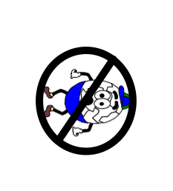
4. Attach the proper amount of string to your egg, and get ready to bungee jump!
(Remember, you need a few extra centimeters to hold with your hand.)

Good Luck!

TEACHER NOTES: Generally, students use 14-18 size#33 rubberbands. Eggs (raw) are placed in a 3 oz dixie cup (that 4 holes have been punched, and is tied like a mini-bucket). It is wise to put a scotch tape “seatbelt” over the cup so the egg does not fly out when it rebounds. I place a tarp below the egg zone!

