Car Crash Lab
Purpose: To use ideas of conservation of momentum and conservation of energy to solve for the speed of a car.
Materials: Hot wheels track
2 cars
Ring stand
Meterstick
Masking tape
String/weight to make a plumb line
Procedure:
- Show all your work for each question!
- Connect the track together and tape to ring stand so that it makes a continuous ramp to the edge of the table. Have it flatten out enough at the edge of the table for a car to sit there and not roll off.
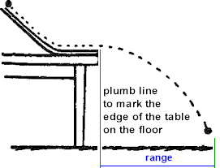
- Mass your cars.
Car 1 (heavy): Car 2 (light):

- Place the lighter car (Car #2) at the base of the ramp and select a spot for the heavier car (Car #1) to start somewhere up the hill of the ramp. Mark the starting point of Car #1 with a piece of tape.
- Let Car #1 roll down and collide with Car #2. Mark on the floor with tape where each car lands.
- Measure the horizontal distance (range) that each car traveled through the air.
- Repeat Steps 5-6 a couple times and average your results. Be as consistent as possible with your start position and other parameters that might affect your results.
 | Car #1 range (m) | Car #2 range (m)
Trial 1Trial 1:

Trial 2Trial 2:

Trial 3Trial 3:

Average:

- Find the time for the cars to reach the ground.

- Find the velocity of each car after the collision. Velocity = range/time
Velocity of Car #1:
Velocity of Car #2:
- Use Conservation of Momentum to calculate Car #1’s velocity before the collision since you now know the velocity of each car after the collision.

Now calculate the speed of Car #1 before the collision using Conservation of Energy. Compare to your answer from Question 10. How closely to these two numbers compare? What would be some reasons for any difference between the numbers?

