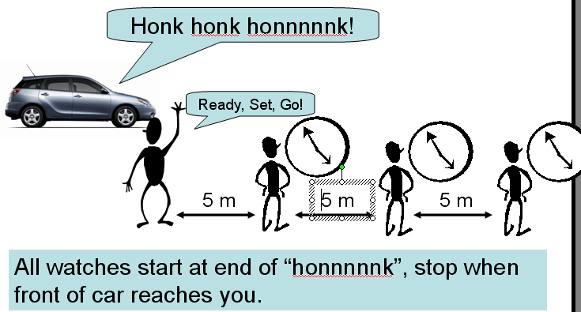
Pushy Pushy Lab

Purpose: Model motion using equations and graphs.

Secondary purpose: Error analysis. Learn kinematics terminology.

Skills: Interpret meaning of data, graphs, and equations. Properly label data and graphs, including units. Develop equations from non-linear data. Graph velocity and acceleration from position. Find change in position and change in velocity from velocity and acceleration graphs.

The lab write-up: Neatness counts. Use pencil and a ruler. Each section needs a heading. All numbers need units. Data and graphs must be completely labeled. Analysis and conclusions in complete sentences, never starting with “its”, “his”, “her”, “yes”, “no” or similar vague terms.

Perform the lab, day 1:
- Gather, record, and graph x vs. t data on paper (see instructions below).
- Find slope of tangent near start, at max speed, and at end (if different).
- Answer: What can you say about the speed of the car during the trip? (from graph).

Data table: Include title, row and column headings with units, and data.
Graph: Position vs. time.
- TIME MUST BE ON THE HORIZONTAL AXIS.
- Use most of the entire sheet of paper.
- Draw a best fit smooth curve through data points (Do NOT connect the dots!).
Check graph for the following: Title, x-axis label with units and equally spaced numbers (time), y-axis label with units and equally spaced numbers (position), best fit line through each segment of data (separate lines, each run).

Finish the lab, day 2: For this part of the lab, use Logger Pro to graph, find slopes, areas, equations.
Use Logger Pro to graph position vs. time (scatter plot). Be sure time is in the first column so it ends up on the x-axis. Find best fit curve and activate slope tool.
- Write equation on your paper (be sure to use correct symbols (x and t) and to identify what this equation is.
- Use your position vs. time graph to make a data table of time (first column) and velocity. Write this data table on your lab report. Find the velocity for at least 8 different times, using the slope tool. Refer to data table instructions on previous page.
- Graph velocity vs. time (time on x-axis) on Logger Pro. Find best fit line (hopefully straight line) and activate slope tool.
  - On your paper, sketch the graph. You do not need all the numbers, but put a few identifying numbers on each axis. Use correct graphing techniques.
  - Find slope of the line and record on your paper. What does the slope of this line represent? Be sure to label it correctly on your paper and use units. (If the graph is not linear, make a new data table of time and acceleration.)
- Activate the AREA tool (integration) and find the area under the velocity-time graph between two times for which position is known.
  - Record the numerical value of the area on your paper. Label this well (“The area under the velocity-time graph from t = XX seconds to t = YY seconds is…”
  - Compare to displacement (Δx) for this same time interval using your position vs. time graph. Record on your paper and label this well.
  - Find % difference (show calculation).
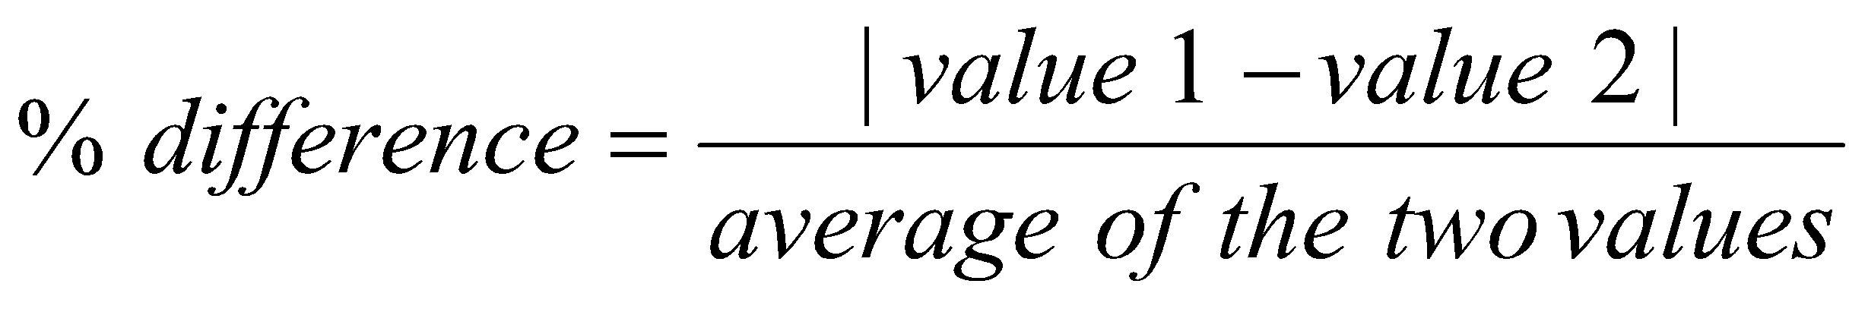
- Write a short conclusion about the relationship between the area under the velocity-time graph and displacement from the position-time graph.
- Use your slope information from the velocity vs. time graph (or time vs. acceleration data table) to graph acceleration on Logger Pro.
  - On your paper, sketch the graph like you did for velocity vs. time.
- Activate the AREA tool (integration) and find the area under the acceleration-time graph between two times for which velocity is known.
  - As you did above, record the area on your paper (well labeled) and compare to CHANGE in velocity from the velocity-time graph or data.

Additional Work (Think as you do and learn from this)
- Use the velocity vs. time graph to find average velocity. CLEARLY mark and label this point on your v-t graph sketch AND show how to calculate this. (Label your calculation).
- Use the position vs. time graph to find the average velocity. DRAW and CLEARLY label the line used to determine this on your x-t graph (label it). ALSO, show how to calculate this. (Label well).
- Answer on your paper (include question in your answer): What units did you use for displacement as found from the area under the v-t graph? Why are the area units not meters² in this lab? This is an important question – no fluff! Discuss with teacher or a fellow student if you can’t figure it out.

