Mini Musical Instrument Lab
INTRODUCTION
Most people would say that everybody likes music, but not everybody can play a musical instrument. I say that not only does everybody like music, but also everybody can understand the physics of music, and everybody can play a musical instrument. I will prove it to you by the end of this lab. The instrument you build today will be very crude – just four graduated cylinders (filled partially with water) that you blow across to make a tone. With these four graduated cylinders and the theory of the physics of music from the previous section, you should be able to put an instrument together that can play a song with four notes – like the one at the end of this lab.
PURPOSE
To use physics of music and physics of musical instruments ideas to construct a crude musical instrument with four graduated cylinders.
EQUIPMENT
• Four graduated cylinders
• meter stick
PROCEDURE
1. Measure the temperature of the room.
2. Measure the length of your graduated cylinder.
Use this length to calculate the fundamental frequency it would produce as a closed pipe musical instrument.
3. Find the closest C note that has a frequency above the lowest you can produce. This will be your octave.
4. Calculate the necessary lengths of a closed pipe to produce the frequencies of the C, D, E and G note in that octave.
5. Fill your graduated cylinders with the appropriate amount of water.
6. Check for accuracy by practicing the following song:
E D C D E E E D D D E G G E D C D E E E E D D E D C
7. When you're ready, show me your calculations (everyone in the group) and play the practiced song for me.
DATA
• Temperature of room: __________ °C • Length of longest graduated cylinder: __________ m
CALCULATIONS
- Calculate the fundamental frequency of your graduated cylinder.

- Octave you will be in:

- Calculate the lengths for the closed pipes that will play the above frequencies.

  - C

  - D

  - E

  - G
Aerophone Problems
- Part of the reason that human hearing is so sensitive in the 3,000 Hz range is because this is the resonant frequency for the ear canal (also the frequency of a baby’s cry…interesting). Use this idea to calculate the length of the ear canal. (2.9 cm)

- What are the other frequencies that the human ear is very sensitive to?

- An organ pipe is 112 cm long. What are the first three audible harmonics if the pipe is (a) closed at one end, and (b) open at both ends? (76.6 Hz…etc, 153.1 Hz…etc)

Use this information for problems 4 – 6. The sound pipe (pictured below) is a fun musical toy. Depending on how fast it twirls, it is possible to make four different audible frequencies. Both ends of the sound pipe are open.
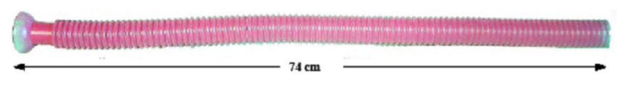

- If you twirled this sound pipe, what is the lowest pitch you could produce? (232 Hz)

- What length would you have to cut from this sound pipe so that it produces the frequency of the B closest to the fundamental frequency of this sound pipe? (4.5 cm)

- Imagine you had two sound pipes identical to the one in the photograph. If 1.0 cm were cut from one of them, what would be the difference of frequencies if they were resonating in their 2nd mode? (6.3 Hz)

