Center of Mass Activity

Purpose: Use the concept of center of mass and balancing of torques to determine the mass of a lump of clay.

1. Grab and meter stick and place your forefingers under each end of the meter stick. Move the hands inward and find the center of mass. It should be at 50 cm. Why does this happen every time?
2. Measure the mass of the meter stick on a digital scale. Mass of meter stick: _______________
3. Grab a lump of clay and attach it to one end of the meter stick. Do a series of trials, finding the new location of center of mass of the meter stick + clay:

Average location of new center of mass a.k.a. pivot point:

|  |  |
| --- | --- |
| Trial | Location of center of mass (cm) |
| 1 |  |
| 2 |  |
| 3 |  |
| 4 |  |
| 5 |  |

1. The force of gravity on the meter stick is acting on all points of the stick, but it can modeled as the whole force of gravity acting at 50 cm. With the new pivot point, calculate the torque generated by gravity on the meter stick:
2. If the whole apparatus is balanced, what does that tell you about the torque due to the weight of the clay? Determine the mass of the clay blob from this idea.
3. Once you have your calculated mass, bring the blob of clay up front and see how close you are. If you are within 5% you will earn Extra credit in participation.

Actual Mass of clay: ________ % Error: ___________

Post Activity Problems:

1. A 59-kg woman and a 71-kg man sit on a seesaw, 3.5 m long. Where is their center of mass?
2. Three 4-Newton forces act on a plywood hexagon as shown in the diagram. The sides of the hexagon each have a length of 1 meter.



Rank, from greatest to least, the magnitude of the torque applied about the center of the hexagon by each force.

Greatest 1 _______ 2 _______ 3 _______ Least

1. A system consists of two spheres, of mass *m* and 2*m*, connected by a rod of negligible mass, as shown above. The system is held at its center of mass with the rod horizontal and released from rest near Earth’s surface at time *t* = 0 .

Which of the following best explains why the system does not rotate around its center of mass as it falls?

(A) The Earth exerts the same gravitational force on both spheres, causing them to accelerate at the same rate.

(B) The Earth exerts the same gravitational force on both spheres, generating torques that cancel out.

(C) The Earth exerts a larger gravitational force on the sphere of mass 2*m*, but that sphere is closer to the center of mass and the torques cancel out.

(D) The Earth exerts a larger gravitational force on the sphere of mass 2*m*, but that sphere has more inertia and the torques cancel out.

1. 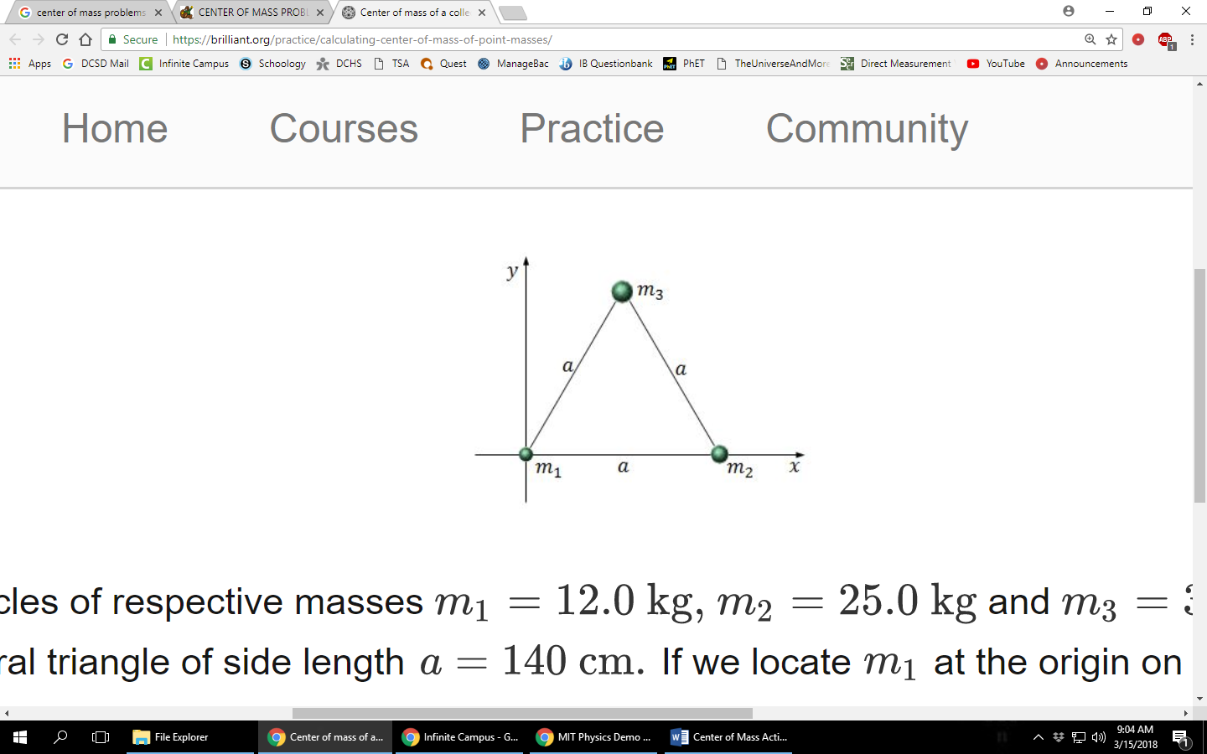Three particles of respective masses m1 = 12 kg, m2 = 25 kg and m3 = 38 kg form an equilateral triangle of side length a = 140 cm. If we locate m1 at the origin on the xy-plane, and put m2 to the right of m1 on the x-axis, as shown in the above figure, what are the approximate coordinates of the center of mass of this system?