Rotational Kinetic Energy and Momentum Problems

1. Four objects- a hoop, a solid cylinder, a solid sphere and a hollow sphere- each have a mass of 4.8 kg and a radius of 0.23 m.
   1. Find the moment of inertia for each object as it rotates about its central axis.
   2. Supposed each object rolled down a ramp. Rank the translational speed of each object from the highest to lowest.
   3. Rank the objects’ rotational kinetic energies from highest to lowest as the objects hit the bottom of the ramp.
2. A 25 kg hollow sphere 0.2 m in radius rolls without slipping 6.0 m down a ramp that is inclined at 37o. What is the angular speed of the sphere at the bottom of the slope if it starts from rest? (**6.52 m/s**)
3. The six figures below show spheres (not drawn to scale) that are about to roll up inclines without slipping. The spheres all have the same mass, but their radii, and linear and angular speeds at the bottom of the incline vary. Specific values are given in the figures for the linear and angular speeds at the bottom.



Rank these systems on the basis of the maximum height reached on the incline by each sphere.

Greatest 1 _______ 2 _______ 3 _______ 4 _______ 5 _______ 6 _______ Least

Please explain your reasoning.

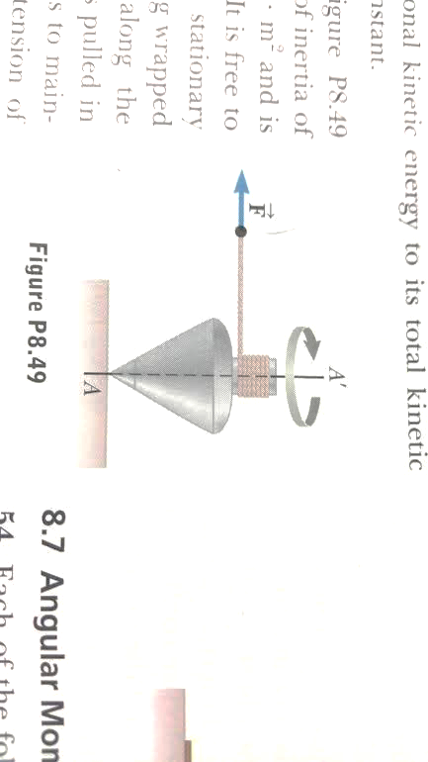

1. The top shown on the right has a moment of inertia of 0.0004 kgm2 and is initially at rest. A force of 5.57 N is applied along the string. If the string does not slip while wound around the peg, what is the angular speed (in rpm) of the top after 80 cm of the string has been pulled off the peg? (Hint: think about energy) (**1425 rpm**)
2. There is a comet called 45P that is passed close to us last year. As the comet passes through our solar system, the closest is gets is 0.5326AU and the furthers from the sun it gets is 5.5167AU (an AU is the average distance from the Earth to the Sun) If the comet goes about 54 km/s at its closest to the sun, how fast does it go when it is furthest from the sun? (think about L) (**5.213 km/s**)
3. The mass of the Earth is 6E24 kg, the radius is 6.4E6 m and is 1.5E8 km from the Sun. Determine the angular momentum of the Earth
   1. About its rotational axis (assume the Earth is a uniform sphere)
   2. In its orbit around the Sun (think of the earth as a single particle orbiting the Sun)
4. When stars get close to the end of the life cycles, some stars can collapse to neutron stars which are INSANELY dense. Suppose you have star about the same size as our sun (Rsun = 7*105 km) that is rotating about its axis once every 10 days. It collapses down to a neutron star with a radius of 100 km. What is its new rotational speed? How fast is the outer edge of the star moving? (**3,902 rpm, 23,437,500 km/hr**)