Capacitor Problems

1. You have a parallel plate capacitor.
   1. Determine the average E field between the plates if a 120 V potential difference is placed across the plates. Their separation is 0.50 cm. (**24,000 N/C**)

* 1. A spark will jump if the magnitude of the E field exceeds 3.0E6 V/m when air separates the plates. What is the closest the plates can be placed to each other without sparking? (**40 μm**)

1. Capacitors are used in all kinds of devices that require quick flow of charge. This happens in our bodies as well. Cells can be capacitors as they are surrounded by conduction fluid and have conducting fluid inside as well, separated by a nonconducting membrane. See figure below.
   1. Assume that each cell has a surface area of 1.8E-9m2, a membrane thickness of 8.0 nm, a dielectric constant of 8.0. If you have about 1013 cells in your body, what is your total capacitance? (**159.3 F**)
   2. If those cells in your body have on average about a 0.07V potential difference across the membranes, how much charge separation (q) is in your body at any time? (**11.15 C**)
2. How much energy is stored in a 220 µF camera flash capacitor that has been charged to 330 V? What is the average power delivered to the flash lamp if this capacitor is discharged in 1.0 ms? (**12 kW**)
3. 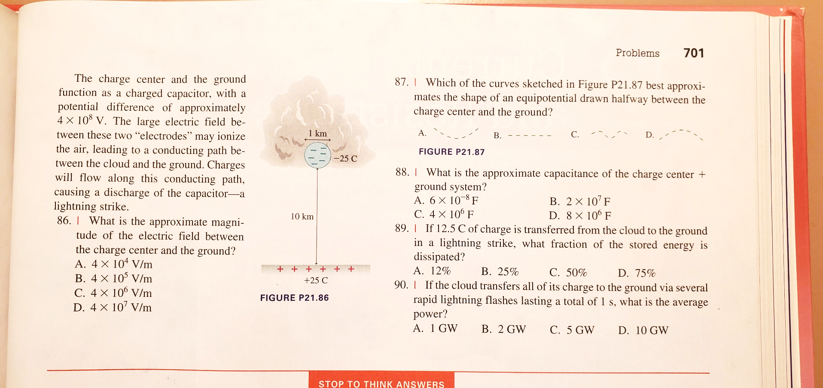Storm clouds build up large negative charges in charge centers, regions of concentrated charge. Supposed a cloud has -25 C in a 1.0 km diameter spherical charge center located 10 km above the ground. The negative charge center attracts a similar amount of positive charge that is spread on the ground below the cloud. The charge center and the ground function as a charged capacitor, with a potential difference of about 400MV. See the diagram below and answer the questions:
4. A parallel-plate capacitor is connected to a cell of constant emf (electro-motive force a.k.a. voltage). The capacitor plates are then moved further apart without disconnecting the cell. What are the changes in the magnitude of the electric field between the plates and in the capacitance of the capacitor?



1. In each case, an ion is momentarily at rest between the plates of a charged capacitor. The electric potential of each capacitor plate and the separations between the capacitor plates are shown.

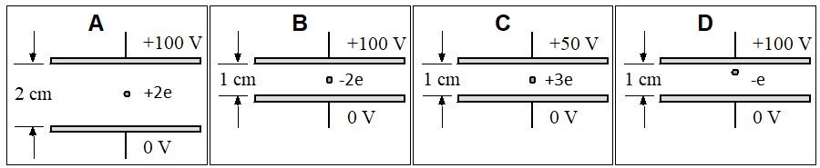

Rank the magnitude of the force exerted on the ion.

