**Time to explore potential energy, kinetic energy and conservation of energy.**Then make your screen look like the picture by

* clicking the box next to bar graph
* clicking the box next to pie chart
* Dragging the skater to the top of the ramp
* Releasing the skater.
  1. Discuss the changes in the bar graph as the skater moves on the track



* 1. Use the symbols to fill in the data table:

|  |  |  |  |  |
| --- | --- | --- | --- | --- |
| Skater’s movement |  | Potential energy  **( ↑ ↓ S )** | Kinetic energy  **( ↓ ↑ S )** | Total energy  **( ↑ ↓ S )** |
| Down the hill | Skater down |  |  |  |
| Up the hill | Skater up |  |  |  |

**(↑ increases, ↓ decreases, S for stays the same)**

Phet FrictionTime to explore friction!

1. At the bottom, click “Friction”
   1. Click the box next to bar graph
   2. Click the box next to pie chart
   3. Move the slider to change the friction

Discuss the changes in the bar graph as the skater moves up and down on the track.



1. Use the symbols to fill in the data table.

|  |  |  |  |  |
| --- | --- | --- | --- | --- |
| Skater’s movement | Potential energy  **( ↑ ↓ S )** | Kinetic energy  **( ↓ ↑ S )** | Total energy  **( ↑ ↓ S )** | Thermal Energy  **( ↑ ↓ S )** |
| Down hill |  |  |  |  |
| Up the hill |  |  |  |  |

(**↑** increases, **↓** decreases, **S** stays the same)

Data Collection and Analysis:

1. Select the Friction option on the bottom. Select the half pipe track and turn on Grid and Speed. Start with NO Friction
2. You will calculate the changes in energy- total, kinetic, and potential over time. To do this, we need to define our system. **This is a skater-earth system**.
3. We also need to establish numbers for mass and speed.

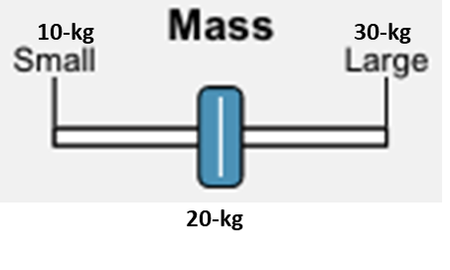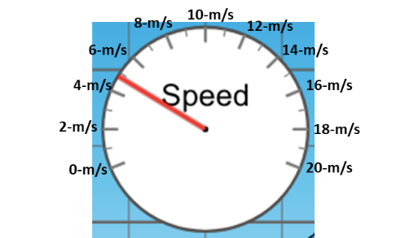

1. Choose “Slow Motion.” Place the skater at 6-m. Pause the sim when the skater is at the grid lines. **Record** the height, speed and then **calculate** the Gravitational Potential, Kinetic and Mechanical energies at those points.

|  |  |  |  |  |
| --- | --- | --- | --- | --- |
| **Height (m)** | **Velocity (m/s)** | **Ugrav (J)** | **K (J)** | **Mechanical Energy (J)** |
| 6 | 0 |  |  |  |
| 5 |  |  |  |  |
| 4 |  |  |  |  |
| 3 |  |  |  |  |
| 2 |  |  |  |  |
| 1 |  |  |  |  |
| 0 |  |  |  |  |

1. What do you notice about the Mechanical Energy of the system throughout the run with no friction? Explain why this happens.

|  |  |  |  |  |
| --- | --- | --- | --- | --- |
| **Height (m)** | **Velocity (m/s)** | **Ugrav (J)** | **K (J)** | **Mechanical Energy (J)** |
| 6 | 0 |  |  |  |
| 5 |  |  |  |  |
| 4 |  |  |  |  |
| 3 |  |  |  |  |
| 2 |  |  |  |  |
| 1 |  |  |  |  |
| 0 |  |  |  |  |

1. Now turn on Friction to **LOTS** and retake the data.
2. What do you notice about the Mechanical Energy of the system throughout the run with friction? Explain why this happens.

**Playground**

Create the skate paths as shown. If the skater starts on the left side, will he have enough energy to make it all the way to the right side? _________ Why or why not?

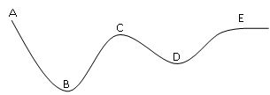If the skater starts on the left on the path here, match the letter here with the following conditions:

C

1. Maximum kinetic energy __________

D

1. Maximum potential energy _________
2. Two locations where the skater has about the same speed _____

B

If the skater starts at the top of the ramp on the left, show how high will he be on the right side of the ramp. Let the skater go down the ramp. Does she get back to the original height? Explain why this happens in terms of types of energy.

Try to make a Loop da Loop. Move the skater around and determine a relationship between where the skater starts and whether he makes the loop or not. Record your ideas below.

**Conclusion Calculations: *use g = 10.0 m/s2***

Complete the table of kinetic and potential energies:

|  |  |  |  |  |  |
| --- | --- | --- | --- | --- | --- |
| Mass of skater (kg) | Height (m) | Velocity (m/s) | K (J) | Ugrav (J) | Mechanical Energy (J) |
| 20 | 14 |  |  |  | 4240 |
| 60 | 6.0 |  | 1920 |  |  |
| 0.20 | -18 |  |  |  | 4 |
|  | 6.0 | 5.0 |  | 600 |  |

Work is the amount of energy added or removed from a system. Most of the time, to find the work, it is easiest to focus on the energy that is being changed, instead of going straight to the work equation.

1. Shown below are graphs of velocity versus time for six identical objects of mass 5 kg, that move along a straight, horizontal surface. A single external force acts on each object.



Rank (from greatest to least) the work done on the objects by the external force during the 4-second time interval shown. HINT: The Work is turning into Kinetic Energy.

Greatest 1 _______ 2 _______ 3 _______ 4 _______ 5 _______ 6 _______ Least

If given a Force vs displacement graph, to find the work done on the system, W = FΔx, which of the 3 aspects of a graph (coordinates, slope or area) would we focus on?

1. The graph below shows the force that an employee exerts on a cart loaded with wood at a lumberyard. This force varies as a function of position. Six segments are marked in the graph.



Rank these segments from greatest to least on the basis of the energy the employee transfers to the cart.

Greatest 1 _______ 2 _______ 3 _______ 4 _______ 5 _______ 6 _______ Least