Demonstrating the Existence of Dark Matter

Introduction: What is dark matter?

In this exercise, you will learn a bit about dark matter, a forefront research topic in physics! Dark matter is a mysterious kind of matter that makes up around 85% of the matter in the universe, yet we know very little about it. We call it “dark” matter for exactly that reason: it is dark. We can’t see it. On the other hand, it’s different from other kinds of matter we can’t see, such as air. There are some cases where we can feel air:
There are also some cases where we can see air:
So far, we’ve been unable to either see or feel air.

We expect the Earth to be moving through a wind of dark matter, but we can’t feel this wind. In fact, there could be as much as roughly 5 x 10³⁷ dark matter particle passing through the palm of your hand every second! How fast is this wind?

Exercise: A wind of dark matter
We expect that we’re moving through a wind of dark matter. To estimate the wind speed, we can use Newton’s laws! The cause of this wind is that the Solar System is orbiting the center of our galaxy, the Milky Way. We’re moving in nearly circular motion around the center of the galaxy. We’ve measured that 27,000 light-years from the center of the galaxy. A light-year is the distance light travels in the year, which is about 9.46 x 10¹⁵ m. We’ve also inferred that there is about 10¹¹ times the mass of the Sun of “stuff” that we’re orbiting around. The mass of the Sun is about 2 x 10³⁰ kg. Using Newton’s laws and the orbital speed for circular motion, calculate the speed at which we’re orbiting around the center of the Milky Way. After calculating your answer in m / s, convert to miles per hour to get a feel for what this means in everyday terms. Since we’re moving at this speed around the Milky Way, we expect that we’re roughly facing a headwind of that speed through the dark matter, since the dark matter is not expected to be moving in the same direction as us in general. How do we know that? Well, that’s a much longer story, but has to do with how little the dark matter seems to bounce into things.
Source: NASA

If we can’t feel it, how do we know it’s there?
To date, we haven’t been able to “feel” the wind of dark matter. We’re trying very hard to feel the wind by building gigantic experiments where we fill a vessel with literal tons of liquid and wait for a dark matter particle to bounce off the atoms in the liquid. With ever more sensitive detectors of this kind, as well as a few other creative strategies, we’re hoping to feel this wind soon and thereby learn a lot more about the nature of dark matter and how it fits into our understanding of the Universe.
But if we can’t feel this wind, how do we know dark matter is out there? You will explore one of the key pieces of evidence for dark matter in the rest of this tutorial. To infer the existence of dark matter, we look at distant galaxies. It’s possible to do that with our very own Milky Way, but it’s easier to do with other galaxies. One particularly nice galaxy for seeing the existence of dark matter is called M33 or the Triangulum galaxy. This galaxy is a whopping 2.73 million light-years away from us! We look at this galaxy using very high resolution telescopes like the Very Large Array and the Green Bank telescope, which can resolve angles on the sky 120 milliarcseconds or nearly 1 part in 10⁵ degrees. From these measurements, astronomers have studied the properties of the stars and gas in this galaxy at various distances away from its center.
The observations measure two key properties of the stars and gas. First, we can simply determine how much stars and gas are out there by how much of it we see. The brighter the light coming from a given distance, the more mass there is at that distance. Astronomers have carefully calibrated a relation between the brightness or intensity and the mass. This modeling has been carefully tested in a variety of scenarios.
Second, we can determine the speed at which the stars and gas are orbiting the center of the galaxy. To do this, we use the Doppler effect for light. For sound, you may have noticed that a siren on an emergency vehicle that’s moving away from you sounds lower in pitch, while one moving toward you sounds higher in pitch. The same thing is true for light waves. Light moving toward us is higher frequency or more “blue”, while light moving away from us is lower frequency or more “red.” By looking at stars whose color we know and seeing how much it is shifted in M33, we can determine the orbital speed.
This data, taken from Corbelli et. al., Astronomy & Astrophysics, vol. 572, article A23 (2014), is in your spreadsheet. The distances here are in a convenient galactic distance unit called a kiloparsec or kpc.

Exercise (optional): A parsec
A parsec is a unit of distance that’s defined as the distance to a star that moves on the sky by one arcsecond or 2.78 x 10⁻⁴ degrees on the sky between the Earth and the Sun. The distance between the Earth and the Sun is called an Astronomical Unit and is measured to be 1.50 x 10¹¹ m. Calculate 1 parsec in m.

Exercise: Galactic rotation curve
Use your spreadsheet to plot the measured speed as a function of distance from the center of M33. Then, calculate the expected speed based on the mass of stars and gas enclosed at each distance in km / s, following a similar calculation to your determination of the dark matter wind earlier. Add this to your plot. Once you’re done, compare your plot to the official one made by scientists, which can be found on this Wikipedia page: https://en.wikipedia.org/wiki/Galaxy_rotation_curve#/media/File:Rotation_curve_of_spiral_galaxy_Messier_33_(Triangulum).png.

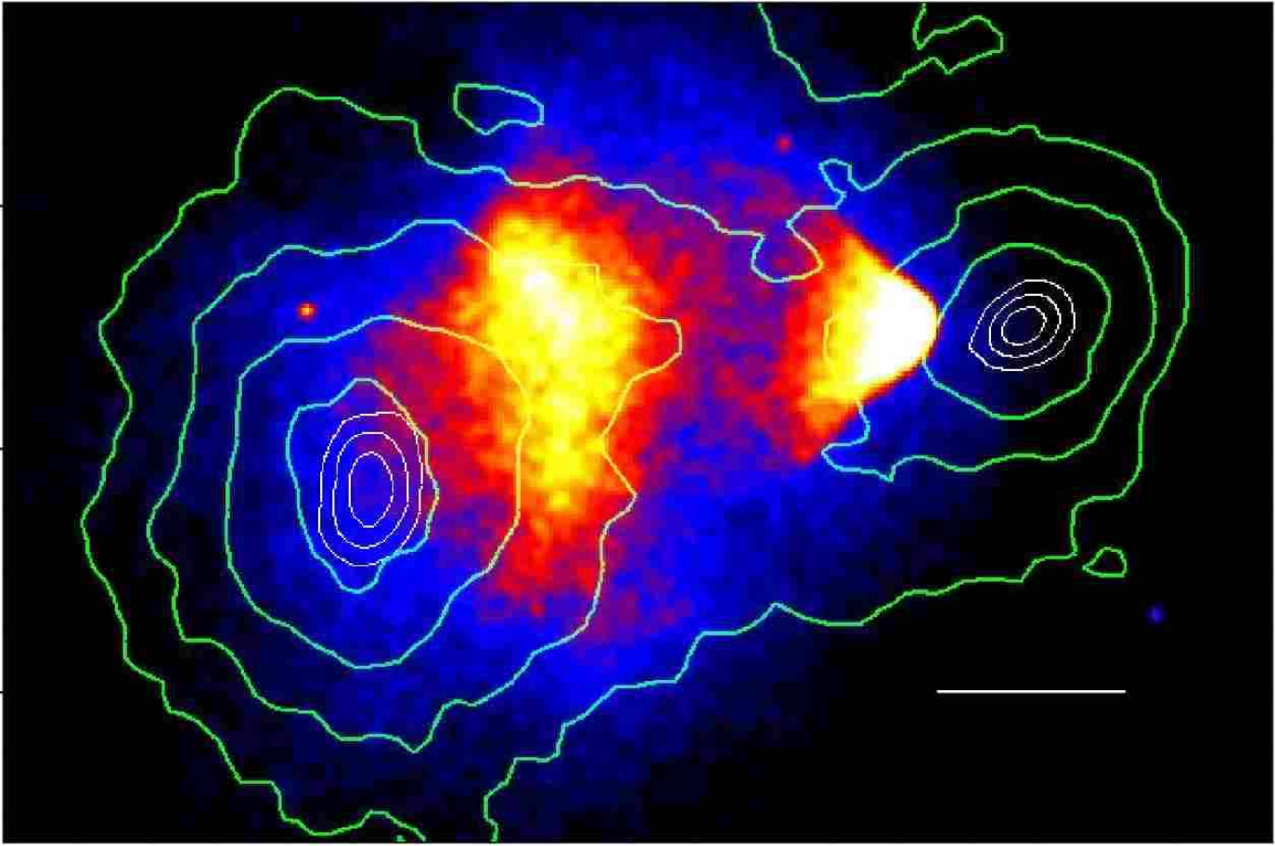
Interpretation
Clowe et. al.: Astrophys. J. Lett. 648 (2006) L109-L113
If all went according to plan, you should see a mismatch between the observed orbital speeds of stars and gas in M33 and the expected orbital speeds from Newton’s laws. What’s going on here? There’s two possibilities that, just based on this data, are plausible. Either there’s some kind of matter we’re not seeing, namely dark matter, or Newton’s laws don’t apply to galaxies. Scientists entertained both possibilities for a long time, but other corroborating evidence has disfavored the idea that Newton’s law of gravitation doesn’t apply here. One tangible piece of evidence that there really is some kind of matter we can’t see, rather than a break down of our laws of gravity comes from a pair of clusters of galaxies called the Bullet Cluster. We’ve observed that galaxies group up into gravitationally bound clusters. The Bullet Cluster is actually the aftermath of the collision of two clusters of galaxies. We observed the Bullet Cluster in two different ways. First, just like with galaxies, we look and see how bright the collided clusters are. It turns out clusters of galaxies are easiest to see by taking X-ray images, not all that different from how we look at bones using X-rays. Second we map out the actual mass of the clusters using something called gravitational lensing. The principle behind gravitational lensing is that everything bends around massive objects due to gravity, including light itself! By looking at how light bends around the clusters, we can map out their masses. The resulting image is:
The bright, yellow areas are the brightest in X-rays. The green contours indicate the observed mass using gravitational lensing. They are contours of constant density, so that the closely spaced concentric contours indicate high concentrations of mass. In the aftermath of the collision of these clusters, we see that the inferred mass and the brightest parts don’t overlap. Gas and stars that we can see are get dragged a bit as they pass through each other, so they pass through each other slowly, while the bulk of the matter appears to pass through more easily. From this image, we learn a number of things. First, the separation strongly hints that there is a form of dark matter in these clusters of galaxies. Second, we can actually place a bound on how much dark matter can get dragged by moving either through a concentration of itself or some concentration of visible matter. Normal matter can be felt, but dark matter can’t even feel itself, as far as we can tell so far.

