Specific Heat Capacity Mini Lab

Specific heat capacity is a physical property of a material. For pure water, the specific heat capacity is 4186 J/kgoC. From the specific heat capacity and knowing the mass of a material you can determine how much Heat is required to raise the temperature of the material by 1oC. The equation for this is:

$$Q=mc∆T$$

Today we will be doing a quick mini lab to determine your value for the specific heat capacity of tap water.

**Materials:**

Styrofoam cup Electric Coil Heater (rated at 300W) Temperature probe

Water Electronic Balance Magnetic stir bar and stirrer

**Procedure**:

1. Measure the mass of the empty cup
2. Pour water into the cup and measure the mass of the water + cup
3. Place heater coil into water before being plugged in (VERY IMPORTANT: COIL MUST BE IN WATER BEFORE PLUGGED IN OR YOU WILL BREAK THE COIL)
4. Place stir bar in water and lower temp probe so that the tip is in the middle of the water.
5. Start stir bar spinning and start taking temperature data.
6. Plug in coil to wall socket
7. Let the water heat up for about a minute. You should be seeing a linear trend on the Temp vs Time graph.
8. Unplug the coil, turn off stir bar, and let sit as it cools down.

Analysis:

1. From your data, determine the slope of the trend line for the linear portion of the data. What was that slope?
2. If the coil is rated at 300W, that means it puts out 300J of energy every second. Derive an equation for the specific heat of the water in terms of mass, Power input, and your slope.
3. What was your value for the specific heat of water? If the specific heat for pure water is 4186 J/kgoC, what is your percent error?
4. Why do you think we needed the stir bar? How would your result change if we did not use the stir bar?

Temperature and Heat Problems

1. Three students are discussing the temperature of objects that have been sitting untouched on a bedside table overnight. The room they are in has been at a constant temperature of 25 °C.

Four students are discussing the temperatures of these objects.

*Abigail:* All of the objects have been sitting there all night. They will be at the same temperature as the room.

*Beto:* That can’t be -- if you touch them you can feel the differences. I think the scissors will have the lowest temperature, then the glass of the mirror, then the plastic mirror frame. The wood will be warmest.

*Carlos:* I agree with Beto that the temperatures will be different, but I think you have to pay attention to the masses as well. The actual temperature depends on the material and the mass, with the more massive objects keeping cooler. It’s hard to say whether the scissors will have a lower temperature than the mirror glass, and it’s also hard to say whether the plastic will be warmer than the wood, but the mirror and metal will definitely be cooler than the wood and plastic.

*Dee Dee:* I think the mirror and the mirror frame are going to transfer heat to each other until they are the same temperature, because they are in contact. They’ll reach some temperature that is between the cold scissors and the warm brush handle.

With which, if any, of these students do you agree?

Abigail _____ Beto _____ Carlos _____ Dee Dee _____ None of them______

Explain your reasoning.



1. Two glasses each contain 500 mL samples of water. The water in glass A has a temperature of 66 °C and the water in glass B has a temperature of 94 °C.

A student makes the following contention:

“Since both glasses have the same amount of water, but glass B has a higher temperature, glass B contains more heat.”

There is a problem with the student’s contention, identify the problem and explain how to correct it

1. A teacher prepares a cup of instant coffee by heating 200 grams of water that was initially at 20 °C with an electric immersion heater placed directly in the cup. It takes 207 seconds to warm the water to 90 °C.

(a) Another teacher with an identical cup uses the same heater to warm up 150 grams of water initially at 20 °C. Is the time taken to heat this second cup of water to 90 °C (a) *greater than*, (b) *less than*, or (c) *equal to* 207 seconds?

Explain.

Answer: It takes less time to heat the second cup because there is less water to heat up and the temperature difference is the same.

(b) A third teacher with an identical cup uses the same heater to warm up 200 grams of warmer water initially at 30 °C. Is the time taken to heat this third cup of water to 90°C (a) *greater than*, (b) *less than*, or (c) *equal to* 207 seconds?

Explain.

Answer:

1. Lake Granby has a capacity of 0.6658 km3. The specific heat of water is 4186 J/kgoC and the density of water is 1000 kg/m3.
   1. How much energy would be required to raise the temperature of the lake from 11.0oC to 12.0oC? (**2.79E15 J**)
   2. How many days would it take to supply this amount of energy by using the 1000 MW exhaust energy from an electric power plant running continuously? (**32.3 days**)
2. 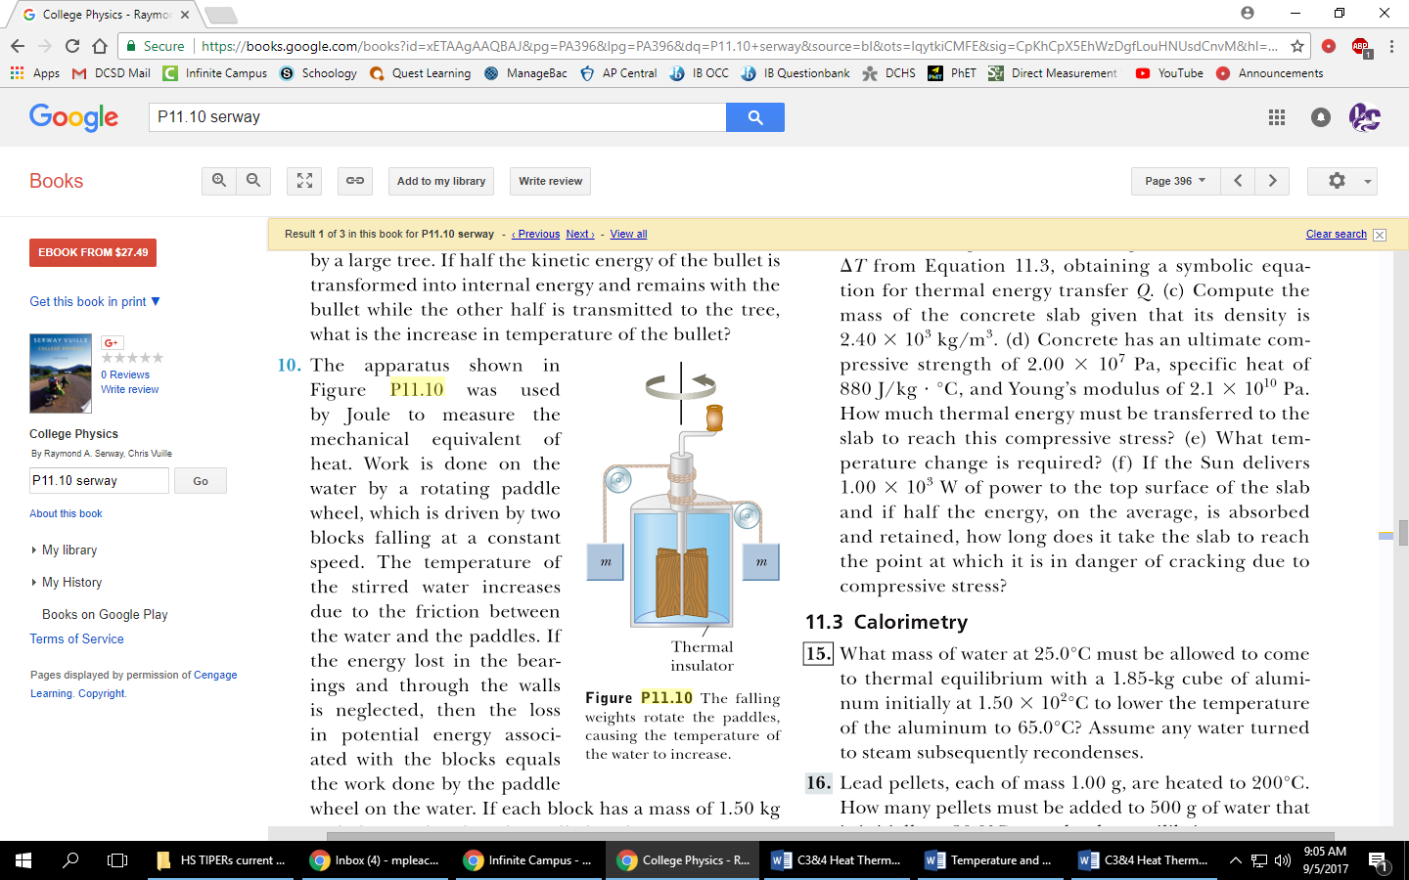The apparatus shown on the right was used by Joule to measure mechanical equivalent energy of heat. Work is done on the water by rotations the paddle wheel, which is driven by two blocks calling at a constant speed. Assuming no heat loss through the insulator, how much does the temperature of the water increase by if each block has a mass of 1.5 kg, the container is filled with 200 g of water and the blocks fall 3 m? (**0.11oC**)
3. A sample of ice starts at -20oC. Heat is constantly added to it until the water has turned to steam with a temperature of 120oC. Sketch the Heat vs Temperature graph of the whole process below and label each state of matter the molecules exist in.

Temp (oC)

Heat added (J)

0

1. A 75 kg cross country skier glides over the snow. The coefficient of frictions between the skis and the snow is 0.20. Assume all the snow beneath her skis is at 0oC and that all the internal energy generated by friction is added to the snow, which sticks to her skis until it melts. How far would she have to ski to melt 2 kg of snow if the Latent Heat of Fusion for water is 333 kJ/kg? (**4.53 km**)