Capacitors in Circuits Activity
Inquiry Questions for Activity:
- How do capacitors interact with each other when placed in both series and parallel circuits?
- How do resistors and capacitors interact when in circuits together?
Materials: Power supply, connecting wires, various capacitors, multimeter
Series Circuit.
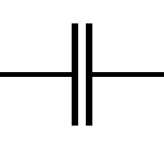
Set up a circuit (complete loop) so that one capacitor comes after another one in the circuit. When drawing diagrams of circuits, we use symbols to represent different items.
Capacitor: Voltage supplies (batteries):

With those symbols, draw your circuit diagram below, labeling the 3 capacitors and the total voltage of the circuit:

Use the voltmeter to measure the voltage drop across each capacitor:
Capacitor | Capacitance (µF) | Measured Voltage (V)
1
2
3

How do the voltages of the 3 capacitors compare to the total voltage being provided by the supply?

Calculate the amount of charge placed on each capacitor using the Capacitor equation. What do you notice about those charges?
Capacitor | Capacitance (µF) | Calculated Charge (C)
1
2
3

Thinking about how current flows through the circuit, what claim can you make about the movement of charge through a series circuit?

Parallel Circuit:
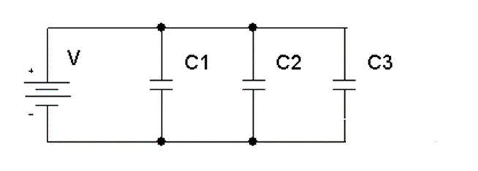
Using the same capacitors, construct a parallel circuit like the diagram on the side:

Using the voltmeter and measure the voltages across each capacitor.
Capacitor | Capacitance (µF) | Measured Voltage (V)
1
2
3

How do the voltages compare?

Use the capacitor equation to calculate the amount of charge for each capacitor:
Capacitor | Capacitance (µF) | Calculated Current (A)
1
2
3

Thinking how current acts in a parallel circuit, can you make a claim about how the charge moves in a parallel circuit for capacitors?

Practice Problems:
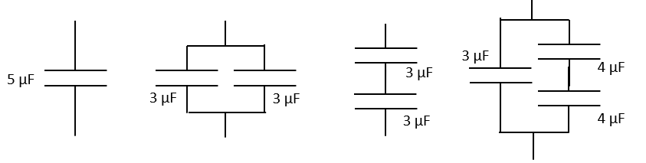
- Rank the Equivalent capacitances of the configurations below, with 1 the highest and 4 lowest:

- Fill in the table for the Charges and Voltages for each capacitor:
Capacitance (μF) | Applied Charge (μC) | Voltage (V)
2
4
6
8
10
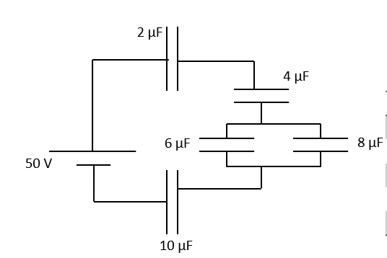
HINT: (you have the total voltage, so start by finding the total capacitance of the circuit)

- A capacitor of 0.10 F was charge by connecting it to a 5.9 V supply. When it was disconnected from the supply then connected to in parallel with another uncharged capacitor of unknown capacitance, the voltage across them fell to 0.71 V.
- Calculate the charge on the 1st capacitor before the 2nd capacitor was connected. (0.59 C)

- Determine the combined capacitance of the two capacitors in parallel. (0.831 F)

- What was the unknown capacitance? (0.731 F)

RC Circuits
Materials: Power supply, 1 Farad Capacitor, lightbulb and holder.

Hook up the power supply, capacitor and lightbulb in series. BEFORE turning on the power supply, make a prediction what will happen to the bulb:

Turn on the power supply. What happened to the bulb? _____________________________________________________
Can you give an explanation why there was a change in the status of the bulb as time went on?

Can you make a claim about the current through a capacitor “after a long time” has passed?

Now hook up the power supply, capacitor and bulb in parallel. BEFORE turning on the power supply, make a prediction what will happen to the bulb:

Turn on the power supply. What happened to the bulb? _____________________________________________________
Can you give an explanation why there was a change in the status of the bulb as time went on?

Do we care about a capacitor in a parallel circuit “after a long time”? Why or Why not?

What about “right away”? Does the capacitor change the circuit the moment charge starts to flow?

Now charge up the capacitor. If we hook up the bulb just to the capacitor, what should happen?

Hook the capacitor up to bulb and see the result. Can you explain the phenomenon that occurred?

Grab an ammeter and have it be part of the circuit. Watch the graph of current vs time. Sketch the results below:

Post Lab Questions for RC Circuits:
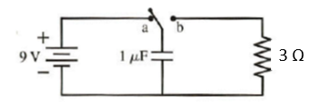
- The switch in the figure below has been set at a for a long time. The switch is then moved to b at t = 0 s. What is the charge of the capacitor and current through the resistor at t = 5.0 μs?
(1.7 μC, 0.567 A)

- The current at the beginning of a capacitor discharge is 45.7 mA. If the capacitance is 470 μF and it is discharging through a 2.0 kΩ resistor.

- What is the time constant for this circuit? (0.94 sec)

- What will the current be after 1 second? After 2 seconds? (15.77 mA, 5.44 mA)

- What was the initial voltage across the resistor (and capacitor)? (91.4 V)

- The voltage across a 2000 μF capacitor is 12.4 V when it starts discharging through a 3250 Ω resistance. How long will it be before the voltage has fallen to exactly 1 V? (16.365 seconds)

- In an experiment to determine the value of an unknown capacitor, a discharge current through it was found to fall to 10% of the previous value in a time of 39 seconds. If the discharge was through a resistor of value 57.6 kΩ, what was the unknown capacitance? (294 μF)

