Capacitors in Circuits Problems
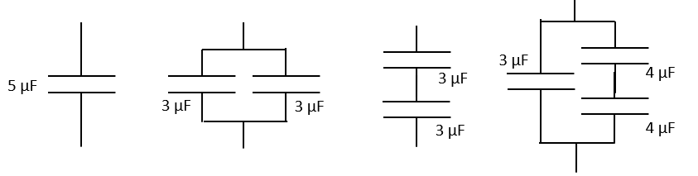
- Rank the Equivalent capacitances of the configurations below, with 1 the highest and 4 lowest:

- Fill in the table for the Charges and Voltages for each capacitor:
Capacitance (μF) | Applied Charge (μC) | Voltage (V)
2
4
6
8
10
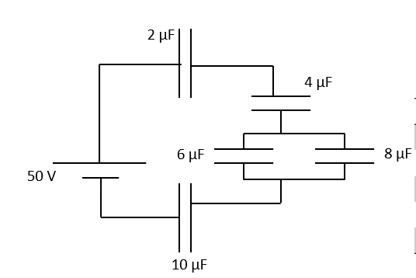
HINT: (you have the total voltage, so start by finding the total capacitance of the circuit)

- A capacitor of 0.10 F was charge by connecting it to a 5.9 V supply. When it was disconnected from the supply then connected to in parallel with another uncharged capacitor of unknown capacitance, the voltage across them fell to 0.71 V.
- Calculate the charge on the 1st capacitor before the 2nd capacitor was connected. (0.59 C)

- Determine the combined capacitance of the two capacitors in parallel. (0.831 F)

- What was the unknown capacitance? (0.731 F)
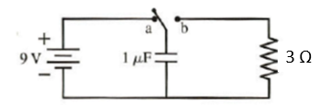
- The switch in the figure below has been set at a for a long time. The switch is then moved to b at t = 0 s. What is the charge of the capacitor and current through the resistor at t = 5.0 μs?
(1.7 μC, 0.567 A)

- The current at the beginning of a capacitor discharge is 45.7 mA. If the capacitance is 470 μF and it is discharging through a 2.0 kΩ resistor.

- What is the time constant for this circuit? (0.94 sec)

- What will the current be after 1 second? After 2 seconds? (15.77 mA, 5.44 mA)

- What was the initial voltage across the resistor (and capacitor)? (91.4 V)

- The voltage across a 2000 μF capacitor is 12.4 V when it starts discharging through a 3250 Ω resistance. How long will it be before the voltage has fallen to exactly 1 V? (16.365 seconds)

- In an experiment to determine the value of an unknown capacitor, a discharge current through it was found to fall to 10% of the previous value in a time of 39 seconds. If the discharge was through a resistor of value 57.6 kΩ, what was the unknown capacitance? (294 μF)

