Circuit Problems
- Four 70 W Christmas tree lights are connected in parallel to each other and to a 110 V source. What is the total current that is coming from the source? (2.54 A)

- A 75 W (at 120 V) lightbulb is connected in parallel with a 40 W (at 120 V) lightbulb. What is the total resistance? (125.2 Ω)

- Draw the circuit diagram for a home where the 120 volt source is the power station, you have a circuit breaker that can stop the current if it get too high (usual limit is around 20 Amps) and then you have a 111 W plasma tv, a 12,200 W stove and oven, and a 2790 W clothes dryer running at the same time. Does the breaker get tripped? Why or why not?

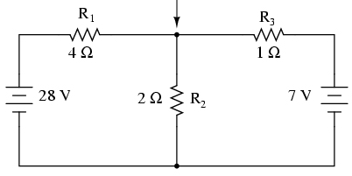
- Determine the 3 currents traveling through the circuit on the right and find the total power output of this circuit. (133 W)

- In the circuit on the right, R has a resistance of 1 kΩ and ε is a potential difference of 250 V. If the right battery has a total charge capacity of 2500 mAhr, how long will this circuit last in this setup? (19.23 hr)
R
2R
3R
4R
ε
2ε

