Polarization Problems
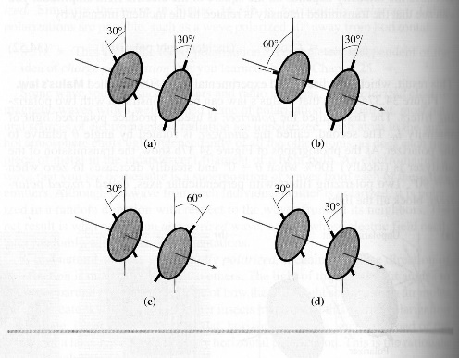
- Unpolarized light of equal intensity is incident on four pairs of polarizing filters. Rank in order, from largest to smallest, the intensities I_{a} to I_{d} transmitted through the second polarizer of each pair.

- Two polarizers are oriented at 60º to one another. Unpolarized light is sent through them. What fraction of light intensity is transmitted? (1/8)

- What angle should the axes of two polarizers be placed so as to reduce the intensity of the light for 1/3 the original level? (35.26º)

- A 200mW horizontally polarized laser beam passes through a polarizing filter whose axis is 25º from the vertical. What is the power of the laser beam as it emerges from the filter? (35.7 mW)

- What angle should the axes of two polarizers be placed so as to reduce the intensity of the light for 1/10 the original level? (63.4º)

- If 2 polarizers a placed at 90º to each other no light gets through. But what happens if you place another polarizer at 15º from the 1st polarizer? What is the resultant intensity factor? (1/32)

- Unpolarized light of intensity I_{o} is incident on a stack of 7 polarizers, each with its axis rotated 15º clockwise with respect to the previous filter. What light intensity emerges from the last polarizer? (0.33I_{o})

- Two polarizers are 90º off from each-other. At what angle do I need to place a third polarizer so that the resultant intensity is 1/12 the original? (27.4º)
Hint: cos(a-b) = cos(a)cos(b) + sin(a)sin(b) and sin(2a) = 2sin(a)cos(a)

