Finding the Focal Length of a Lens Lab
Purpose: To use the lens/mirror equation to determine the focal length of various lenses.
Choose 2 different lenses. You will need to place the lens a distance away from the lightbulb and find the resulting image distance. Do this for 10 different object distances for each lens.
Lens 1:
You will need a known value to compare your experimental value to. Discuss with your group another method to finding the focal length. Hint: you may need to go outside.
Measured Focal Length:
Lens 1:_____________________
Lens 2:_____________________

Trial | Object Distance (cm) | Image Distance (cm)
1
2
3
4
5
6
7
8
9
10
Lens 2:
Trial | Object Distance (cm) | Image Distance (cm)
1
2
3
4
5
6
7
8
9
10
To find your calculated value for the focal lengths, I want you to find it graphically. DO NOT TAKE ANY AVERAGES!!! Your formal lab report is about how close your calculated focal length is from your measured focal length. The lab report is due on Friday March 11th.
Constructing a telescope.
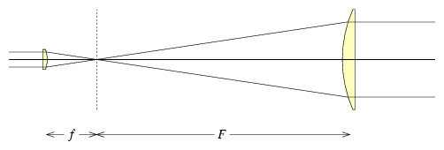
Take your 2 lens in each hand and place the smaller focal length lens in front of your face with the larger focal length lens behind it. Move them back and forth until you can clearly see a distant object in your lenses. You have made a telescope.
Measure the length between the two lenses.
Telescope length:______________
Looking at the diagram, what should the telescope length be? Compare your result to the theoretical:

Post Lab Problems
Object Distance (cm) | Image Distance (cm)
15.4 | 22.8
21.8 | 14.7
32.7 | 12.4
- The following data is from an experiment done with a thin converging lens. Use it to determine the image distance produced when the object is 25.0 cm from the same lens. (14 cm)

- If a lens produces a virtual image twice the size of the object when the object is 15.0 cm from the lens, what is the strength (in diopters, where the diopter strength = 1/focal in meters) of the lens? (+3.333)

- A light bulb is placed 120 cm from a screen. What are two positions from the screen where a 20 cm focal length converging lens can be placed in order to produce real images of the light bulb on the screen? (25.4 cm and 94.6 cm)

- Two thin lenses, one a converging lens on the left with a 14.0 cm focal length and the other a diverging lens on the right with a -5.00 cm focal length are placed 30.0 cm apart. An object is placed 40.0 cm to the left of the converging lens. Determine the overall magnification. (Hint, the image from the converging lens become the object for the diverging lens) (M=-0.2 or 20% the size)

