Opstical Course Review Activity
Look at the diagram below and determine the location, wavelength and intensity of the light when it makes it through the light obstacle (opstical) course to earn Extra Credit.
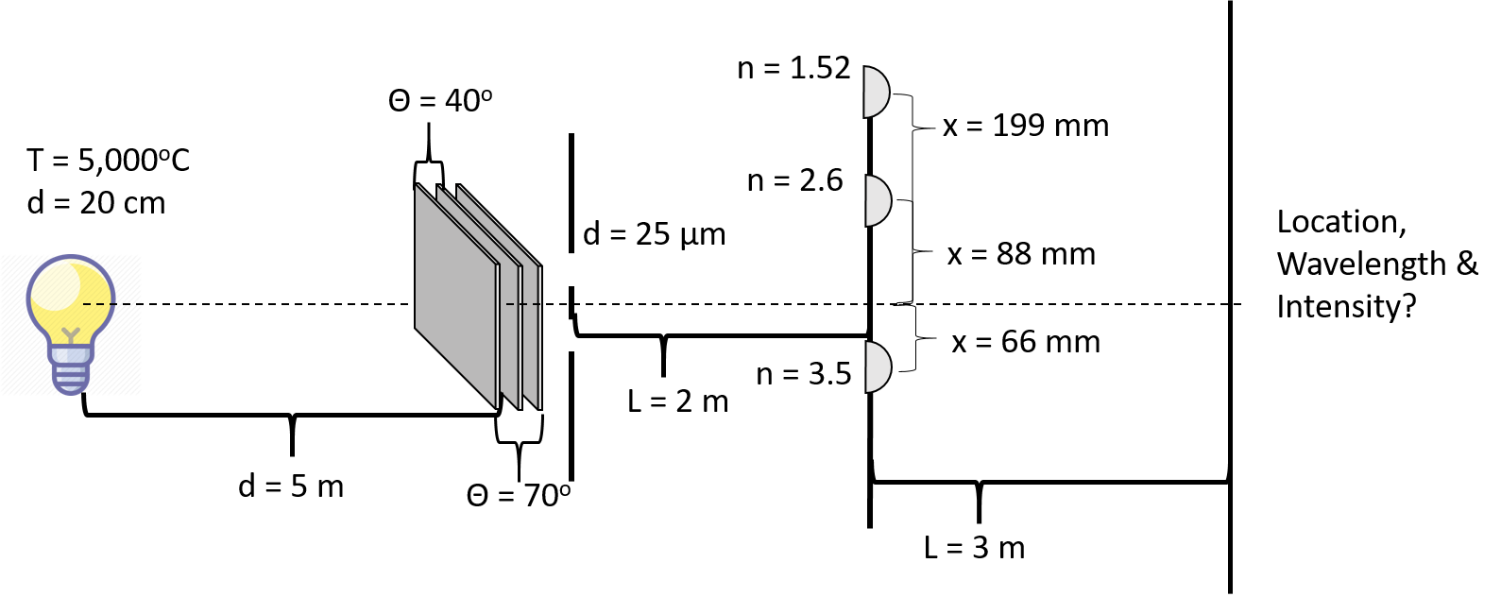

Opstical Course Review Activity
Look at the diagram below and determine the location, wavelength and intensity of the light when it makes it through the light obstacle (opstical) course to earn Extra Credit.

