Optics Online Simulations
Bending Light Simulation
Open the bending light simulation and play around with it.
Intro:
- Click the option in the top left for Wave. Look closely at the waves leaving the laser and then the waves passing through the bottom material. What do you notice about those two different waves?

- Change the index of refraction for the bottom material. What 2 things change about the light wave?

- Reset simulation and choose “Mystery A” if your birthday is from January to June or choose “Mystery B” if your birthday is from June to December.
- Choose the protractor and set the laser to an angle of incidence, θ₁, at 30°.
- Ignore the reflected ray (the ray that remains in air). Using the protractor, measure the angle of refraction, θ₂, of the laser and record in Table 2.
- Repeat steps 2 and 3 for angles of incidences of 50° and 70° of your own choosing. Record the results in Table 2.
- Calculate sin θ₁ and sin θ₂ for each trial. Record the results in Table 2.

Table 2
Trial | θ₁ (degrees) | θ₂ (degrees) | Sin θ₁ | Sin θ₂
1 | 30
2 | 40
3 | 50
4 | 60
5 | 70

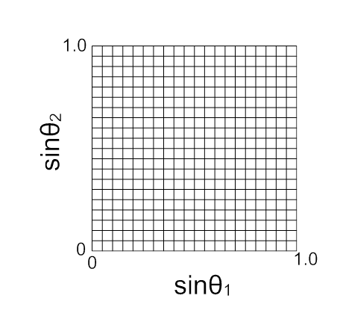
- Draw a graph of the Sin θ₂ vs. Sin θ₁ on the grid below. Draw in your best-fit line and find the slope. Show slope work below.

- What does your slope represent?

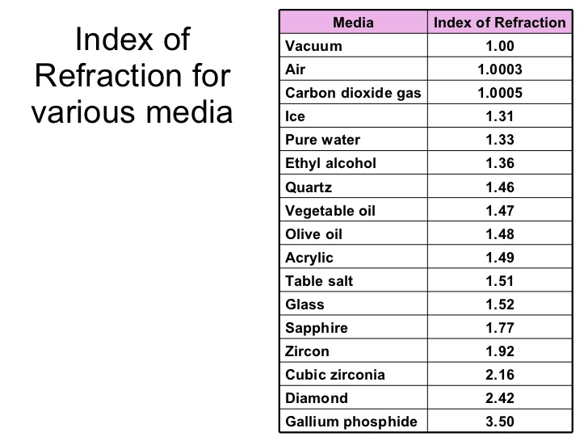
- Using the chart below of various indices of refraction for various media, identify your mystery material you had in your experiment.

Prisms: Play around with this simulation a bit. Prisms are used to use refraction to manipulate light waves. The index of refraction is slightly different for different colors of light, thus different colors refract at different angles, resulting in the cover of “the Dark Side of the Moon”. Try to recreate that cover in this simulation. Draw the setup below:

More Tools: Set the lower material to air and the upper material to the other Mystery A or B (which ever one you did not find in the first part) Move the laser around to find the critical angle. Show work below to determine the index of refraction for that material and use the table above to identify the material.

oPhysics: Concave and Convex Lenses
- Go to the oPhysics Link on Canvas.
- Take some time to play with the simulation to get familiar with how it works. To move the object, grab the blue dot at the top of the arrow. To change the focus, grab the left focus and slide it back and forth.
- In this lab, you will be moving the object to analyze how images are formed. When you are ready fill out the table below.

Position of Object | Image location (Region) | Magnification (Size) | Orientation | Type
Beyond 2f

At 2f

Between 2f and f

At f

Between f and lens
How does this table compare to the Concave Mirror results from the Mirror Ray Diagram Worksheet?

What is the difference between lenses and mirrors in terms of the ray diagrams?

For mirrors, in front of the mirror is the positive region and behind the mirror is the negative region. Is this true for lenses? If you have a positive value for d_{i}, where does that image form?

Set your f = 4, d_{o} = 10 and h_{o} = 2. Use the equation for mirrors and lenses to find the value of d_{i} and h_{i} below. Does the simulation confirm your answers?

When does a converging lens act like a magnifying glass?

Diverging Lens:
Grab the left focal point and drag it over to the right, through the lens. This should change the lens to a diverging lens.

How many different RSOT for the image can you create? List out the results:

Set the f = -2, d_{o} = 6 and h_{o} = 3. Use the equation for mirrors and lenses to find the value of d_{i} and h_{i} below. Does the simulation confirm your answers?

The Human Eye
- Go to the 3rd link on Canvas.
- Explore the simulation on how an eye works. Look at the results when a person is near sighted and far sighted.

What is different about the rays of light that reach the eye from an object near the eye, as compared to rays that come from an object far from the eye?

What type of lens is inside our eyes? Why does it have to be this type of lens and not the other one?

What is nearsightedness? In nearsightedness, what is the issue with the lens?

What type of lens can correct for this?

What is farsightedness? In farsightedness, what is the issue with the lens?

What type of lens can correct for this?

