Wave Interference Lab

**Purpose**: to determine the line spacing on CD, DVD and Blu-ray discs.

**Procedure**:

1. Choose a color laser. Record its wavelength
2. Grab a CD and place it on the ring stand. Measure the height of the CD.
3. Place the laser under the CD and turn it on so that you can see the central maximum and the points of constructive interference on the table or floor.
4. Measure the distances between the central maximum to the points of constructive interference.
5. Now grab a DVD and repeat process.
6. Now grab and Blu-ray. Record your observations.

**CD Spacing**

Distance from floor to cd: __________________

Wavelength of laser: ________________

|  |  |  |  |
| --- | --- | --- | --- |
| m value | Distance | Angle | d value |
|  |  |  |  |
|  |  |  |  |
|  |  |  |  |
|  |  |  |  |

1. Calculate the angles for the bright spots for the laser using the distances and the distance from the floor to the cd. Show sample calculation.
2. Calculate the d value for each of the bright spots using the angle, the m value and the wavelength of the lasers. Show sample calc.

**DVD Spacing**

Distance from floor to DVD: __________________

Wavelength of laser: ________________

|  |  |  |  |
| --- | --- | --- | --- |
| m value | Distance | Angle | d value |
|  |  |  |  |
|  |  |  |  |
|  |  |  |  |
|  |  |  |  |

1. Calculate the angles for the bright spots for the laser using the distances and the distance from the floor to the DVD. Show sample calculation.
2. Calculate the d value for each of the bright spots using the angle, the m value and the wavelength of the lasers. Show sample calc.

**Blu-ray Spacing:**

When you shine your laser on the Blu-ray, do you see any points of constructive interference?

Why do you think this is? What can this mean about the spacing of the lines on a Blu-ray disc?

**Post Lab Questions**:

1. A He-Ne laser produces a light with wavelength of 656 nm. If the laser is focused on 2 slits 0.06 mm apart, how far apart are the 1st dark spots on a screen 3.6 m away? **(4 cm)**

Coherent monochromatic light of wavelength λ in air is incident on two narrow slits, the centers of which are 2.0mm apart, as shown above. The interference pattern observed on a screen 5.0 m away is represented in the figure by the graph of light intensity I as a function of position x on the screen.

1. At point P in the diagram, there is a minimum in the interference pattern. Determine the path difference between the light arriving at this point from the two slits.
2. Determine the wavelength, λ, of the light.
3. 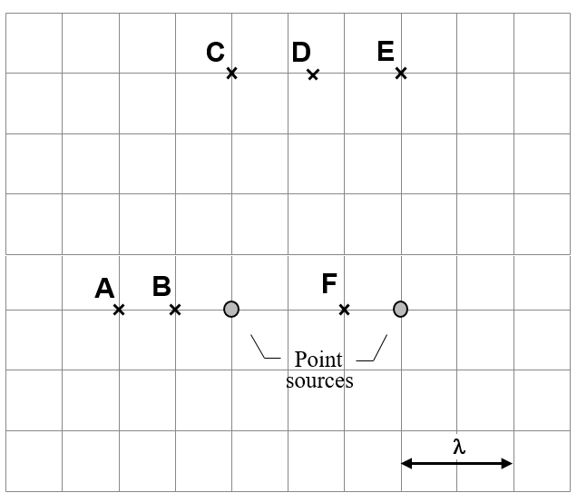Shown is a situation where two point sources are generating waves with the same frequency and amplitude. The two sources are in phase with each other. A distance equal to one and a half times the wavelength, 1.5λ, of the waves, separates the two sources.
4. List all the labeled points above that have constructive interference. If there are no such points, indicate that by stating “none of them.”
5. List all the labeled points above that have destructive interference. If there are no such points, indicate that by stating “none of them.”
6. Draw a point G where another constructive interference point will be.
7. A grating has 3500 lines/cm. How many complete spectral orders (rainbows ranging from 400 nm – 700 nm) can be seen when the grating is illuminated with white light? **(4)**

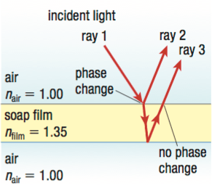When you look at the underside of a DVD, it looks like a rainbow. This is due to the interference of the light and because different colors have different wavelengths, you see certain colors at one angle and different colors at other angles. A similar thing happens when looking at soap bubbles, or an oil spill in a puddle. Pretty much, if you see a shifting rainbow effect, interference is going on.

This is called “Thin film interference”. When light strikes a surface, like a soap bubble, some of the light reflects and some refracts and then reflects. The result is 2 waves leaving the material that can constructively or destructively interfere.

1. 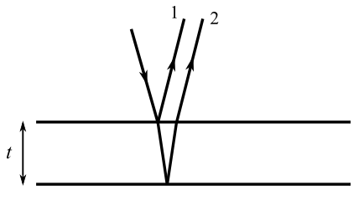If an oil spill has a thickness of t, how does the thickness compare to λ if constructive interference occurs? Create an equation with t and λ.
2. If the oil spill above has a thickness of 1.625 μm (micro is 10-6) when red light of wavelength 650 nm shines on it, do I see red light coming back?
3. A possible way to make planes invisible to radar is to coat them with an antireflective polymer. If radar waves have a wavelength of 3.00 cm, how thick does the coating need to be to ensure that no waves come off the plane (or the waves coming off the plane destructively interfere)?