Feynman Diagrams
Feynman diagrams were developed to describe the interactions of charged particles in quantum physics and they have found a wide use in describing a variety of particle interactions.
They are a type of space–time diagram; the time axis points upwards and the space axis points to the right, as shown in Figure 1. (Particle physicists often reverse this orientation.) Particles are shown as lines with arrows that denote the direction of their travel in time. (Particle physicists show antiparticles moving in the opposite direction.) Note that the lines do not show the actual trajectory of particles in space.
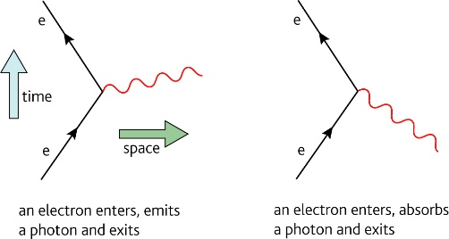
Virtual, or exchange, particles such as the photon or the W boson (W⁻ or W⁺) are shown as wavy lines. W bosons are heavier than a neutron and give rise to the weak force. Since they exist for a very short time they do not violate the law of conservation of energy.

Particle | Symbol | Rest energy/MeV | Particle | Symbol | Rest energy/MeV
photon | γ | 0 | neutron | n | 939.551
 |  |  | proton | p | 938.257
neutrino | ν | 0 | electron | e or β⁻ | 0.511
antineutrino |  | 0 | positron | e⁺ or β⁺ or ē | 0.511
Questions
- The Feynman diagram for beta decay is shown in Figure 2.
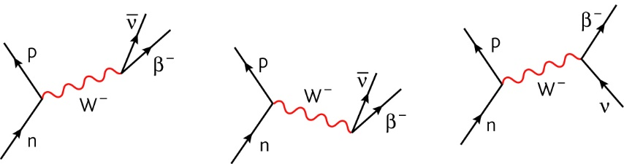
Figure 2 Figure 3 Figure 4
- Explain what is happening in Figure 2.

- Why is it wrong to draw beta decay as shown in Figure 3?

- What are the differences and similarities between Figure 2 and Figure 4?

- Draw the Feynman diagram for the following:
- Pair production of an electron and a positron from a photon.

- Proton-electron collision: p + e⁻ n + υ_{e}

- The two types of neutron-electron neutrino collision:
n + υ_{e} n + υ_{e} and n + υ_{e} p + e⁻

- Look at the Feynman diagrams for β⁻ and β⁺ decay in Figure 6. Describe, in your own words, the difference between these decays.
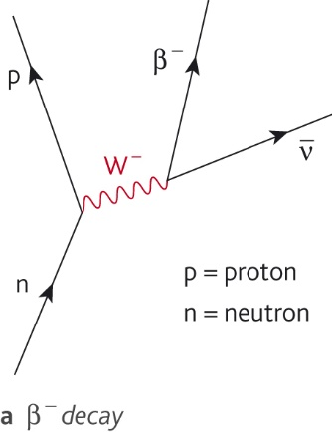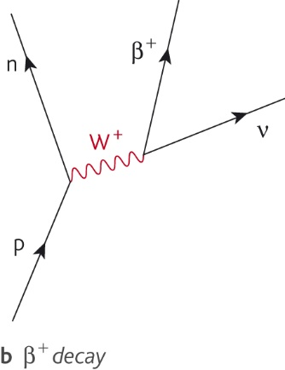

- The rest energies of different particles are given in the table on the previous page.
- Calculate the energy in joules released in the decay n → p + β⁻ +

- β⁺ decay can be represented as p → n + β⁺ + ν
Look at the rest energies of the particles involved and make a comment.

- What are the important differences between a proton and a positron?

Compare and comment on the amount of energy produced when an electron meets a positron in annihilation and when an electron meets a proton in electron capture.

