Radioactive Decay Worksheet

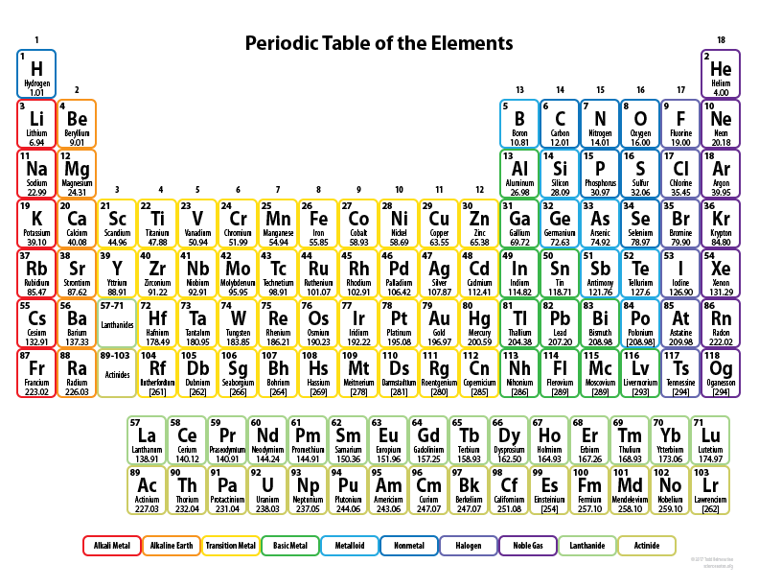

1. Fill in the missing isotope or emitted particle below

${}_{92}^{238}U→{}_{90}^{234}{Th}+___$

${}_{84}^{216}{Po}→___+{}_{-1}^{0}{β^{-}}$

${}_{90}^{234}{Th}→{}_{91}^{234}{Pa}+___$

${}_{84}^{215}{Po}→___+{}_{2}^{4}α$

${}_{83}^{210}{Bi}→___+{}_{-1}^{0}{β^{-}}$

${}_{8}^{15}O+{}_{-1}^{0}e→___$

${}_{92}^{238}U+{}_{1}^{2}H→___+2{}_{0}^{1}n$

${}_{7}^{13}N→___+{}_{1}^{0}{β^{+}}$

${}_{96}^{240}{Cf}+{}_{8}^{16}O→___+4{}_{0}^{1}n$

|  |  |  |  |  |  |  |  |
| --- | --- | --- | --- | --- | --- | --- | --- |
| Type of decay | **Parent** | **alpha** | **Beta minus** | **alpha** | **EC** | **Beta minus** | **alpha** |
| Z (atomic number) | 85 | 83 | 84 | 82 | 81 | 82 | 80 |
| Symbol | At | Bi | Po | Pb | Tl | Pb | Hg |
| Isotope Name | Astatine | Bismuth | Polonium | Lead | Thallium | Lead | Mercury |
| A (atomic mass) | 210 | 206 | 206 | 202 | 202 | 202 | 198 |

Here is an example of a decay chain

Complete the tables below for the decay chains

|  |  |  |  |  |  |  |  |
| --- | --- | --- | --- | --- | --- | --- | --- |
| Type of decay | **Parent** | **Beta minus** | **alpha** | **Beta Plus** | **alpha** | **alpha** | **Beta minus** |
| Z (atomic number) | 90 |  |  |  |  |  |  |
| Symbol | Th |  |  |  |  |  |  |
| Isotope Name | Thorium |  |  |  |  |  |  |
| A (atomic mass) | 232 |  |  |  |  |  |  |

|  |  |  |  |  |  |  |  |
| --- | --- | --- | --- | --- | --- | --- | --- |
| Type of decay | **Parent** | **alpha** | **Beta minus** | **alpha** | **Beta minus** | **alpha** | **Beta minus** |
| Z (atomic number) | 92 |  |  |  |  |  |  |
| Symbol | U |  |  |  |  |  |  |
| Isotope Name | Uranium |  |  |  |  |  |  |
| A (atomic mass) | 235 |  |  |  |  |  |  |

1. Polonium 214 (mPo = 213.995186 u) decays by alpha radiation (mα = 4.002602 u) to Lead 210 (mPb = 209.984173 u). How much energy is released as the alpha particle leaves the nucleus? (**7.83 MeV**)
2. Determine the symbol  for the parent nucleus whose α decay produces the same daughter as the β- decay of thallium .
3. How much energy is released when tritium ( m = 3.016049 u) decays by β- emission to  (m = 3.016029 u)? (**18.6 keV**)
4. Does  m = 11.011434 u decay by β- to become  m = 11.011334 u or β+ to become  m = 11.009306 u? What is the energy released?
5. Berkelium 247 (m = 247.070299 u) decays to Americium 243 (m = 243.061373u) through α decay. Assuming that Berkelium was originally at rest and that energy and momentum are conserved, find the speed of the α particle (**1.67*107 m/s**)