Conservation of Energy Problems

- An archer fires 3 arrows from the top of a cliff; one straight up, on straight down, and one horizontally. Each of them strikes the ground below the cliff. Assuming no air resistance, which one (or ones) strikes the ground with the greatest speed? Why?

- If you do consider air resistance in the previous problem, does this change your answer? Why?

- A spring launcher with a spring constant of 500 N/m is compressed a distance of 15 cm. A 45 g ball is placed in the launcher. When fired it travels through the air. Assuming no air resistance, how fast is it going when it is 10m above the launch position? (7.35 m/s)
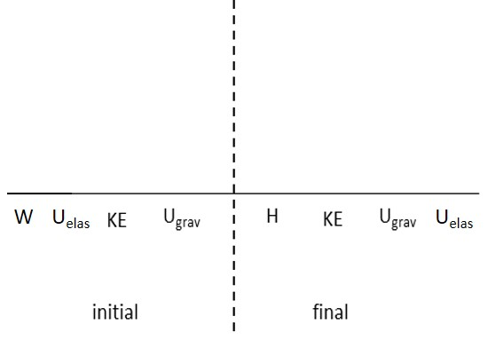

- A 75.0 kg Delta Force Ranger fast-slides from rest, 30.0 m down a rope, connected to a Black Hawk helicopter, moving with a speed of 8.50 m/s at the bottom of the rope. Considering that Heat is the Work done by friction, what is the force of friction on the way down? (645 N)

- In screeching to a halt, a 1200 kg car leaves skid marks 75 m long. If the coefficient of friction is 0.80, how fast was the car going before the driver applied the brakes? (34.3 m/s)

- A vertical spring (ignore its mass), whose spring constant is $\text{950}N/m,$ is attached to a table and is compressed down 0.150 m. (a) What upward speed can it give to a 0.30-kg ball when released? (b) How high above its original position (spring compressed) will the ball fly? (8.26 m/s, 3.63 m)

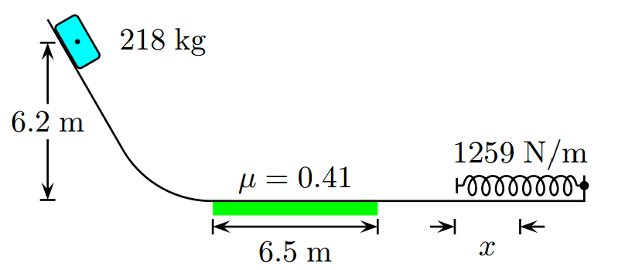
- A 218 kg block is released at a 6.2 m height as shown. The track is frictionless except for a portion of length 6.5 m. The block travels down the track, hits a spring of force constant 1259 N/m. The coefficient of kinetic friction between surface and block over the 6.5 m track length is 0.41. Determine the compression of the spring x from its equilibrium position before coming to rest momentarily. (3.46m)

- WARNING! HARD PROBLEM! A 100 kg man is attached to a bungee cord that has a spring constant of 490 N/m and is 50 m long (unstretched). He drops off of a bridge and falls some distance before coming to a stop. How far down from the top of the bridge does he fully stop? Assume he drops from rest and that the average force of air resistance is 120 N. (65.1 m)

